VistA Scheduling Enhancements (VSE)

VS GUI  
User Guide



January 2017

Department of Veterans Affairs

Office of Information and Technology (OI&T)

Version 1.7

Revision History

|  |  |  |  |
| --- | --- | --- | --- |
| Date | Revision | Description | Author |
| 01/27/2017 | 1.6 | Addressed VA comments. Added section 5.1.8 Viewing/Editing Recall Request; added alt text to all figures and tables; added sections for Acronyms and Hot Keys. | M. Woehrle  C. Kron  E. Phelps |
| 01/18/2017 | 1.5 | Performed internal peer review. Removed references to W2VA. Updated sections Section 2, pp. 6-8, added VSE Additional Enhancements description. | M. Woehrle  L. Masucci  E. Phelps |
| 01/08/2017 | 1.4 | Updates from UAT, pp. 7, 9, 11, 15, 22, 23, 25, 27, 35-37, 46-48, 50, 52, 55, 57-58,60,63,69,71, 74,76,79,81,84,86,89-91,93,96-109,117-118,120-121, 123, 125, 127-130,132-147,166,181-195. Technical edit for format and consistency. | C. Kron  E. Stuck  C. Zavala E. Phelps |
| 12/21/2016 | 1.3 | Updates to TOC, footers, Pg. 161-211. Technical edit – fixed figure captions, added table list, added queries for author | C. Kron E. Phelps |
| 12/7/2016 | 1.2 | Updates to Clinic Grid, Pg. 31,37-38,72,91 | C. Kron |
| 11/21/2016 | 1.1 | Updates from CIT/ST, Pg. 6-13,16-21,23-24,27-95,97,99-104,123-124,127,129-131,133,135-137,139-145,157-161,168-171,173-174,176,184 | C. Kron |
| 05/02/2016 | 1.0 | Initial Baseline | D. Reed |

Table of Contents

1 Introduction 1

1.1 Purpose 1

1.2 Overview 1

1.3 Project References 1

1.3.1 Information 1

1.3.2 Coordination 1

1.3.3 Help Desk 1

1.3.4 Organization of the User Guide 2

2 System Summary 3

2.1 User Access Levels 7

3 Getting Started 8

3.1 Logging On 8

3.2 Logging Off 9

3.3 VS GUI Tabs 10

3.3.1 Tasks Tab 10

3.3.2 System Tab Action Areas 11

3.3.3 Reports Tab Action Areas 12

3.4 Searching 12

3.4.1 Search for Patient 12

3.5 Filtering 13

3.5.1 Filtering Lists 14

3.5.2 Paging Through Records 14

3.5.3 Filtering by Facility or Clinic 15

3.5.4 Filtering by Time Period 15

3.6 Sorting 15

3.6.1 Sorting by Column 16

3.7 Printing and Exporting a Request Management Grid 17

3.7.1 Printing a Request Management Grid 17

3.7.2 Exporting a Grid 18

3.8 Viewing 19

3.8.1 View Only Mode 19

3.8.2 Viewing Requests by Request Type 19

3.8.3 Viewing Requests by Patient 20

3.8.4 Changing the Schedule View 21

4 Ribbon Bar 23

4.1 Patients Demographics 23

4.1.1 Finding a Patient 23

4.1.2 Viewing Patient Demographics in the Ribbon Bar 23

4.1.3 Patient Eligibility Information 25

4.1.4 Updating Patient Demographics 25

4.1.5 Editing Permanent Address 26

4.1.6 Adding a Temporary Address 27

4.1.7 Marking for Bad Address 28

4.2 Actions 30

4.2.1 New Request 30

4.3 Arrangement 31

4.3.1 View Mode 31

4.4 Pending Appointment Window 31

4.5 Special Needs/Preferences 33

4.5.1 Adding/Removing Special Needs/Preferences from Requests 33

4.6 Patient Flags 34

4.7 Mobile Requests 36

4.8 Tools 36

4.8.1 Print 36

4.8.2 Export 36

4.8.3 Refresh 36

4.8.4 Query 37

4.9 Settings – User Preferences 38

5 Request Management 41

5.1 Request Management Procedures 41

5.1.1 Viewing a Patient’s Existing Requests 41

5.1.2 Adding Appointment Request 42

5.1.3 Viewing/Editing Appointment Request 44

5.1.4 Disposition or Removing an Appointment Request 47

5.1.5 Transfer to EWL Request for a Patient 48

5.1.6 Disposition or Removing a Patient from the EWL 49

5.1.7 Adding Recall Request 50

5.1.8 Viewing/Editing Recall Request 51

5.1.9 Disposition or Remove Recall Request 55

5.2 Contacting a Patient 57

5.2.1 Call Attempt 1 57

5.2.2 Call Attempt 2 58

5.2.3 Call Attempt 3 59

5.2.4 Letter Sent to Patient 60

6 Appointment Management 62

6.1 Adding Appointments 62

6.1.1 Add Appointment for Appointment Request 62

6.1.2 Add Appointment for EWL Request 67

6.1.3 Add Appointment for Recall Request 72

6.1.4 Add Appointment for Consult Request 76

6.2 Disposition Appointments 82

6.2.1 Edit Appointment Information 82

6.2.2 View Appointment Information 83

6.2.3 Cancelling an Appointment 85

6.2.4 Mark as No Show Appointment 88

6.2.5 Undo No-Show Appointment 90

6.2.6 Checking In a Patient 92

6.2.7 Undo a Patient Check In 93

6.2.8 Check Out a Patient 95

6.2.9 Undo a Patient Check Out 97

6.2.10 Rescheduling an Appointment 98

6.3 Multiple Appointment Requests and Appointments 100

6.3.1 Multiple Appointment Request 100

6.3.1.1 Note Regarding Parent and Child Appointment Requests 101

6.3.2 Adding Multiple Appointments from Find Appointment Dialog 102

6.4 Overbooking Appointments 106

6.4.1 Overbooking Appointments with SDMOB Security Key 107

6.4.2 Overbooking Appointments with SDOB Security Key 111

6.5 Variable Length Appointment 115

6.5.1 Identifying a Variable Length Clinic 115

6.5.2 Add a Variable Length Appointment 116

6.6 Compensation and Pension Appointments 120

6.6.1 Adding Compensation & Pension APPT Request 120

6.6.2 Add Compensation & Pension Appointment for Pending 2507 Request NOT Previously Linked to Appointment 121

6.6.3 Add Compensation & Pension Appointment for Pending 2507 Request Already Linked to Appointment NOT Due to Cancellation 122

6.6.4 Add Compensation & Pension Appointment for Pending 2507 Request due to Clinic Cancellation 124

6.6.5 Add Compensation & Pension Appointment for Pending 2507 Request due to Veteran Cancellation/No Show 127

6.6.6 Disposition Appointment Linked to Pending 2507 Request 130

6.7 Veteran Appointment Request Scheduling 131

6.7.1 Scheduling a Mobile Request 132

7 Clinics 135

7.1 Tasks Tab 135

7.1.1 Viewing Clinic Schedule Availability 135

7.1.2 Viewing Clinic’s Availability Cancellation 138

7.1.3 Viewing Clinic’s Length of Appointment and Maximum Overbook 139

7.1.4 Viewing Clinic’s Variable Length Indicator 139

7.1.5 Viewing Clinic’s Special Instructions 140

7.1.6 Viewing Clinic’s Available Slots 141

7.1.7 Time Slot Viewer 141

7.1.8 Viewing Provider Availability 145

7.1.9 Viewing Clinic Group Availability 147

7.2 System Tab 149

7.2.1 Viewing Clinic Availability Information 149

7.2.2 Adding and Removing Privileged Users 150

7.2.2.1 Add Privileged User 150

7.2.2.2 Remove Privileged User 151

7.2.3 Creating Clinic Groups 152

7.2.4 Removing Resource(s) from a Clinic Group 155

8 Reports 156

8.1 Audit Activity Report 156

8.1.1 Generating an Audit Activity Report for Individual Scheduler 156

8.1.2 Generating Audit Activity Report for All Schedulers 157

8.1.3 Working with Audit Activity Report Data 158

8.1.3.1 Sorting by Column Header 158

8.1.3.2 Filtering by Column Data 160

8.1.4 Export Audit Activity Report for Individual or All Schedulers 161

8.2 Clinics Report 161

8.2.1 Clinic Activity Report—Individual Clinic 161

8.2.2 Working with the Clinic Activity Report 162

8.2.2.1 Sorting by Column Headers 162

8.2.2.2 Filtering by Column Data 163

8.2.3 Exporting a Clinic Report 164

9 Trash Queue Cleanup 166

9.1 Compile List of Re-Opened REQUEST Records that Can Be Closed 166

9.2 Commit Records to Be Closed from Compiled List 167

9.3 View Unresolved APPT Requests Reopened by the SDCANCEL Option 169

10 VistA Scheduling 508 Compliance 171

10.1 Tasks Tab 171

10.1.1 Ribbon Bar 171

10.1.2 Request Type Dialog 172

10.1.3 Appointment Request Dialog 172

10.1.4 Query Dialog 173

10.2 Systems Tab 175

10.2.1 Systems Tab Ribbon Bar 175

10.2.2 Scheduling Management Dialog 175

10.2.2.1 Clinics and Users Tab 175

10.2.2.2 Clinic Groups Tab 176

10.2.3 Availability Selection Dialog 177

10.3 Reports Tab 177

10.3.1 Reports Tab Ribbon Bar 178

10.3.2 Audit Activity Dialog 178

10.3.3 Clinic Activity Dialog 179

11 Troubleshooting 180

11.1 Changing User ID and Password 180

11.2 Special Instructions for Error Correction 180

12 Acronyms and Abbreviations 181

13 Hot Keys Quick List 183

List of Figures

Figure 1: User Login 8

Figure 2: Main Screen with Test Environment Displayed 9

Figure 3: User Logoff 9

Figure 4: VS GUI Tabs 10

Figure 5: Mobile Requests Unavailable Displayed in Ribbon Bar 10

Figure 6: Tasks Tab Display 11

Figure 7: System Tab 11

Figure 8: Reports Tab 12

Figure 9: Patient Search 13

Figure 10: Filtering Lists 14

Figure 11: Paging Through Records 14

Figure 12: Filtering by Facility/Clinic 15

Figure 13: Filtering by Time Period 15

Figure 14: Sorting by Column 16

Figure 15: Selecting the Print Option 17

Figure 16: Selecting a Printer 17

Figure 17: Exporting a Grid 18

Figure 18: Request Type Column 20

Figure 19: Select Patient 20

Figure 20: Request Type 21

Figure 21: Patient Pending Requests and Booked Appointments 21

Figure 22: View Mode 22

Figure 23: Changing View of a Specific Schedule 22

Figure 24: Search Patient 23

Figure 25: Patient Demographics in the Ribbon Bar 24

Figure 26: Patient Inquiry Detail 24

Figure 27: Patient's Eligibility Information 25

Figure 28: Request Type–APPT 26

Figure 29: Patient Information Dialog 26

Figure 30: Patient Info Dialog–Permanent Address 27

Figure 31: Patient Info Dialog – Temporary Address 28

Figure 32: Select Patient 29

Figure 33: Request Type 29

Figure 34: Appointment Request Dialog—Bad Address Selection 30

Figure 35: Actions Pane 31

Figure 36: Request Type – APPT 31

Figure 37: Pending Appointment Window—Past Appointment Date 32

Figure 38: Pending Appointment Window—Current less than 3 days in Future 32

Figure 39: Pending Appointment Window—Future Appointment Dates 33

Figure 40: Request Type–APPT 33

Figure 41: Patient Info Dialog —Special Needs/Preferences Section 34

Figure 42: Ribbon Bar—Special Needs/Preferences 34

Figure 43: Patient Record Flags Dialog 35

Figure 44: Patient Record Flags 35

Figure 45: Refresh Button in Tools Pane 36

Figure 46: Request Query 37

Figure 47: Query Rule Validation 38

Figure 48: Request Query Rule Confirmation 38

Figure 49: Settings – User Preferences 39

Figure 50: Settings – Save as Default View 40

Figure 51: Request Type 41

Figure 52: Request Grid and Pending Appointments 41

Figure 53: Request Type - APPT 42

Figure 54: Actions Pane—New Req. Selection 42

Figure 55: Appointment Request Dialog—Request Information Section 43

Figure 56: Special Needs/Preferences Section from Patient Info Dialog 43

Figure 57: Appointment Request Dialog 44

Figure 58: View Request (Read Only) 45

Figure 59: Edit Request (Request Information Only) 46

Figure 60: APPT/Veteran Disposition Options 47

Figure 61: EWL Request Dialog 49

Figure 62: Request Type - RECALL 50

Figure 63: Recall Appointment Request Dialog 51

Figure 64: Recall Disposition Options 56

Figure 65: Recall Comment 56

Figure 66: Contact Options–Call Attempt 1 57

Figure 67: Patient Contact Dialog 58

Figure 68: Contact Options–Call Attempt 2 59

Figure 69: Patient Contact Dialog 59

Figure 70: Contact Options–Call Attempt 3 60

Figure 71: Patient Contact Dialog 60

Figure 72: Contact Options–Letter Sent to Patient 61

Figure 73: Patient Contact Dialog 61

Figure 74: Request Type 62

Figure 75: Select APPT Request–Clinic Schedule Grid Display 63

Figure 76: Select Time Slot 63

Figure 77: Right Click Options–Add Appointment 64

Figure 78: New Appointment Dialog 64

Figure 79: Print Letter? Dialog 65

Figure 80: Closing Request Dialog 65

Figure 81: Clinic Schedule Grid–Past Appointment Date Display 66

Figure 82: Clinic Schedule Grid–Current or less than 3 days in Future Appointment in Clinic Schedule Display 66

Figure 83: Clinic Schedule Grid--Future Appointment Date in Clinic Schedule Display 67

Figure 84: Request Type 67

Figure 85: Select EWL Request 68

Figure 86: Select Time Slot 68

Figure 87: Right Click Options–Add Appointment 69

Figure 88: New Appointment Dialog 69

Figure 89: Print Letter? Dialog 70

Figure 90: Closing Request Dialog 70

Figure 91: Past Appointment Date in Clinic Schedule Grid–EWL Appointment Past Date Display 71

Figure 92: Clinic Schedule Grid–EWL Appointment Current Date 71

Figure 93: Future Appointment Date in Clinic Schedule Grid–EWL Appointment Future Date Display 72

Figure 94: Request Type 72

Figure 95: Select Recall Request 73

Figure 96: Select Time Slot 73

Figure 97: Right Click Options–Add Appointment 73

Figure 98: New Appointment Dialog 74

Figure 99: Print Letter? Dialog 75

Figure 100: Closing Request Dialog 75

Figure 101: Past Appointment Date in Clinic Schedule display–Past Date Appointment 75

Figure 102: Clinic Schedule Display–Current Date Appointment 76

Figure 103: Future Appointment Date in Clinic Schedule Display–Future Date Appointment 76

Figure 104: Request Type 77

Figure 105: Select Consult Request 77

Figure 106: Clinic Schedules 78

Figure 107: Select Time Slot 78

Figure 108: Right Click Options–Add Appointment 78

Figure 109: New Appointment Dialog 79

Figure 110: Print Letter? Dialog 79

Figure 111: Clinic Schedule Display–Consult Past Appointment Date 80

Figure 112: Consult with Current Date or less than 3 days in Future in Clinic Schedule Display 81

Figure 113: Consult Future Appointment Date in Clinic Schedule Display 81

Figure 114: Appointment Right Click Options--Edit Appointment 82

Figure 115: Edit Appointment Dialog 83

Figure 116: Hover Box Displaying Appointment Details 84

Figure 117: Appointment Right Click Options--View Appointment 84

Figure 118: View Appointment Dialog 85

Figure 119: Appointment Right Click Options--Cancel Appointment 86

Figure 120: Cancel Appointment Dialog 87

Figure 121: Pending Appointment Window–Appointment Status Cancelled by Clinic 87

Figure 122: Pending Appointment Window–Appointment Status Cancelled by Patient 88

Figure 123: APPT Request Returns to Request Management Grid and Time Slot Count Increases 88

Figure 124: Appointment Right Click Options—Mark as No Show 89

Figure 125: Mark as No Show Dialog 89

Figure 126: Clinic Schedule Display–No Show Red 90

Figure 127: Pending Appointment Window–Appointment Status No-Show 90

Figure 128: Appointment Right Click Options–Undo NoShow 91

Figure 129: Appointment Clinic Schedule Display–Undo NoShow as Purple 91

Figure 130: Pending Appointment Window Undo NoShow–Appointment Status No Action Taken 92

Figure 131: Appointment Right Click Options–Check In Patient 92

Figure 132: Appointment Check In Dialog 93

Figure 133: Clinic Schedule Display–Check In Yellow 93

Figure 134: Pending Appointment Window–Appointment Status ACT REQ/CHECKED IN 93

Figure 135: Appointment Right Click Options–Undo Check In Patient 94

Figure 136: Clinic Schedule Display–Undo Check In Patient Purple 94

Figure 137: Pending Appointment Window–Appointment Status No Action Taken 95

Figure 138: Appointment Right Click Option–Check Out Patient 95

Figure 139: Appointment Check Out Dialog 96

Figure 140: Clinic Schedule Display–Check Out Patient Orange 96

Figure 141: Pending Appointment Window–Appointment Status ACT REQ/CHECKED OUT 97

Figure 142: Appointment Right Click Options–Undo Check Out Patient 97

Figure 143: Clinic Schedule Display–Undo Check Out Patient Yellow 98

Figure 144: Pending Appointment Window--Appointment Status ACT REQ/CHECKED IN 98

Figure 145: Move Appointment? Dialog 99

Figure 146: Cancel Appointment Dialog 99

Figure 147: Pending Appointment Window–Appointment Status Cancelled and Future 100

Figure 148: MRTC Interval/Appt. # Dialog 101

Figure 149: MRTC Requests displayed in Request Management Grid 102

Figure 150: Find Appointment Dialog 104

Figure 151: Find Appointment Dialog and MRTC Booking Status Dialog 105

Figure 152: Future Clinic Inactivation Date 106

Figure 153: Request Type 107

Figure 154: Clinic Schedule Display–APPT Request Future CID/Preferred Date 108

Figure 155: Max Overbook Limit 108

Figure 156: Appointment Right Click Options–Add Appointment 109

Figure 157: New Appointment Dialog – Appointments 109

Figure 158: Print Letter? Dialog 110

Figure 159: Closing Request Dialog 110

Figure 160: Clinic Schedule Display--Overbook Appointment 111

Figure 161: Request Type 111

Figure 162: Clinic Schedule Display–APPT Request Future CID/Preferred Date 112

Figure 163: Overbook After Hours Time Slot 112

Figure 164: Appointment Right Click Options–Add Appointment 113

Figure 165: Overbook Confirmation Dialog 113

Figure 166: New Appointment Dialog 114

Figure 167: Print Letter? Dialog 114

Figure 168: Closing Request Dialog 115

Figure 169: Clinic Schedule Display–Overbook Appointment After Hours 115

Figure 170: Clinic Schedules–Clinic Search 116

Figure 171: Clinic Schedule Grid 116

Figure 172: Variable Length Indicator 116

Figure 173: New Appointment Dialog 117

Figure 174: Clinic Schedule Display–Multiple Time Slot Selected 118

Figure 175: New Appointment Dialog–Variable Length Appointment Duration 119

Figure 176: Clinic Schedule Display–Appointment Length Extended 120

Figure 177: AMIE C&P EXAM TRACKING Record Updated 121

Figure 178: C&P Appointment for Patient with No Pending 2507 Request 121

Figure 179: Comp & Pension Requests Dialog 123

Figure 180: Comp & Pension Request Due to Cancellation Dialog 123

Figure 181: AMIE C&P EXAM TRACKING Record Updated 123

Figure 182: Comp & Pension Requests Dialog 125

Figure 183: Comp & Pension Request Due to Cancellation Dialog 125

Figure 184: Comp & Pension Request Appointment Links Dialog 126

Figure 185: C&P Appt Links Due to Veteran Cancellation or No Show 126

Figure 186: Comp & Pension Due to Cancellation Dialog 126

Figure 187: C&P Appointment Link Adjustment Dialog 127

Figure 188: Comp & Pension Request Dialog 128

Figure 189: Comp & Pension Request Due to Cancellation Dialog 128

Figure 190: Comp & Pension Request Appointment Links Dialog 129

Figure 191: Comp & Pension Canceled Appointment Links Dialog Warning 129

Figure 192: C&P Appt Links Due to Veteran Cancellation or No Show 129

Figure 193: AMIE C&P EXAM TRACKING Record Updated 130

Figure 194: C&P Cancel Appointment Associated 2507 Request Updated 131

Figure 195: C&P Cancel Appointment NOT linked to Pending 2507 Request 131

Figure 196: Mobile Requests 132

Figure 197: Mobile Request List 132

Figure 198: Mobile Request Selected 133

Figure 199: Veteran APPT Request 134

Figure 200: Message to Veteran Dialog 134

Figure 201: Mobile Request Removed from Grid 134

Figure 202: Clinic Schedules Search 136

Figure 203: Clinic Schedules Display Available vs Unavailable 136

Figure 204: Clinic Schedules Display Hours of Operation 137

Figure 205: Clinic Schedules Display–Holiday Bookable 137

Figure 206: Clinic Schedules Display--Holiday Unbookable 138

Figure 207: Clinic Schedule Display–No Availability Defined 138

Figure 208: Clinic Schedule Display–Cancel Availability 139

Figure 209: Appointment Length and Max Overbook Allowed 139

Figure 210: Variable Length Indicator 140

Figure 211: Special Instructions Indicator 140

Figure 212: Time Slot Count 141

Figure 213: Overbook Time Slot Count 141

Figure 214: Minimized Time Slot Viewer 142

Figure 215: Expanded Time Slot Viewer 142

Figure 216: Time Slot Viewer Displays Slot Details 143

Figure 217: Time Slot Viewer Right Click Options–Add Appointment 143

Figure 218: Time Slot Viewer Right Click–Edit, View, Cancel 143

Figure 219: Time Slot Viewer–Check In Patient 144

Figure 220: Time Slot Viewer–Check Out Patient 144

Figure 221: Time Slot Viewer–Mark as No Show 145

Figure 222: Provider Schedules 145

Figure 223: Provider Schedules Selection List 146

Figure 224: Provider Schedule Display 146

Figure 225: Provider Schedules Booked Appointments 146

Figure 226: Fixed View Size 147

Figure 227: Clinic Groups 147

Figure 228: Clinic Groups Search Result List 148

Figure 229: Clinic Groups Schedule Display 148

Figure 230: Provider Schedules–Fixed View Size 148

Figure 231: Clinic Availability Search 149

Figure 232: Clinic Availability 150

Figure 233: Clinics and Users 151

Figure 234: Add Privileged User 151

Figure 235: Remove Privileged User 152

Figure 236: Create New Clinic Group 153

Figure 237: Find Resource 154

Figure 238: Add Resource to Clinic Group 155

Figure 239: Remove Resource from Clinic Group 156

Figure 240: Reports Tab Selections 156

Figure 241: Audit Activity Report–Individual Scheduler 157

Figure 242: Audit Activity Report–All Schedulers 158

Figure 243: Audit Activity Sort–Ascending 159

Figure 244: Audit Activity Sort –Descending 160

Figure 245: Audit Activity Report–Filtered 160

Figure 246: Audit Activity Report–Multiple Filters 161

Figure 247: Clinic Activity Report Sort–Ascending Order 163

Figure 248: Clinic Activity Report Sort–Descending Order 163

Figure 249: Clinic Activity Report–Filtered 164

Figure 250: Clinic Activity Report–Multiple Filters 164

Figure 251: Clinic Activity 165

Figure 252: Save As 165

List of Tables

Table 1: Clinic Schedule Availability 135

Table 2: Hot Keys for Ribbon Bar Components 171

Table 3: Hot Keys for Request Type Dialog 172

Table 4: Hot Keys for Appointment Request Dialog 173

Table 5: Hot Keys for Systems Tab Ribbon Bar 175

Table 6: Hot Keys for Scheduling Management Dialog 176

Table 7: Hot Keys for Clinic Groups Tab 177

Table 8: Hot Keys for Availability Selection Dialog 177

Table 9: Hot Keys for Reports Tab Ribbon Bar 178

Table 10: Hot Keys for Audit Activity Dialog 179

Table 11: Hot Keys for Clinic Activity Dialog 179

Table 12: Warning Messages 180

# Introduction

Department of Veterans Affairs (VA) Veterans Health Information System and Technology Architecture (VistA) Scheduling (VS) Graphical User Interface (GUI) module is the Windows GUI version of the Patient Information Management System (PIMS) Scheduling module. It provides appointment management functions included in PIMS Scheduling, but with the added convenience and usability of a GUI.

## Purpose

The Veterans Health Administration (VHA) Office of Veterans Access to Care (OVAC) requested an enterprise enhancement for the VistA Scheduling Package. The enhancement reduces operating cost for VHA and improves operational efficiencies resulting in patient centered access to care, coordinated care, increased customer satisfaction, and the reduction of excessive cycle/wait time used for scheduling patients.

## Overview

VS GUI is a software module that allows Schedulers to make appointments quickly by viewing multiple appointment request types and multiple clinics in one screen. A Scheduler can easily view patient requests for service, find the next available open appointment, view the provider’s availability in multiple clinics, and track a patient’s appointment process.For a more detailed description of VS GUI functionality, refer to Section 2.

## Project References

### Information

The VS GUI points of contact (POCs) include:

* OVAC VSE PM – Ms. Debbie Malkovich, [Debbie.Malkovich@va.gov](mailto:Debbie.Malkovich@va.gov)
* OI&T VSE PM Mr. Shannon Ayers, Shannon.Ayers@va.gov, [Robert.Schmidt@va.gov](mailto:Robert.Schmidt@va.gov)

**Note:** The VSE Project SharePoint site can be accessed via the following link: <http://vaww.oed.portal.va.gov/pm/iehr/vista_evolution/enhancements/SitePages/Home.aspx>

### Coordination

Coordination between the project and its specific support functions (e.g., installation coordination, security, etc.) for VS GUI are the same as those for VistA.

### Help Desk

**Note:** Please refer to Section 11 Troubleshooting for additional information.

### Organization of the User Guide

The user guide is comprised of eleven sections. They are:

1. Introduction. Discusses general project information.
2. System Summary. Contains system configuration, data flows, and user access level information.
3. Getting Started. Contains procedures for logging on and off of the system, information on VS GUI tab displays, basic functions for searching, sorting, filtering, and viewing of information. The Getting Started section also provides instructions on how to print and export schedules.
4. Ribbon Bar. Located in the uppermost window of the screen, it includes patient demographics, new request actions, view mode, patient preferences, and many other useful pieces of information. It launches when a patient is searched for and selected.
5. Request Management. The patient’s pending requests are displayed in the Request Management Grid, 25 at a time, and booked appointments are displayed in the Pending Appointments Window in the Ribbon Bar of the **Tasks** tab.
6. Appointment Management. After selecting a patient, the option appears to schedule a new appointment or a recall. A list of recent and upcoming appointments is displayed in the ribbon bar.
7. Clinics. Viewing and appointments with clinics and administrator actions with clinics are located in this section.
8. Reports. An overview of viewing and printing reports, as well as procedures to generate Audit and Clinic reports is contained in this section. A list of warnings is also included.
9. Trash Queue Cleanup. For administrators who need to identify and purge unresolved requests, the solution allows a task to be run to identify open appointment requests or duplicate appointment requests and close them, producing a report for administrators.  
      
   **Note:** Excludes VAR requests, which are called Veteran Requests or Mobile requests, stored in the SDEC APPT REQUEST file.
10. VistA Scheduling 508 Compliance. This enables VS GUI to be utilized from the keyboard. Many hot keys have been added for ease of use. Graphics are also within current guidelines.
11. Troubleshooting. Contact the help desk for any problems with the VS GUI module.

# System Summary

The VSE project delivers a series of enhancements to legacy VistA Scheduling v5.3 via the VS GUI application. The initial release, which consists of features listed in the Enhancement 1, Enhancement 2, NSR #002, VAR Interface, Optional Task 3, Optional Task 4, and Enhancement 3 following paragraphs. These enhancements are included in VS GUI 2.0.0.5 and VistA patches SD*5.3*627, SD*5.3*628, SD*5.3*642, SD*5.3*643, SD*5.3*645 and GMRC*3*83 and were approved for National Release on 4/29/2016 and Released on 5/3/2016 for Test environments only.

The VS GUI 2.0.0.8 and VistA M patches GMRC*3*86, SD*5.3*651, and SD*5.3*658 provide the existing functionality listed above in addition to the features which are listed in the VSE Additional Enhancements paragraph below**.**

**Enhancement 1:** VHA requires an aggregated (combined) view of clinic profile scheduling grids to allow the user to view the resource’s availability collectively and decrease the time it takes to match an available resource with the patient’s request and improve the appointment scheduling process. Enhancement 1 provides an aggregated view of clinic profile scheduling grids for VistA Scheduling to include:

1. A standard tool for viewing and scheduling aggregated resources in order to improve performance for appointment scheduling
2. Improved visibility into resources across clinic profiles
3. Exposes previously underutilized resources
4. Improves business processes and efficiency

**Enhancement 2:** This enhancement consolidates information from multiple appointment request sources so all patient requests are available collectively to be queried, filtered, and sorted to improve the appointment scheduling process. The single queue of request lists for appointment requests provides immediate, incremental relief to the field, including:

1. Promotes a standard tool for consolidating, viewing, sorting and prioritizing appointment requests in order to improve performance for appointment scheduling
2. Improves the business’ ability to accurately prioritize patient appointment needs regardless of method of request and work list
3. Improves business processes and efficiency by streamlining the process and removing duplication
4. Eliminates waste in a Scheduler’s workload processes related to appointment requests

**New Service Request (NSR) #002:**

1. The aggregated request list functionality built into the VS GUI must be separated from the wait list file structure in VistA.
2. Assigning of schedulers to clinics must be done on an exclusionary instead of the current inclusionary basis.
3. The current capability to link multiple appointments to a single appointment request must be replaced by a one-to-one linkage (one appointment request per appointment).
4. The aggregated request list functionality built into the VS GUI only displays Wait Lists associated with Clinics whose clinic profiles allow such display.
5. In multiple return to clinic scenarios (multi-book appointments), VS GUI calculation of subsequent Desired Dates based on initial Appointment Booking Date rather than initial Desired Date.

**Veteran Appointment Request (VAR)** **Interface:** Provides an interface between the VS GUI and the VAR appointment request database, including:

1. Link an appointment requested in VAR and processed in VistA such that the state of the appointment in VistA (e.g. cancelled, checked out) can be displayed in the VS GUI application
2. View appointment requests within VS GUI
3. Communicate or message the Veteran from within VS GUI up to a limit of four times
4. Close out requests from VS GUI

**Optional Task #3 (OT3):** Three enhancements to the VS GUI have been identified by VHA to support the Scheduling workflow and policy:

1. Appointments generated from Consults in CPRS shall use the Consult **Earliest Appropriate Date** to populate the **DESIRED/RECALL DATE** and **ENTERED/RR NO DATE** fields in the VS GUI when a value is present other than **Today’s** date (as set as default by CPRS) and is not equal to the Appointment Entered Date.
2. Remove functionality in Legacy VistA Scheduling and VS GUI that provided the ability to hide appointment requests associated with Wait Lists associated with Clinics
3. Veteran Disabilities display in the VS GUI to aid in determining eligibility for specific clinics.

**Optional Task #4 (OT4) Functionality** consists of additional enhancements identified by VHA to support the Scheduling workflow and policy:

1. The VSE GUI shall follow the same rules as in VistA for Overbooking and Master Overbooking Security keys.
2. The VSE GUI shall display number of available appointment slots in the calendar view for the clinic within each appointment time slot to allow booking of several appointments.
3. The VSE GUI shall have a consistent color visual indication for the following:

* Hours of operation.
* Non-workable hours during that specific day (after hours bookable using a key).
* Unavailable for any type of scheduling.
* Clinic inactive.
* Holiday but bookable.
* Holiday but NOT bookable.
* No availability created for the clinic.

1. The VSE GUI shall allow entering variable length appointments only for clinics with variable appointment lengths defined in the VistA Clinic Setup Parameters.
2. The VSE GUI shall display a visual indicator for clinics that allow variable appointment lengths.
3. The VSE GUI shall display special clinic instructions on the screen e.g. “only make new appointments on Tuesday and Thursday”.
4. The VSE GUI shall NOT shall display Occasion of Service Clinics (OOS) - (field 50.01 = yes is the OOS indicator) including drop down lists.
5. The VSE GUI shall display message "No availability was created for the clinic" when a grid does not exist for the clinic (example: VCL and admin clinics) similar to current VistA Scheduling processing.
6. The VSE GUI shall allow for entering Clinically Indicated Date (CID)/Preferred Date' and/or appointment date within the appointment requests using past dates.
7. Multi-book Enhancement GUI.

* For inpatients, the VSE GUI shall display ward location in patient demographic area for each patient.
* Comp & Pension Appointments need to be linked to the 2507 Request as it currently does in VistA.
* Multi-Appointment Booking Wait Time.
* Scheduling “Desired Date” Change.
* Recall Reminder Parameters.
* Recall Reminder Print Failures.
* Modification to VistA Recall Reminders.

**Enhancement 3:** Enhancement 3 provides a consolidated view of resource management metrics related to scheduling supply and demand, for appropriate organizational components (e.g., clinic, facility levels). The tool is referred to as Resource Management Reporting. The enhancement provides aggregate views of Legacy VistA Scheduling data and does not directly contain Personally Identifiable Information (PII) data.

**VSE Additional Enhancements:** This group of enhancements provides the following modifications to VS GUI:

1. Provide the VS GUI Scheduler the ability to schedule appointments at times and with the variations needed to support clinic operation, as well as identifying the exact appointment times for unscheduled patients/walk-ins
   * Display clinic hours of operation based on the clinic profile definition, which only defines “Clinic Start Time”.
   * Display availability start and end time accurately in VS GUI based on the appointment length, dislay of increments er hour and availability set up in the clinic profile.
   * Display the current available appointments per slot.
   * Overbooking indication and warning.
   * Allow VS GUI Scheduler to enter exact time when booking an unscheduled appointment.
     + Identify appointment type as “Unscheduled”.
2. Provide the ability for VS GUI Schedulers to manage requests more efficiently and effectively by editing requests, saving and viewing all comments, and reopening requests as needed, while always preserving the original preferred date (PD).
   * Editing, displaying, and auditing certain non-editable fields in APPT, EWL and RECALL Requests
   * View the correlating request that was previously closed when an appointment is “No Showed” so that the information is available for future appointments
   * RM grid no longer displays the appointment request when performing an “Undo No Show” so that an appointment can no longer be booked against it
3. Patient demographic updates made in VS GUI are automatically updated in VistA.
   * VS GUI displays patient demographics
   * VS GUI displays the Veteran’s next of kin address information in the Veterans Demographics and Special Needs view
   * VS GUI no longer displays the Contact Information Tab
   * VS GUI displays Patient and National Record flag notices to the VS GUI Scheduler.
4. Synchronizes the patient information across functional areas (CPRS and VistA) within VS GUI to the patient in focus and provides more information about a patient’s identification in the calendar view of appointments.
5. VS GUI displays the last 4 digits of the patient’s social security number along with the patient (last name, first name).
6. Enables improved printing of letters and Veteran appointments.
7. Provides the ability to identify and purge unresolved appointment requests for administrators via VistA.
8. Allows a VS GUI user to set their default view preferences and adds a view only option for those users that are not VS GUI schedulers.
   * Provides a means for the user to save column order and filtering criteria for the RM grid as the default for part of their user preferences.
   * Provides a means for the user to be aware that their user preferences are in use.
   * Provides a means for the VS GUI user to be aware that they are in View Only mode.
   * Removes the “Patient” label on the “Request Type” window.
9. The VAR queue ddisplays the telephone number that was entered into the VAR screen by the Veteran.
10. The VS GUI sends a “Not Booked” message to the VAR system when the Scheduler does not book an appointment so that the Veteran is accurately informed of his request to book an appointment.
11. Provides efficient and effective response time, displaying pick lists/drop down lists, query results and reports real time.
    * Displays message indicating system is retrieving data while system is processing a search by patient, provider, clinic, or service/specialty.
    * Displays message indicating system is retrieving data whenever a query is processing in Query Tool.
    * Displays message indicating system is retrieving data while system is processing Clinics Reports and Audit Activity Reports.
    * Displays message indicating system is retrieving data while system is processing for any feature in use on the Tasks tab.
    * Resource Management Reports are disabled and no longer available to the VS GUI user.

## User Access Levels

The VS GUI module uses three access levels:

1. **Providers and Non-Schedulers (View Only):** Can view patient appointments, clinics, and provider’s availability in VS GUI.
   * **VS GUI –** Can view patient appointments, clinics, and provider’s availability.
   * **Find Appointments –** Specify the dates to view only available appointments in a clinic or list of clinics.
   * **Resource Schedules –** Display Clinic Schedules
   * **Appointment Schedule –** Display the Appointment Schedules for a clinic and be able to view a provider’s schedule for the day, week, or month in 10, 15, 20, 30, or 60 minute time slots.
   * **Request Management Queue –** Displays a list of patients waiting for an appointment.
2. **Scheduler**: Can make appointments quickly by viewing multiple clinics in one screen. The user can easily find the next available open appointment, view the provider’s availability in multiple clinics, and track a patient’s appointment process in VS GUI.

* **Find Appointments** – Specify the dates to select for the next available appointment in a clinic or a list of clinics.
* **Resource Schedules** – Display Clinic Schedules.
* **Appointment Schedule** – Display the Appointment Schedules for a clinic and be able to view a providers schedule for the day, week or month in 10, 15, 20, 30, 60 minute time slots.
* **Request Management Queue** – Shows a list of patients waiting for an appointment.
* **Ribbon Bar** – Organizes the VS GUI into a series of tabs at the top of the module. Tabs being Tasks, System, Reports.
* **Mobile Requests** – Shows number of pending mobile requests and provides access to the Mobile Request List for scheduling.

1. **Administrator:** Can performall Scheduler functions in VS GUI in addition to the following:

* **System** – Allows an administrator to add/delete privileged users from a prohibited clinic and set up clinic groups.
* **Reports** – Allows for viewing and exporting reports.

# Getting Started

This section provides a general walkthrough of the system from initiation through exit. The logical arrangement of the information shall enable the user to understand the sequence and flow of the system.

## Logging On

VistA User Access and Verify codes are required in order to log on to the VS GUI.

**Note:** If User Access and Verify codes are needed, contact your supervisor or site administrator.

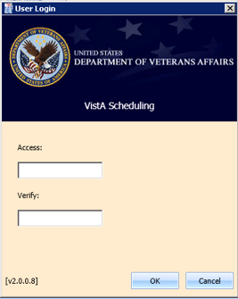

Figure 1: User Login

**Note:** The main screen of the application informs user whether they are logged into the test or production environment. The environment to which the user is logged in will be displayed in the top right corner of the main screen page.

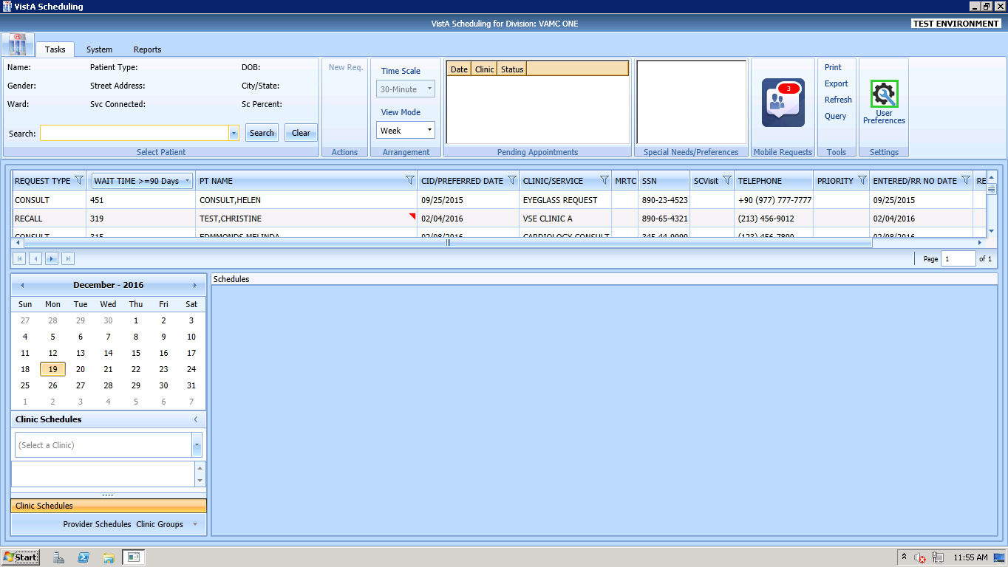

Figure 2: Main Screen with Test Environment Displayed

## Logging Off

To log off when you are finished scheduling appointments, click the Close button (**X**) in the upper right corner of the VS GUI.



Figure 3: User Logoff

## VS GUI Tabs

The VS GUI provides the following tabs:

* **Tasks:** Allows Scheduler to search for patient requests, view clinic resources, and make appointments.
* **System:** Allows an administrator to add/delete privileged users from a prohibited clinic and set up clinic groups.
* **Reports:** Allows for various reports to be generated by users holding the SDECZMGR security key.

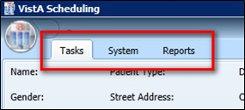

Figure 4: VS GUI Tabs

### Tasks Tab

The **Tasks** tab display includes the following sections:

1. **Select Patient:** Search for and view information about a selected patient
2. **Actions:** Allows Scheduler to initiate new APPT or Recall requests
3. **Arrangement:** Time Scale (30-Minute) and View Mode (Day, Week, or Month) for the clinic schedule grids of the screen
4. **Pending Appointments**: Date, clinic, and status of any pending appointments for the selected patient
5. **Special Needs/Preferences:** Identified special needs and/or preferences for the selected patient
6. **Mobile Requests:** Shows number of pending mobile requests and provides access to the Mobile Request List for scheduling. If the mobile request service is not available, **UNAV** is displayed in place of the request number.

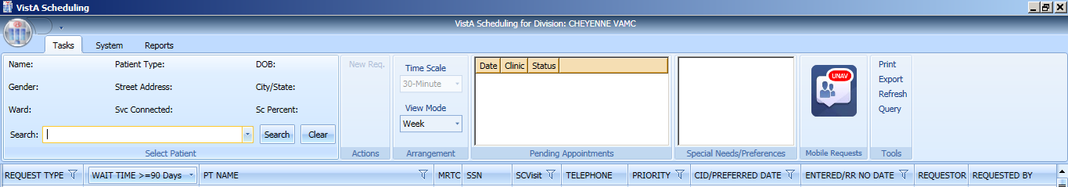

Figure 5: Mobile Requests Unavailable Displayed in Ribbon Bar

1. **Tools:** Options include print, export, refresh, and queries.
2. **Settings:** Access to User Preferences.
3. **Request Type:** View a list of patients waiting for an appointment.
4. **Resources:** Calendar to choose a desired appointment date and to search for and access **Clinic Schedules**, **Provider Schedules**, and **Clinic Groups**
5. **Schedules:** View multiple clinic schedules in one screen



Figure 6: Tasks Tab Display

### System Tab Action Areas

The System tab display includes the following sections:

1. **Resource Management:** **Scheduling Management** allows for management of privileged users within Prohibited and Clinic Groups as well as the creation and management of clinic groups.
2. **Resource Schedules:** **Availability** allows for search of resource by name.
3. **Selected Clinic:** Provides a quick view of the selected clinic’s Primary Provider, Overbook Limit, Inactive Date, and ReactiveDate.

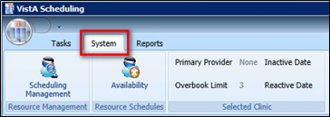

Figure 7: System Tab

### Reports Tab Action Areas

The **Reports** tab display allows for viewing and exporting of **Audit Activity** and **Clinics** setup information.

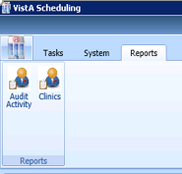

Figure 8: Reports Tab

## Searching

The search feature enables a Scheduler to:

1. View and search clinic profiles to view appointments resources by clinic or by clinic groups
2. View and search patient requests by request type
3. Sort the request queue by any column in ascending or descending order
4. Sort results and save the search into various outputs, such as Microsoft Excel or Adobe PDF
5. Generate an audit report of search and sort results
6. Print various screens and open lists

### Search for Patient

1. Log into VS GUI.
2. In the **Tasks** tab display, in the **Search** text box, type the patient’s last name or patient’s first initial of last name and last 4 of SSN (e.g. S1234), click the **Search** button, and select the requested patient name. Click **Search**.
3. In the Search field, the following options are available for searching for a patient:

* Last name, First name
* Full Social Security Number (SSN)
* First initial last name + last four SSN (ex. T0170)
* Last four of SSN (0170)
* Last name only (3 character minimum)

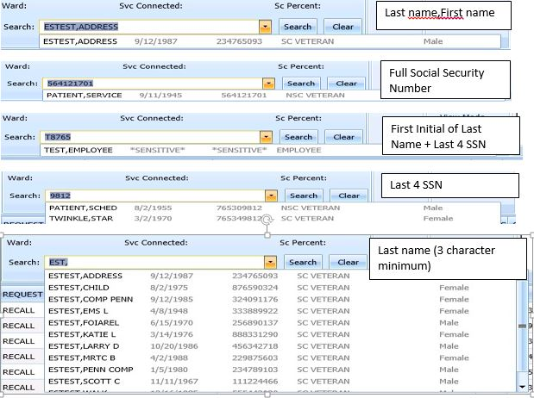

Figure 9: Patient Search

## Filtering

Filtering can be accomplished in a number of areas of the VS GUI. Items that can be filtered are:

1. Lists
2. Time Period
3. Facility

The following sections describe basic filtering.

### Filtering Lists

You can filter any column on the request grid to narrow the type of information that you want to view. In the request grid, click any column that shows a filter icon, and then select a filter option.

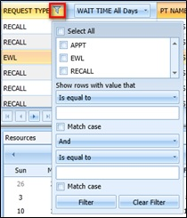

Figure 10: Filtering Lists

### Paging Through Records

Filtered results are retrieved from the database and displayed in 25 row increments. To view additional records, use the arrow key located below the list to page through the records.

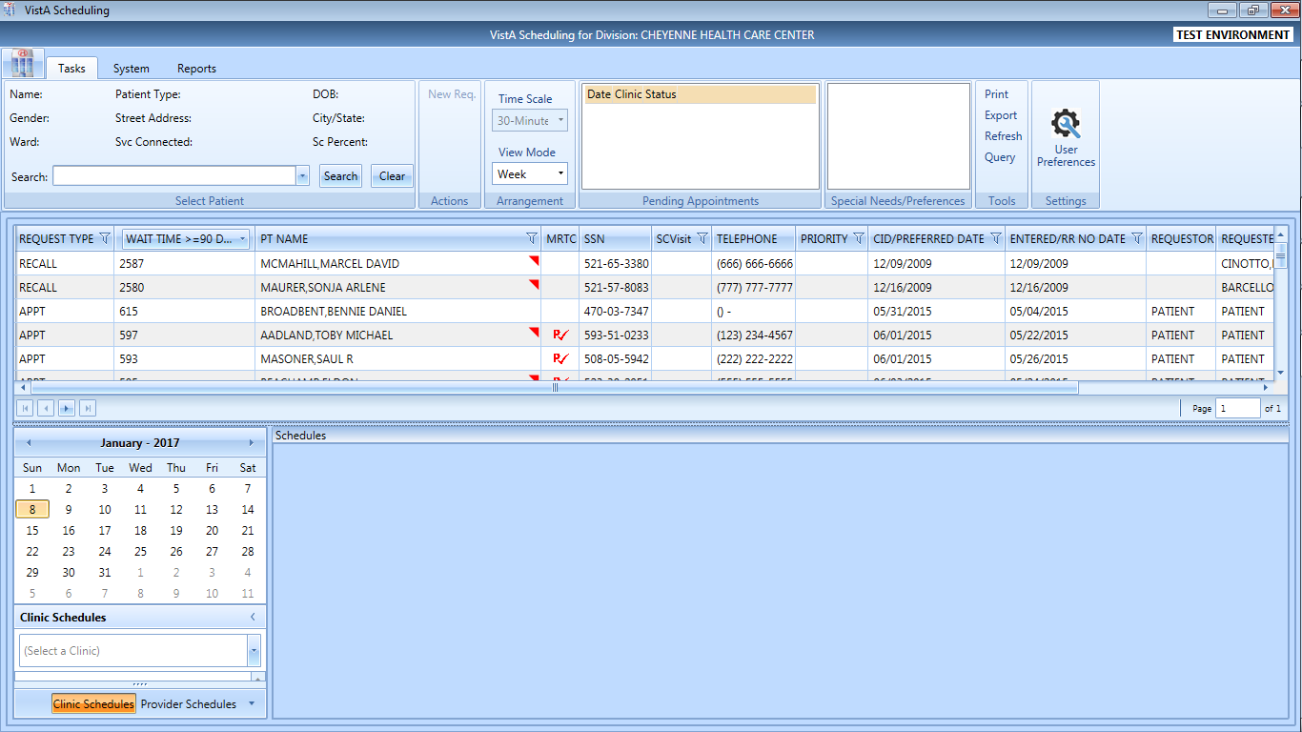

Figure 11: Paging Through Records

### Filtering by Facility or Clinic

To filter by facility or clinic, in the Clinic Schedules pane, type in the name of the desired clinic (6 character minimum when searching by clinic name; 4 character minimum when searching by clinic abbreviation) and then choose the desired clinic to view by clicking the clinic name from the drop down menu.

VS GUI Filtering by Facility or Clinic window

Figure 12: Filtering by Facility/Clinic

### Filtering by Time Period

To filter by time period, in the Resources pane, search for and select a desired clinic and then use the calendar to select a month and day for viewing appointments. Clicking the back and forward arrows moves to the previous or next month respectively.

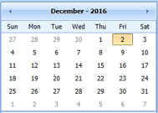

Figure 13: Filtering by Time Period

## Sorting

You can sort the consolidated list of requests in the request grid in different ways to isolate the information that you need to see.

### Sorting by Column

You can sort the consolidated list of requests in ascending or descending order. The default sort is by Priority Group, Service Connected priority, Preferred Appointment date, and Date entered (Request date).

**Note:** A user can override the default sort by setting and saving their preferred sort order (refer to Section 4.9 Setting User Preferences).

Perform the following procedure to sort by column.

1. Log on to VS GUI.
2. Click any of the column headers to change the sort order.

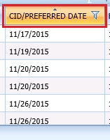

Figure 14: Sorting by Column

1. Click on the column header again to return to the default sort order.

## Printing and Exporting a Request Management Grid

### Printing a Request Management Grid

The VS GUI also allows for printing of a Request Management Grid. Use the following procedure to print a request grid.

**Note:** Only requests downloaded on Request Management Grid will print.

1. On the ribbon bar, in the Tools section, select the **Print** option.

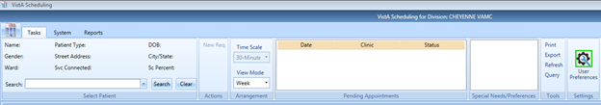

Figure 15: Selecting the Print Option

1. Select the desired printer and click **Print**.

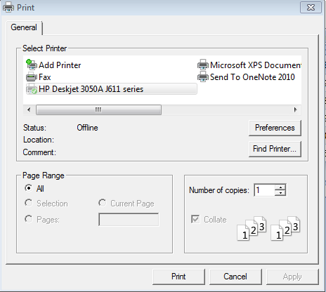

Figure 16: Selecting a Printer

### Exporting a Grid

The VS GUI also allows for exporting of a Request Management Grid in Microsoft Excel format. Use the following procedure to export a schedule.

1. On the ribbon bar, in the Tools section, select the **Export** option.

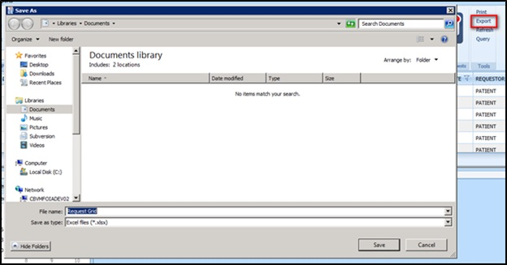

Figure 17: Exporting a Grid

1. In the **Save As** dialog box, type a file name, select a file type, browse to the location where you want to save the information, and then click **Save**.
2. Open the file and review the contents. All data displayed in the Request Management Grid is saved.

**Note:** Only data that was displayed on screen at the time of export will be exported to the file. Users may need to load more screens to see all of the data.

## Viewing

### View Only Mode

A View Only mode is available for non-scheduling personnel. To provide this mode to a user, the SDECVIEW security key must be assigned to the user. This mode allows users to view data in VS GUI but no changes or edits will be allowed. This key overrides other VS GUI keys and assigns the user to View Only.

Information available for viewing include:

* All Pending Requests
* Previously scheduled appointments.
* Clinic with appointment scheduled for day and week
* Provider with appointments scheduled for day
* Clinic Group with appointments scheduled for day
* Patient demographics and special needs/preferences

### Viewing Requests by Request Type

A Scheduler can view requests for Veteran Appointments (APPT) requests—Consults, Recall reminders, or Electronic Wait List (EWL) reminders. The default view is for requests that are 90 days or older. A user can change the view for a particular session or change the default view by changing their user preferences (refer to Section 4.9 Settings – User Preferences).

Use the following procedure to view requests by request type. Requests display 25 records at a time. Additional requests can be viewed by paging to the next page.

1. Log on to VS GUI.
2. View the request grid. Consult, APPT, EWL, and Recall requests that have a wait time of 90 days or more will appear in the grid. The preferred date for the patient request type is shown in the **CID/Preferred Date** column.

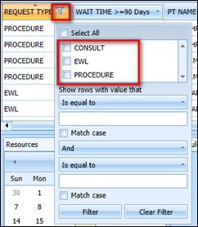

Figure 18: Request Type Column

1. Click the **Request Type** column to filter specific requests. Only request types that are in the current request grid display in the filter tool.
2. Select **EWL** to view the Electronic Wait List requests.
3. Select **APPT** to view appointment requests.
4. Select **Recall** to view recall requests.
5. Select **Procedure** to view procedure requests.
6. Select **Consult** to view consultation requests.
7. Or any combination of the above.

### Viewing Requests by Patient

Use the following procedure to view requests by patient.

1. Log on to VS GUI.
2. In the **Tasks** tab display, in the **Search** text box, type the patient’s last name or patient’s first initial of last name and last 4 of SSN (e.g. S1234), click the **Search** button, and select the requested patient name. Click **Search**.

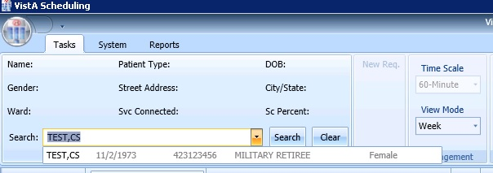

Figure 19: Select Patient

1. In the **Request Type** dialog box select either **APPT** or **RECALL** and click **OK** or click **Cancel**.

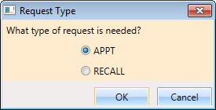

Figure 20: Request Type

The patient’s pending requests are displayed in the Request Management Grid 25 records at a time. Booked appointments are displayed in the Pending Appointments Window in the Ribbon Bar of the **Tasks** tab.

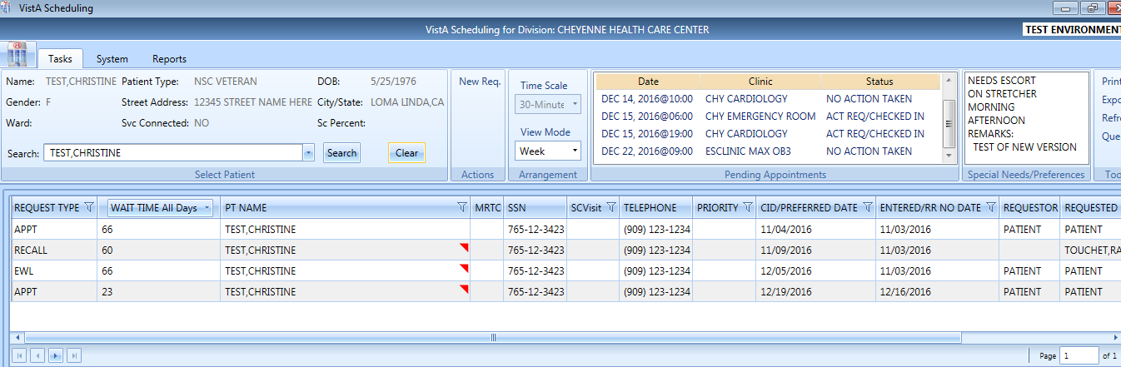

Figure 21: Patient Pending Requests and Booked Appointments

### Changing the Schedule View

The default schedule view for displaying clinic schedule grids is by week, but the view can be changed to day or month view for ease of scheduling. Use the following steps to change the schedule view.

1. Log on to VS GUI.
2. Search and select a Clinic to open.
3. In the Arrangement section, click on the **View Mode** pull-down menu and select:

* Day
* Week
* Month

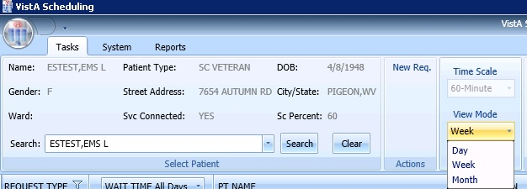

Figure 22: View Mode

1. A view for a specific schedule can be changed at the top of the Schedules section by clicking on the button that reflects the desired view. The available views from the schedule include:

* Day
* Week
* Month
* Timeline

The Timeline view displays.

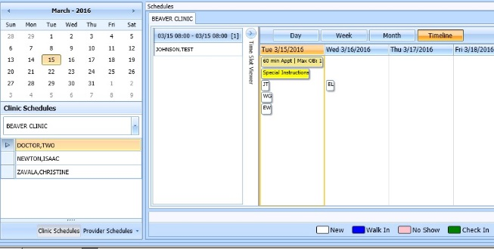

Figure 23: Changing View of a Specific Schedule

# Ribbon Bar

The following section outlines the sections available in the Ribbon Bar of Schedule Manager.

## Patients Demographics

### Finding a Patient

1. Log on to VS GUI.
2. In the **Tasks** tab display, in the **Search** text box, type the patient’s last name or patient’s first initial of last name and last 4 of SSN (e.g. S1234), click the **Search** button, and select the requested patient name. Click **Search**.
3. Select the requested patient name from drop down list.

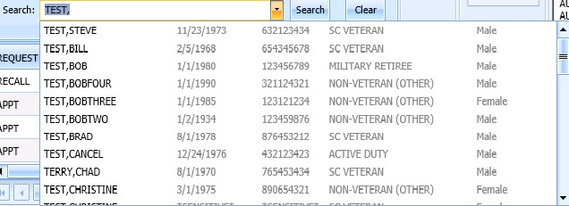

Figure 24: Search Patient

### Viewing Patient Demographics in the Ribbon Bar

You can view basic patient demographic information in the ribbon bar. The ribbon bar provides a limited amount of patient information, but you can choose to display more patient details. Use the following steps to view patient demographics in the ribbon bar.

1. Log on to VS GUI.
2. In the **Tasks** tab display, in the **Search** text box, type the patient’s last name or patient’s first initial of last name and last 4 of SSN (e.g. S1234), click the **Search** button, and select the requested patient name. Click **Search**.
3. In **Request Type** dialog, click **Cancel**.
4. View the patient demographics in the ribbon bar. The following patient demographics are available:
   * **Name:** Last name,First name
   * **Patient Type:** VA patient type
   * **DOB:** Date of birth in mm/dd/yyyy format
   * **Gender:** Male (M) or female (F)
   * **Street Address:** Patient’s street address
   * **City/State:** Patient’s address city and state
   * **Ward:** For inpatients, current ward location display
   * **Svc Connected:** Is the patient service connected (YES or NO)
   * **Sc Percent:** Percent of service connected disability

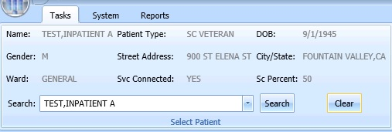

Figure 25: Patient Demographics in the Ribbon Bar

1. Click anywhere in the Select Patient section of the screen to view the Patient Inquiry Detail screen. This allows for viewing of additional patient information.

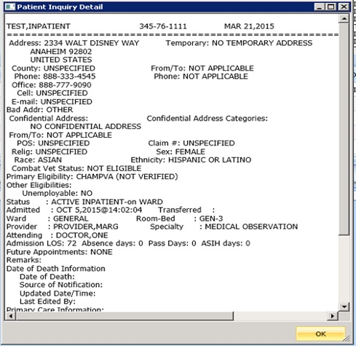

Figure 26: Patient Inquiry Detail

### Patient Eligibility Information

When adding a new Recall or APPT request, a **Patient’s Eligibility Information** window displays along with the **New Appointment** dialog. The user can move the **Patient’s Eligibility Information** window around the screen, for convenience.

The window includes:

1. SC Percent
2. Current Disabilities
3. Primary and Secondary Eligibility Codes

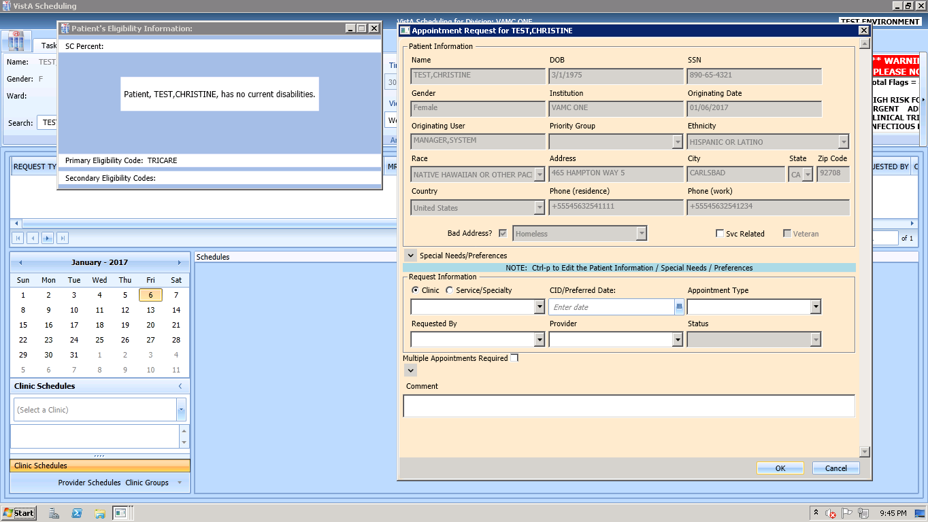

Figure 27: Patient's Eligibility Information

When the **New Appointment** dialog is closed, the **Patient Eligibility Information** window closes automatically.

### Updating Patient Demographics

Patient demographic information, such as ethnicity, race, address, state, ZIP code, country, or phone numbers that were not defined during registration, can be updated at any time during the process. Perform the following procedure to update patient demographic data.

1. Log on to VS GUI as a Scheduler.
2. In the **Tasks** tab display, in the **Search** text box, type the patient’s last name or patient’s first initial of last name and last 4 of SSN (e.g. S1234), click the **Search** button, and select the requested patient name. Click **Search**.
3. In the **Request Type** dialog box, click **Cancel**.



Figure 28: Request Type–APPT

1. Patient demographic information can now be displayed and edited at any point in the process by entering **Ctrl + P** to bring up the Patient Info screen. Undefined patient demographic information displays in empty drop down boxes and text field, in the Patient Information section. Information that is not editable displays dimmed.

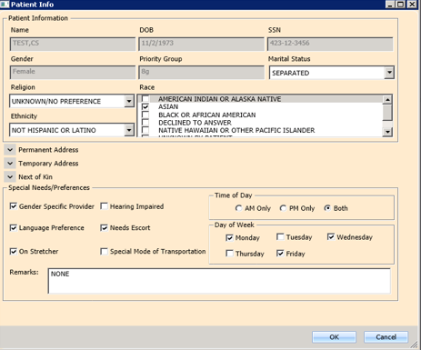

Figure 29: Patient Information Dialog

1. Click **OK** to update patient demographics. At this point the updated information displays in Ribbon Bar.
2. Click **Cancel** to go back to the all patients view.

### Editing Permanent Address

Permanent address for a patient may be edited via the **Patient Info Dialog** screen and is available at any point via the RM Grid. User can view the patient information by entering **Ctrl + P**.

A user can update the patient’s address Line 1 and 2, Zip Code, and Phone Numbers.

* Zip Code – 5 or 9 digits (when entered, the system provides choices for Cities that match that zip code and based on that, automatically completes the State and County fields).
* For Phone numbers, VS GUI automatically formats the Patient Work Phone to (xxx) xxx-xxxx if 10 digits are entered. If more than 10 digits are entered, it auto formats to x-xxx-xxx-xxxx x….  
  Only characters (,), +, -, and X (Except Cell and Pager) are allowed in the Phone Numbers.

Click **OK** when complete to save the information.

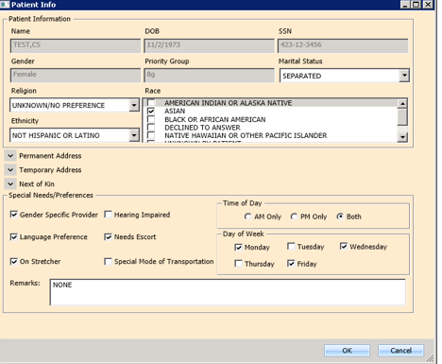

Figure 30: Patient Info Dialog–Permanent Address

**Note:** Any areas shadowed in grey cannot be edited.

### Adding a Temporary Address

Temporary address for a patient may be entered via the **Patient Info Dialog** screen available at any point in the RM Grid by entering **Ctrl + P**.

The Address Active? Box should be checked with a Start Date and End Date (if known).

A user can update the patient’s address Line 1 and 2 and Zip Code.

Zip Code – 5 or 9 digits (when entered, the system provides choices for Cities that match that zip code and based on that, automatically completes the State and County fields).

Click **OK** when complete to save the information.

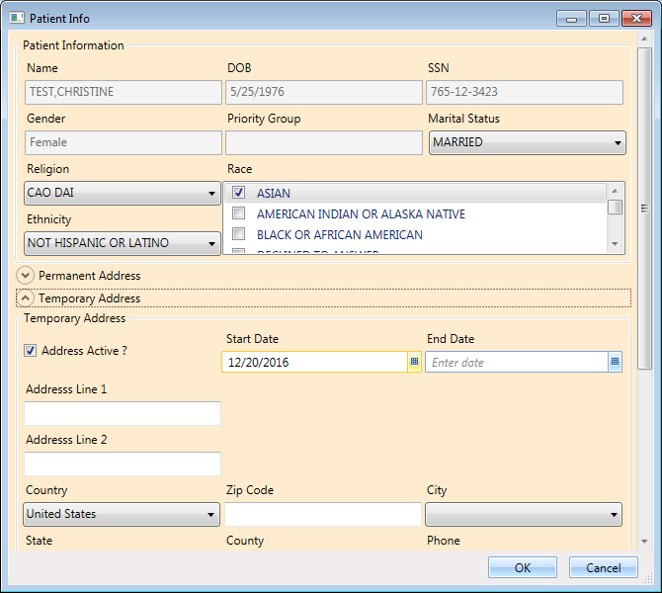

Figure 31: Patient Info Dialog – Temporary Address

**Note:** Any areas shadowed in grey cannot be edited.

### Marking for Bad Address

A patient’s address may be incorrect (e.g., mail has been returned as undeliverable, or if the patient is homeless). If you learn that a patient’s address is incorrect, you must indicate that information on the patient record so notices are no longer sent. The bad address can be indicated while updating the patient’s address information in the Patient Info dialog.

1. Log on to VS GUI as a Scheduler.
2. In the **Tasks** tab display, in the **Search** text box, type the patient’s last name or patient’s first initial of last name and last 4 of SSN (e.g. S1234), click the **Search** button, and select the requested patient name. Click **Search**.



Figure 32: Select Patient

In the **Request Type** dialog box, click **Cancel**.



Figure 33: Request Type

1. Enter **Ctrl + P** to pull up the Patient Information dialog box. Confirm that the patient’s address information is incorrect or missing, and then check the Bad Address check box.

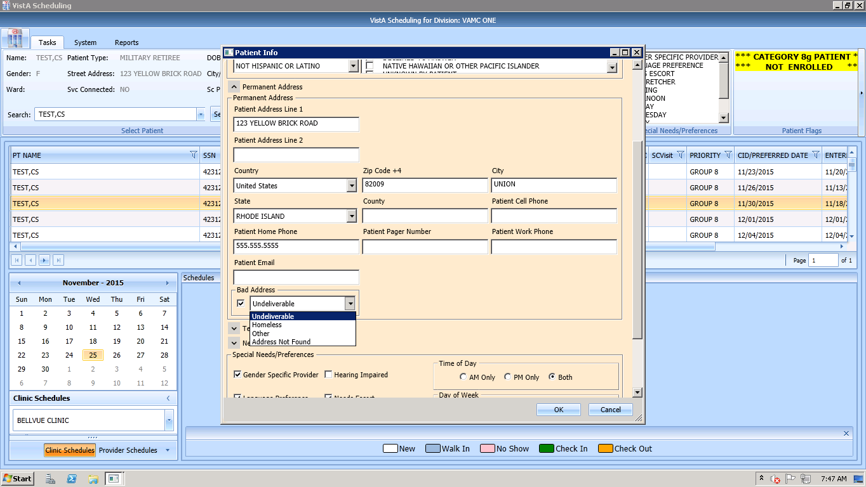

Figure 34: Appointment Request Dialog—Bad Address Selection

1. Choose the reason for the bad address:
   1. Undeliverable
   2. Homeless
   3. Other
   4. Address Not Found
2. Click **OK**.

## Actions

### New Request

After searching for and accessing a specified patient’s demographics and associated pending appointments, the Action pane allows you to create a new request for the patient. For example, creating a recall request as a follow-up to an appointment request or creating a new appointment request after looking at only patient information.

To start a new request for an already selected patient, use the following steps:

1. Patient demographics and pending appointments appear in the Ribbon bar. In the Actions pane, select **New Request**.

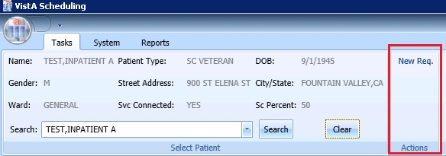

Figure 35: Actions Pane

1. The Request Type dialog box appears, allowing you to create a new request.



Figure 36: Request Type – APPT

## Arrangement

### View Mode

Refer to Section 3.8.4Changing the Schedule Viewfor changing the arrangement of the default calendar view.

## Pending Appointment Window

The Pending Appointment Window displays a patient’s already booked appointments. The appointment view defaults to the current date. The Scheduler can utilize the scroll bar to the right to scroll up to view appointments 365 days in the past. Or, the Scheduler can utilize the scroll bar to scroll down to view appointments 365 days in the future.

Selecting an appointment from the Pending Appointment Window in the Ribbon Bar opens the Clinic Schedule Grid. When you select a past appointment, the clinic schedule defaults to the appointment.

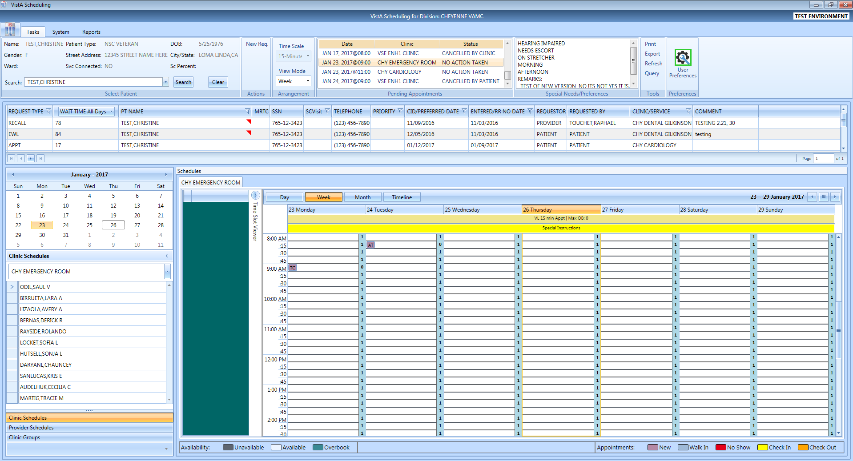

Clinic Schedule displays past appointment date defaulted as day 1+ 6 days.

Figure 37: Pending Appointment Window—Past Appointment Date

The clinic schedule defaults to current (today’s date) when you select an appointment dated “today” or less than three days in the future.

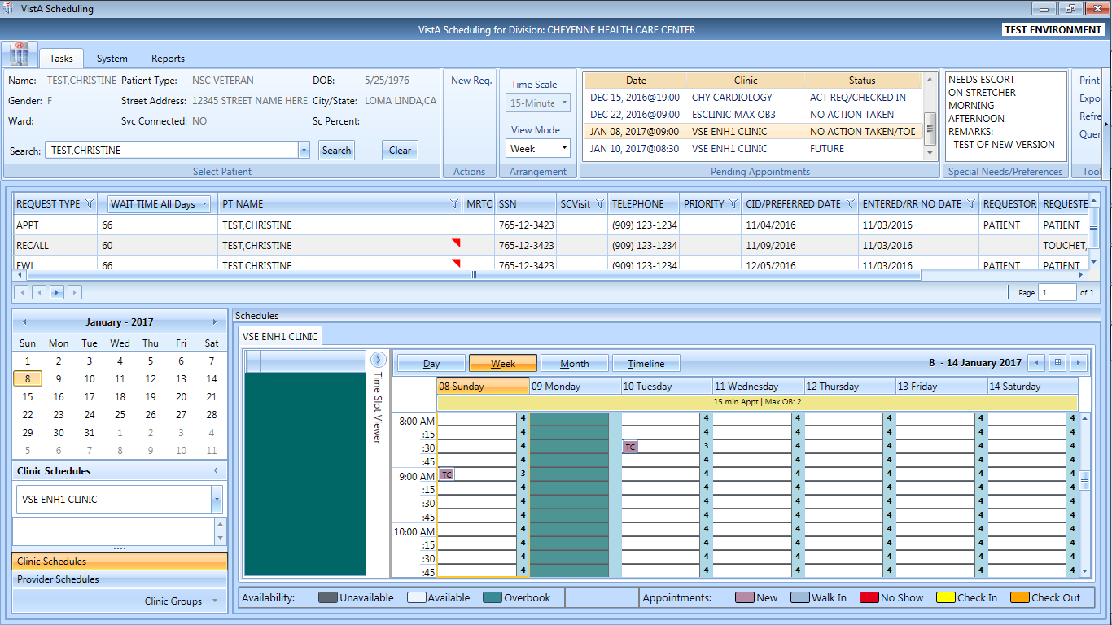

Clinic Schedule displays current appointment date or appointment less than 3 days in future, defaulted as day 1 + 6 days.

Figure 38: Pending Appointment Window—Current less than 3 days in Future

The clinic schedule defaults to -/+3 days of the appointment date for future dates.

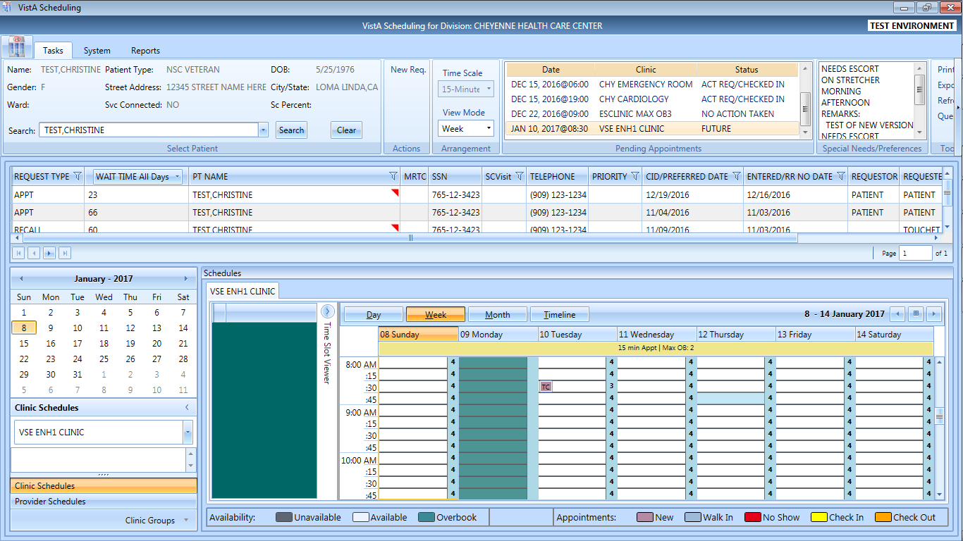

Clinic Schedule displays future appointment date as

-3/+3 days of appointment date.

Figure 39: Pending Appointment Window—Future Appointment Dates

## Special Needs/Preferences

### Adding/Removing Special Needs/Preferences from Requests

Patients visiting the VA may require additional assistance when they arrive for their visit. Some of these special needs/preferences may include issues with hearing, how they are arriving at the VA, Day of the Week or Time of the Day etc.

To add Special Needs/Preferences to an appointment request, perform the following:

1. Log on to VS GUI
2. In the **Tasks** tab display, in the **Search** text box, type the patient’s last name or patient’s first initial of last name and last 4 of SSN (e.g. S1234), click the **Search** button, and select the requested patient name. Click **Search**.
3. In the Request Type dialog box, click **Cancel**.



Figure 40: Request Type–APPT

1. Enter **Ctrl + P** to select the Patient Info dialog.
2. Select the patient’s special needs from the Special Needs/Preferences section of the Patient Info dialog box.
3. Add additional information regarding patient’s Special Needs/Preferences selections in the Remarks field.

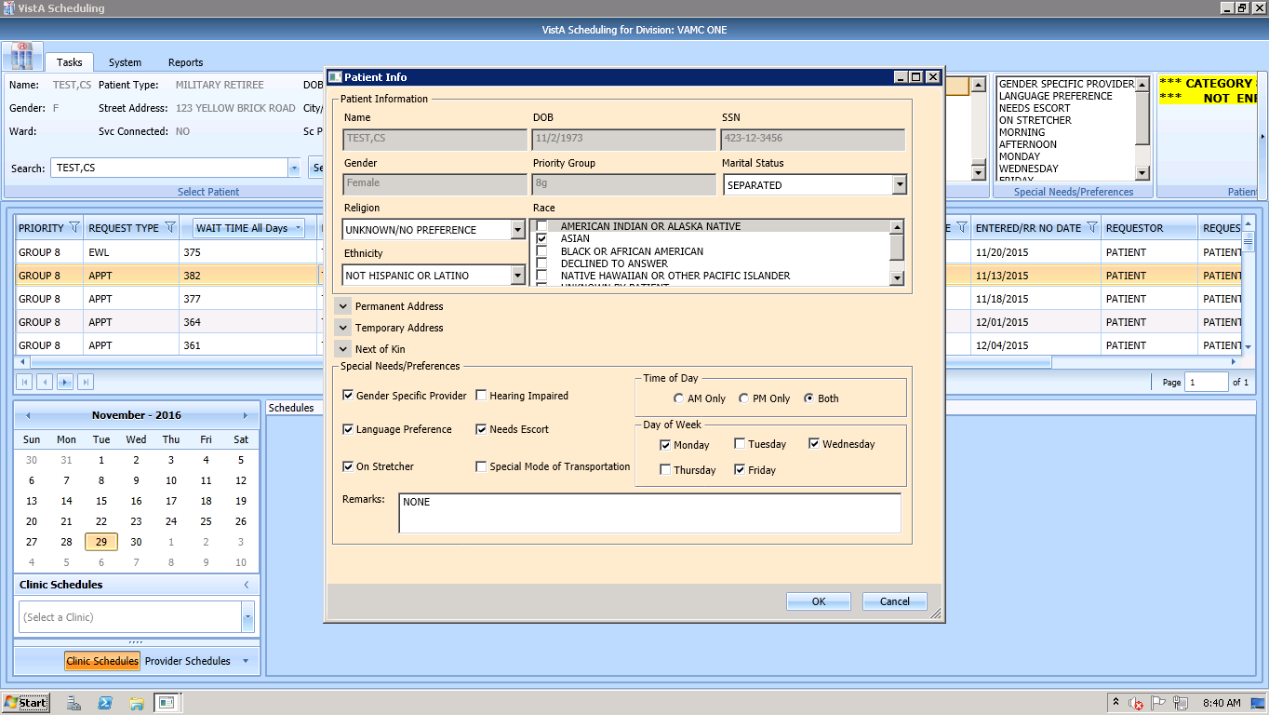

Figure 41: Patient Info Dialog —Special Needs/Preferences Section

1. Click **OK**. Special Needs/Preferences entered display in the Ribbon Bar.

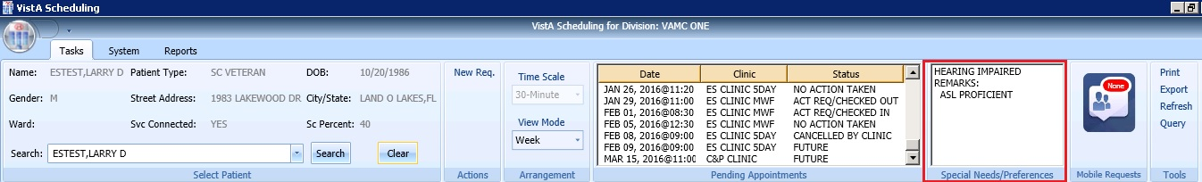

Figure 42: Ribbon Bar—Special Needs/Preferences

## Patient Flags

Patient Record Flags (PRFs) are used to alert Veterans Health Administration (VHA) medical staff and employees of patients whose behavior and characteristics may pose a threat either to their safety, the safety of other patients, themselves, or compromise the delivery of quality health care. PRF assignments are displayed during the patient look-up process.

Each PRF includes a narrative that describes the reason for the flag and may include some suggested actions for users to take when they encounter the patient.

When a patient’s record is flagged, a box appears with appropriate action recommended.

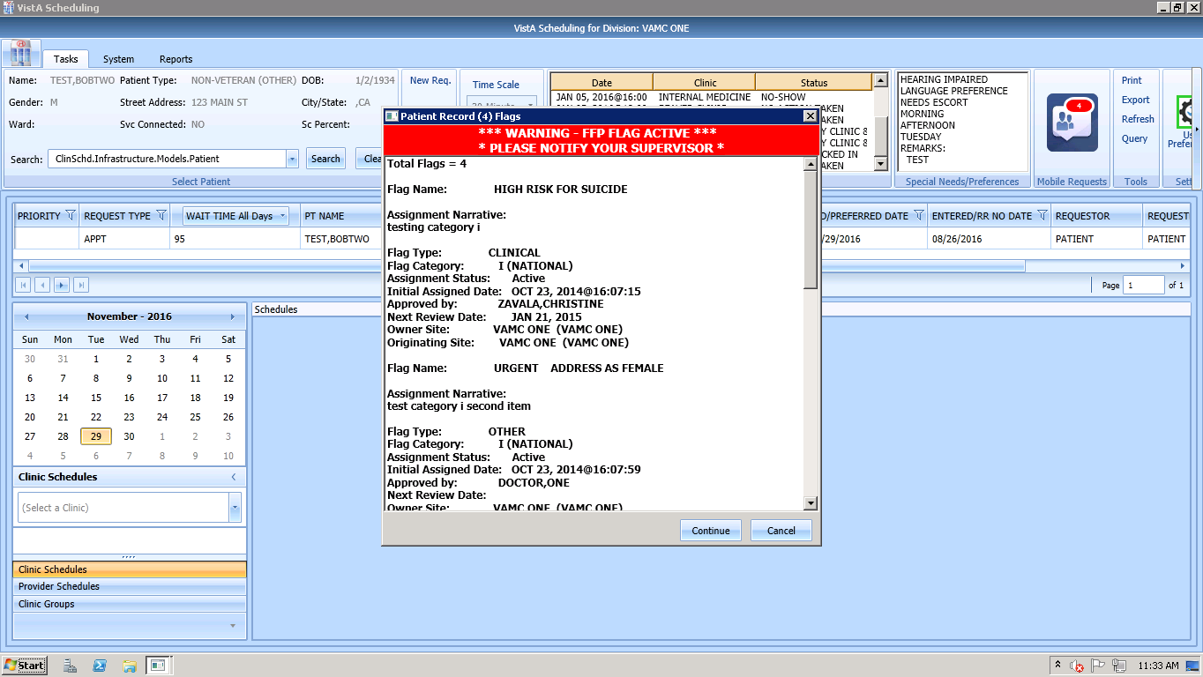

Figure 43: Patient Record Flags Dialog

After appropriate action has been taken and appointment processing is to continue, click **Continue**; otherwise, click **Cancel**.

Once processing has continued, the Patient Record Flag continues to show on the ribbon bar.

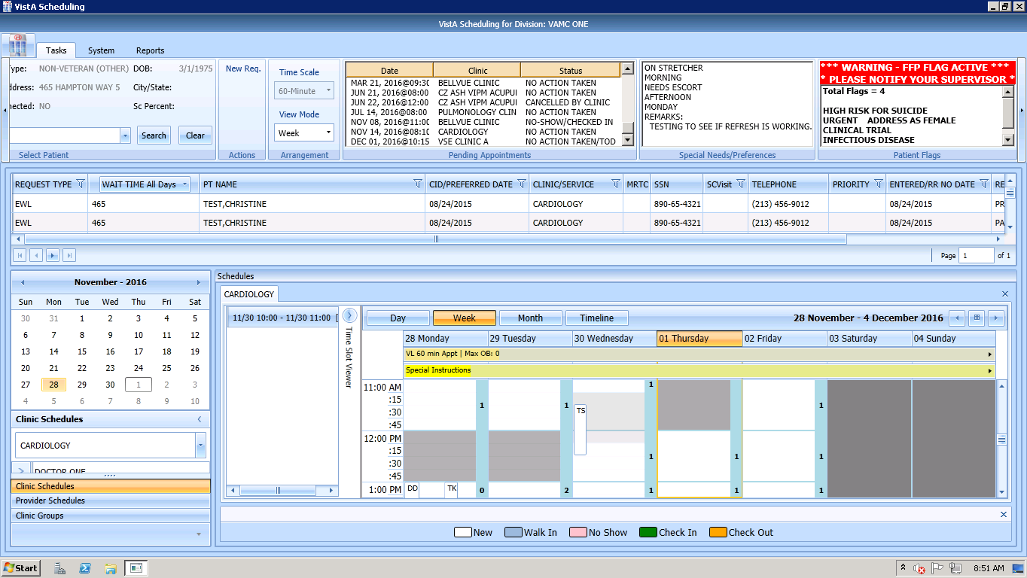

Figure 44: Patient Record Flags

## Mobile Requests

Mobile Requests are requests for appointments submitted by Veterans via the Veterans Appointment Request (VAR) application. If there are pending appointment requests that need processing, a number displays inside a red bubble in the Mobile Requests pane. If there are no pending requests, the word “None” displays in the red bubble. For detailed instructions on processing Mobile Requests refer to Section 6.7 Veteran Appointment Request Scheduling.

## Tools

### Print

Refer to Section 3.7.1 Printing a Request Gridfor details on using the Print functionality of the Tools Pane.

### Export

Refer to Section 3.7.2Exporting a Gridfor details on exporting the request grid.

### Refresh

After checking a patients pending appointments or checking availability for a clinic, you may want to reset the GUI back to the default view from when you first logon to the GUI, clearing all text entered in any fields.

To refresh the GUI, in the Tools pane, click **Refresh**. The GUI resets to its default logon view.

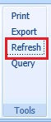

Figure 45: Refresh Button in Tools Pane

### Query

In order to sift through patient data and only view data of a specific type, the Query tool can be utilized to show only data matching specific criteria. Once the query has been performed, only records matching the query criteria appear in the request grid.

* Patients are in **Group A** and can be used independently or in conjunction with other search criteria.
* Request Type + Clinic/Services are in **Group B**. This group can be used independently or in conjunction with other search criteria.
* Priority, Wait Time, SCVisit, Service Connected, Origination Date, CID/Preferred Date and Urgency are in **Group C**. This group must be combined with other search criteria from either Group A, Group B, or Group A and B to satisfy the Query Tool business rules.

To perform a query, use the following footsteps:

1. Log on to VS GUI.
2. Select **Query** from the **Tools** pane. The **Request Query** window displays.

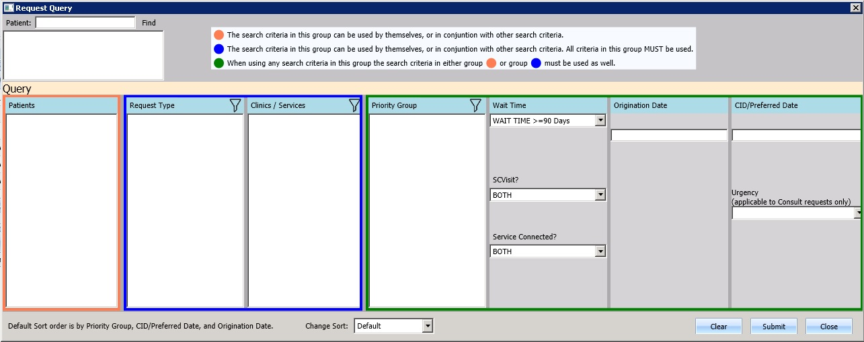

**Group A**

**Group C**

**Group B**

Figure 46: Request Query

1. Click **Submit**. If the search criteria rules are not satisfied, a **Query Rule Validation** dialog box displays.

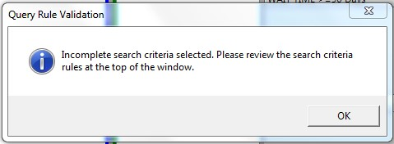

Figure 47: Query Rule Validation

Once all search criteria has been selected and the results have been returned, a **Request Query Confirmation** dialog displays indicating how many records were found that satisfied the search criteria.

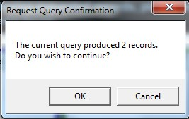

Figure 48: Request Query Rule Confirmation

1. Click **OK** to display the Query results in the Request Management Grid.
2. Click **Cancel** to remove search criteria and start a new search.

## Settings – User Preferences

A user may now set their own column preferences within a session or as their default view.

From the far right of the Ribbon Bar, select User Preferences Setting Icon.

Current Column order is:

Request Type;

Wait Time;

PT Name;

MRTC;

SSN;

SC Visit;

Telephone;

Priority;

CID/PreferredDate;

Entered/RR No Date;

Requestor;

Requested By;

Clinic/Service; and

Comment.

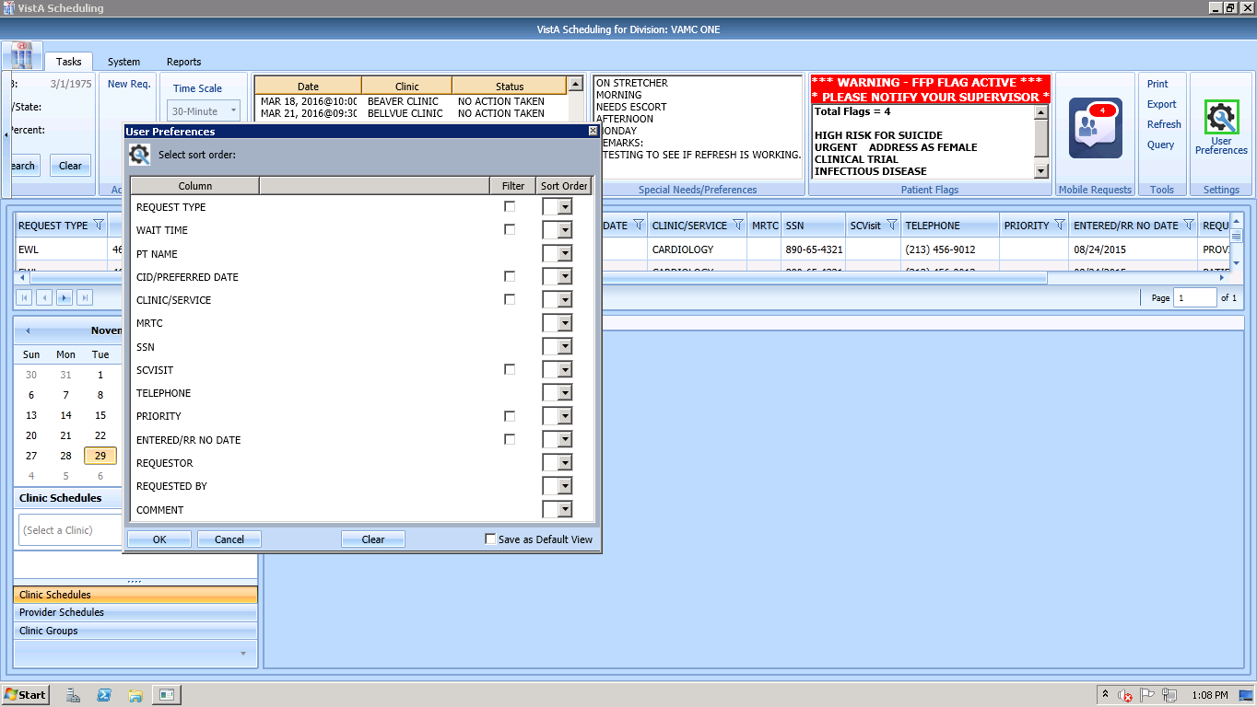

Figure 49: Settings – User Preferences

Filters on the following fields are also available:

* Request Time
* Wait Time
* CID/Preferred Date
* Clinic/Service
* SC Visit
* Priority
* Entered/RR No Date

To save your user preferences:

* Select the sort order or filters to display.
* If you would like to save the selections as your default view, select “Save as Default View” on the bottom right. If you do not select “Save as Default View,” your selections will only be applicable to your current session.
* Select OK to save.

The User Preferences Settings icon displays with green highlight indicating user preferences have been stored.

To remove any existing user preferences for the user’s default view:

* Click on the User Preferences icon.
* In the User Preferences window, click **Clear** then click **OK** to save.

The User Preferences Settings icon will now display without green highlight when no user preferences have been stored.



Figure 50: Settings – Save as Default View

# Request Management

## Request Management Procedures

### Viewing a Patient’s Existing Requests

1. Log on to VS GUI.
2. In the **Tasks** tab display, in the **Search** text box, type the patient’s last name or patient’s first initial of last name and last 4 of SSN (e.g. S1234), click the **Search** button, and select the requested patient name. Click **Search**.
3. Click **Search**.
4. Select the requested patient name from drop down list.
5. In the **Request Type** dialog box, click **Cancel**.



Figure 51: Request Type

1. In the Request Management grid, view the existing requests for the selected patient. Patient’s booked appointments display in Pending Appointment Window in the Ribbon Bar defaulted to current date. Schedulers can scroll up or down to view appointments dated -/+365 days of current date.

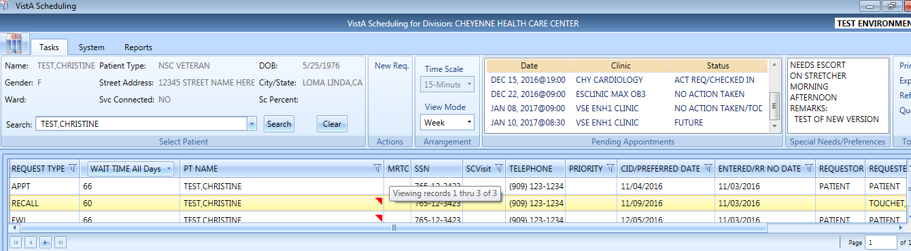

Figure 52: Request Grid and Pending Appointments

### Adding Appointment Request

1. To submit an appointment request, from **Tasks** tab search for the patient using the Search field.
2. Select **APPT** in the **Request Type** dialog.

VS GUI Request Type - Appointment window

Figure 53: Request Type - APPT

**Note:** If the patient has already been selected, the **Request Type** dialog can be accessed by clicking **New Req.** in the Actions Pane of the Ribbon Bar.

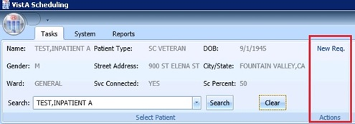

Figure 54: Actions Pane—New Req. Selection

1. In the **Appointment Request** dialog box, confirm Patient Information details.
2. In the **Appointment Request** dialog box, complete the **Request Information** section.
3. Select **Clinic** or **Service/Specialty** radio button. For Clinic, enter clinic name (minimum of six characters) or Clinic abbreviation. For Service/Specialty enter service or specialty (minimum of six characters required).

* Enter **CID/Preferred Date** for the preferred appointment/recall date. Enter date directly or select date from Calendar control option. CID/Preferred Date can be past, current, or future.
* Select **Appointment Type** if not defaulted by patient eligibility and clinic selection then choose from drop down list.
* In **Request By**, select either Provider or Patient.
* If **Provider** selected, then enter provider name (3 character minimum for drop down to populate) and select from list.   
  **Note:** If Patient was selected in Request By field, then Provider field is dimmed and not editable.
* **Status** is automatically populated.

1. Established – The patient has been seen at that clinic in the past 24 months.
2. New – The patient has not been seen at that clinic in the past 24 months.

* Refer to Section 6.3.2 Adding Multiple Appointments from Find Appointment Dialog for additional instructions regarding Multiple Appointment Requiredcheck box options.

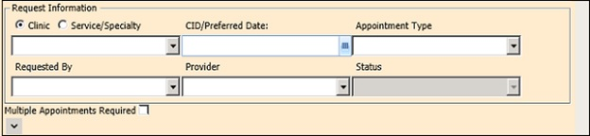

Figure 55: Appointment Request Dialog—Request Information Section

1. If needed, in the **Patient Info (Ctrl + P)** dialog box, complete the **Special Needs/ Preference** section. **Remark**s field is available to add clarifying information regarding selections made. **Selected Special Needs/Preferences** and **Remarks** display in the Ribbon Bar.
2. Text can be added in the **Remarks** field up to 80 characters to add information regarding Appointment Request. Text displays in Request Management Grid under Comment column.
3. Click **OK**. Updated demographics display in ribbon bar. The APPT Request appears on Request Management grid. Clinic Schedule Grid opens for clinic specified in request.

**Note:** APPT Requests with Comments are flagged with a red arrow in the Request Management Grid.

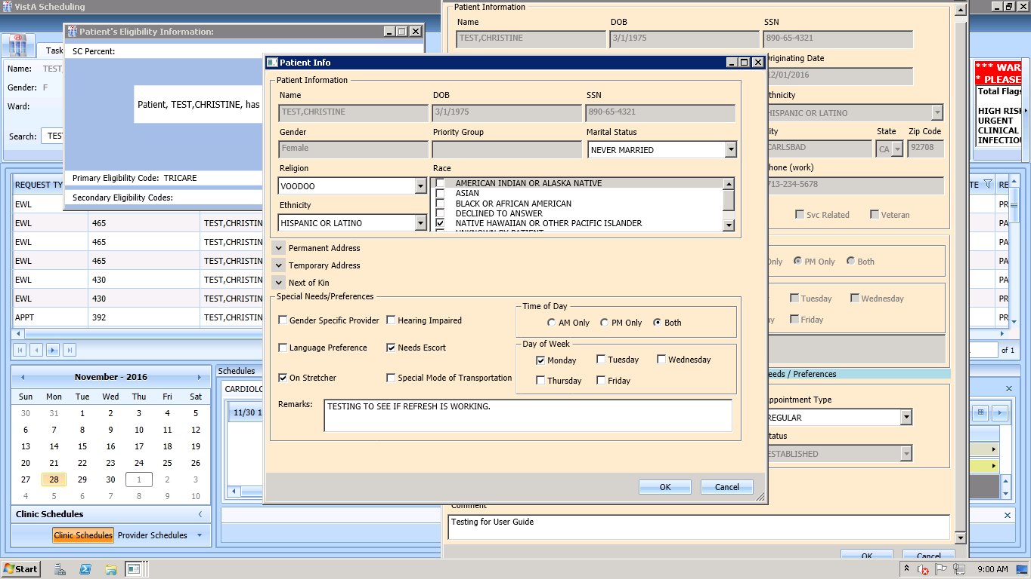

Figure 56: Special Needs/Preferences Section from Patient Info Dialog

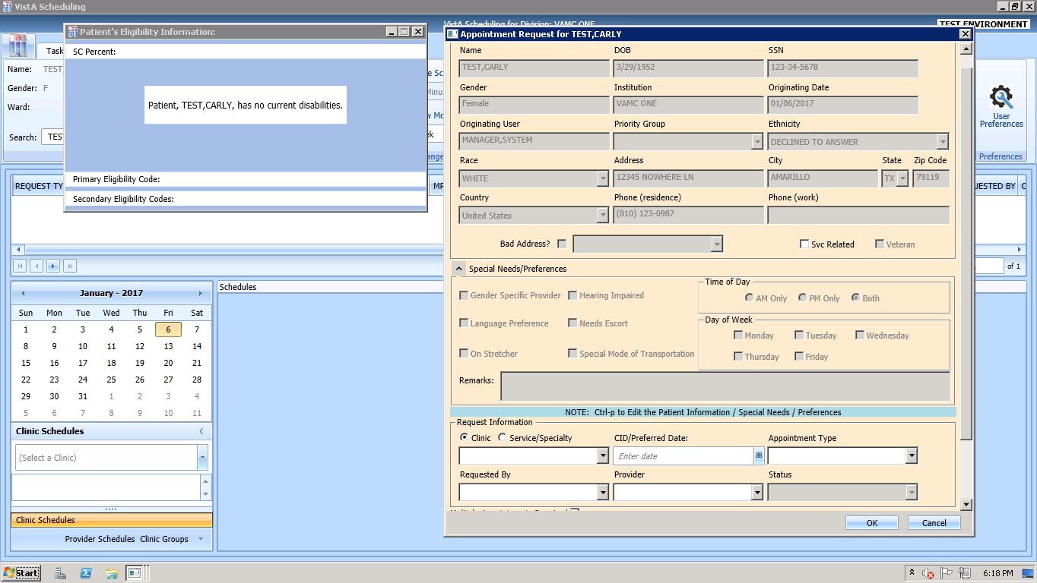

Figure 57: Appointment Request Dialog

### Viewing/Editing Appointment Request

If a request (APPT, EWL, Veteran) needs to be reviewed or modified before being booked, you can View/Edit the request in the Request Grid using the following steps:

1. Log on to VS GUI as a Scheduler.
2. In the **Tasks** tab display, in the **Search** text box, type the patient’s last name or patient’s first initial of last name and last 4 of SSN (e.g. S1234), click the **Search** button, and select the requested patient name. Click **Search**.
3. Select the requested patient name from dropdown list.  
   **Note:** When **Spacebar + Search** is used, the Ribbon Bar and RM Grid adjust to that selected patient.
4. In **Request Type** dialog, select **Cancel**.
5. In the **Request Management** grid, right click on the applicable **APPT** request.
6. Select APPT/VETERAN Disposition option.
7. The following options appear for selection:

* View Request
* Edit Request
* Transfer to EWL – refer to Section 5.1.5 Transfer to EWL Request for a Patient for instructions
* Death
* Removed/Non-VA Care
* Removed/Scheduled-Assigned
* Removed/VA Contract Care
* Removed/No longer Necessary
* Entered in Error

1. Select **View Request**. The **Appointment Request** dialog box appears with everything greyed out as the dialog box is Read-Only.

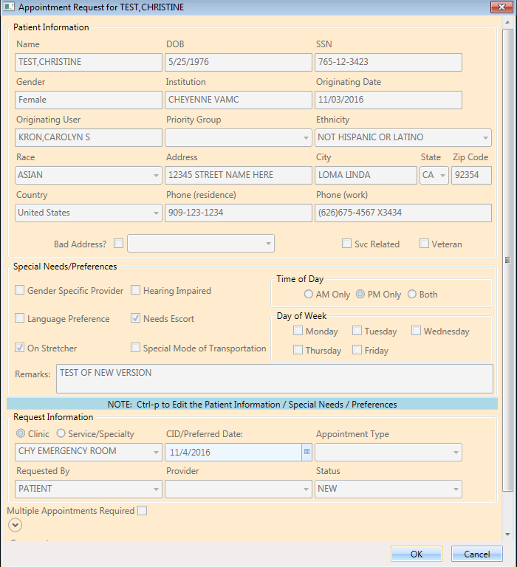

Figure 58: View Request (Read Only)

1. Click **OK**. You return to the RM Grid.
2. Right click on the applicable **APPT** request.
3. Select APPT/VETERAN Disposition option.
4. The following options appear for selection:

* View Request
* Edit Request
* Transfer to EWL – refer to Section 5.1.5 Transfer to EWL Request for a Patient for instructions
* Death
* Removed/Non-VA Care
* Removed/Scheduled-Assigned
* Removed/VA Contract Care
* Removed/No longer Necessary
* Entered in Error

1. Select **Edit Request.** The Appointment Request and Patient’s Eligibility Information dialog displays.



Figure 59: Edit Request (Request Information Only)

The editable fields are Clinic/Service Specialty; Appointment Type; Requested By; Provider, and Comments. CID/Preferred Date is NOT editable.

1. Click **OK**. The request returns to the RM Grid with the altered information listed.

**Note:** If you change the request for a Clinic to a Service/Specialty request, the **Appointment Type** field becomes editable. Also, changes to the **APPT Request** are tracked by the system in the SDEC APPT REQUEST file.

### Disposition or Removing an Appointment Request

If an APPT request is found to no longer be needed, Scheduler can remove from Request Grid following the steps below.

1. Log on to VS GUI as a Scheduler.
2. In the **Tasks** tab display, in the **Search** text box, type the patient’s last name or patient’s first initial of last name and last 4 of SSN (e.g. S1234), click the **Search** button, and select the requested patient name. Click **Search**.
3. Click **Search**.
4. Select the requested patient name from drop down list.
5. In **Request Type** dialog, click **Cancel**.
6. In the **Request Management** grid, right click on the applicable **APPT** request.
7. Select APPT/VETERAN Disposition option.
8. The following options appear for selection:

* Transfer to EWL – refer to Section 5.1.5 Transfer to EWL Request for a Patient for instructions
* Death
* Removed/Non-VA Care
* Removed/Scheduled-Assigned
* Removed/VA Contract Care
* Removed/No longer Necessary
* Entered in Error

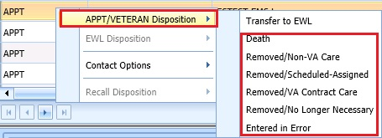

Right click in APPT Request.

Figure 60: APPT/Veteran Disposition Options

1. Select the applicable APPT Disposition option. APPT Request is removed from Request Management Grid.

### Transfer to EWL Request for a Patient

If an appointment cannot be scheduled because of limitations, the patient is put on an Electronic Wait List (EWL) for future scheduling. Use the following procedures to transfer an APPT Request to an EWL Request.

1. Log on to VS GUI as a Scheduler.
2. In the **Tasks** tab display, in the **Search** text box, type the patient’s last name or patient’s first initial of last name and last 4 of SSN (e.g. S1234), click the **Search** button, and select the requested patient name. Click **Search**.
3. Click **Search**.
4. Select the requested patient name from drop down list.
5. In the **Request Type** dialog box, click **Cancel**.
6. In the **Request Management** grid, view the open APPT Requests for the patient.
7. Select the **APPT** request that needs transferred to **EWL**.
8. Right click the APPT request and select **APPT/VETERAN Disposition**.
9. In the APPT/VETERAN Disposition options, select **TRANSFER TO EWL**. The **EWL Request** dialog box displays.  
     
   **Note:** The Transfer to EWL option is not available for Multiple Return To Clinic (MRTC) appointments nor is it available for users that do not have the SDWL MENU Security Key.
10. Confirm **Clinic** defaulted in dialog. If not, search for and select appropriate Wait List Clinic by name. Note that searching by clinic abbreviation is not supported in the EWL Request dialog.   
      
    **Note:** Clinic does not default if not designated as Wait List Clinics in SD Wait List Parameter (File #409.32).
11. **CID/Preferred** date and Status are not editable.
12. **Appointment Type** is defaulted from APPT Request. If a patient is a Veteran and the Service Related box is checked, the Appointment type defaults to Service Connected. This puts the EWL request in a higher priority than other EWL requests.
13. **Requested By** and **Provider** are populated froom the original APPT request but are editable.
14. Enter **Comments** as appropriate.
15. Click **OK**. The request grid shows requests of the selected patient. The newly added request is selected. The calendar defaults to the desired date and shows the clinic schedules.

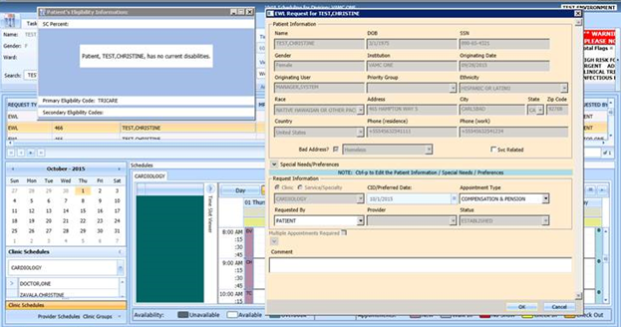

Figure 61: EWL Request Dialog

### Disposition or Removing a Patient from the EWL

If a patient is on the EWL for an appointment or a consult, and information is received that the patient no longer needs the appointment, EWL request can be removed and no longer appears in the Request Management Grid.

To disposition or remove the EWL Request, follow the below steps:

1. Log on to VS GUI as a Scheduler.
2. In the **Tasks** tab display, in the **Search** text box, type the patient’s last name or patient’s first initial of last name and last 4 of SSN (e.g. S1234), click the **Search** button, and select the requested patient name. Click **Search**.
3. Click **Search**.
4. Select the requested patient name from drop down list. The patient must have an existing EWL request.
5. In the request grid, right click on the desired EWL request and select EWL Disposition.
6. The following EWL Disposition options are available for selection:

* Death
* Removed/Non-VA Care
* Removed/Scheduled-Assigned
* Removed/VA Contract Care
* Removed/No longer Necessary
* Entered in Error
* Transferred

The EWL Request is removed from the RM Grid and the next APPT Request is moved up and highlighted.

### Adding Recall Request

Use the following procedure to add a new Recall request for a patient.

1. Log on to VS GUI as a Scheduler.
2. In the **Tasks** tab display, in the **Search** text box, type the patient’s last name or patient’s first initial of last name and last 4 of SSN (e.g. S1234), click the **Search** button, and select the requested patient name. Click **Search**.
3. Click **Search**.
4. Select the requested patient name from drop down list.
5. In the **Request Type** dialog box, select **RECALL** and click **OK**.

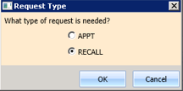

Figure 62: Request Type–RECALL

1. Enter a **Recall Date**. Enter the date the provider requested.
2. Enter a **Recall Date** (per patient). Enter the date the patient prefers.
3. Enter a Recall Appt Type.
   * Follow up
   * Consultation
   * Routine
   * Evaluation
4. Check **Fasting** if patient needs to be fasting for the appointment.
5. Enter the Length of the Appointment.
6. Select **Clinic** (Clinic can be searched by Clinic Name with 6 character minimum or by Clinic abbreviation with 4 character minimum).   
   **Note:** Clinic does not appear for selection if Recall Reminders Letter is not defined for the clinic.
7. Select **Recall Provider** (3 character minimum).
8. Enter a **Comment**.
9. View the **Special Needs/Preferences** window by entering **Ctrl + P** for the Patient Info dialog box and add or edit preferences as appropriate.
10. Click **OK**. The request grid shows requests of the selected patient. The newly added request is selected. The calendar defaults to the desired date and the selected clinic and defaults, and shows the clinic schedules.
11. View the **Special Needs/Preferences** window in the ribbon bar to confirm it is updated.

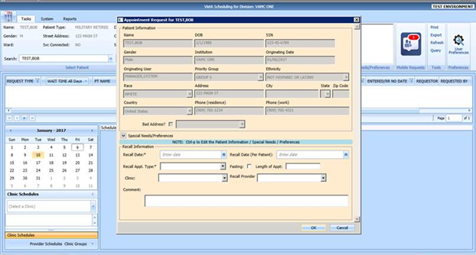

Figure 63: Recall Appointment Request Dialog

### Viewing/Editing Recall Request

If a Recall request needs to be reviewed or modified before being booked, you can View/Edit the request in the Request Grid using the following steps:

1. Log on to VS GUI as a Scheduler.
2. In the **Tasks** tab display, in the **Search** text box, type the patient’s last name or patient’s first initial of last name and last 4 of SSN (e.g. S1234), click the **Search** button, and select the requested patient name. Click **Search**.
3. Click **Search**.
4. Select the requested patient name from drop down list.  
   **Note:** When **Spacebar + Search** is used, the Ribbon Bar and RM grid adjust to that selected patient.
5. In **Request Type** dialog, select **Cancel**.
6. In the **Request Management** grid, right click on the applicable **Recall** request.
7. Select **Recall Disposition** option.
8. The following options appear for selection:

* View Request
* Edit Request
* Failure to respond
* Moved
* Deceased
* Doesn’t want VA services
* Received care at another VA
* Other

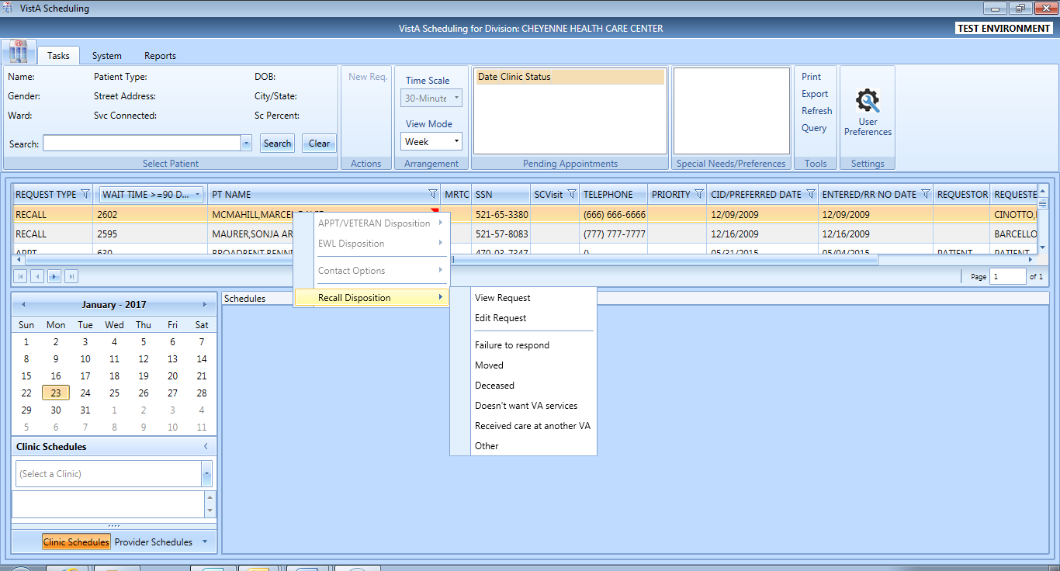

Figure 61: Recall Disposition Dialog

1. Select **View Request**. The **Recall Request** dialog box appears with everything greyed out as the dialog box is Read-Only.

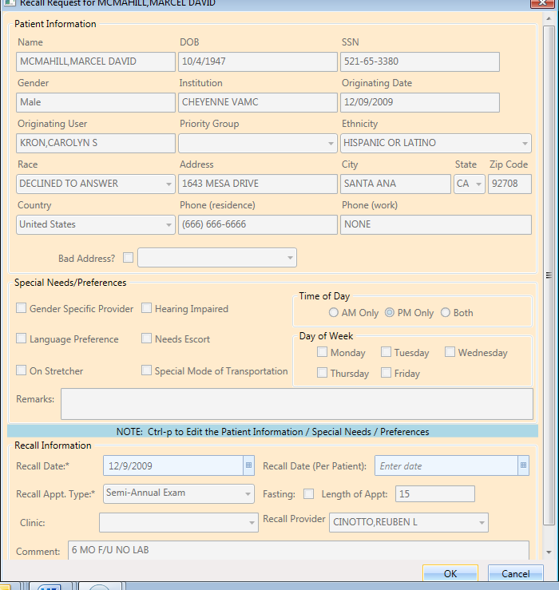

Figure 62: Recall Appointment View Request Dialog

1. Click **OK**. You return to the RM Grid.
2. Right click on the applicable **Recall** request.
3. Select Recall Disposition option.
4. The following options appear for selection:

* View Request
* Edit Request
* Failure to respond
* Moved
* Deceased
* Doesn’t want VA services
* Received care at another VA
* Other

1. Select **Edit Request.** The Recall Request dialog displays.



Figure 63: Recall Disposition Dialog

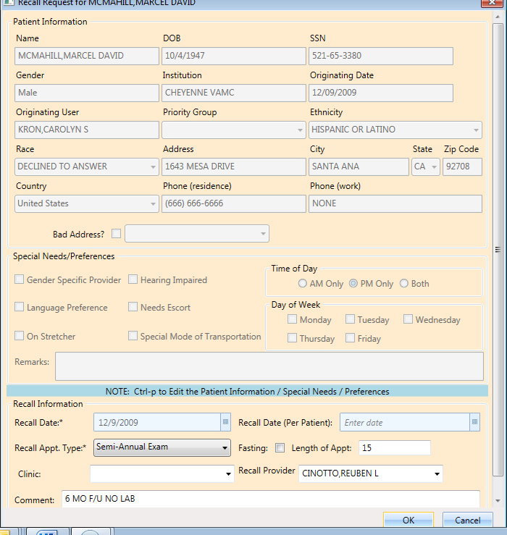

Figure 64: Recall Appointment Edit Request Dialog

The editable fields are Recall Appt. Type, Fasting, Length of Appt, Clinic, Recall Provider, and Comment. Not the Recall Date and Recall Date (Per Patient) are not editable.

1. Click **OK**. The request returns to the **Request Grid** with the altered information listed.

### Disposition or Remove Recall Request

Perform the following procedure to cancel or delete a Recall request.

1. Log on to VS GUI as a Scheduler.
2. In the **Tasks** tab display, in the **Search** text box, type the patient’s last name or patient’s first initial of last name and last 4 of SSN (e.g. S1234), click the **Search** button, and select the requested patient name. Click **Search**.
3. .
4. Click **Search**.
5. Select the requested patient name from drop down list.
6. In the RM Grid, right click the **Recall** request and select **Recall Disposition**. The following dispositions are available for selection:

* Failure to respond
* Moved
* Deceased
* Doesn’t want VA services
* Received care at another VA
* Other

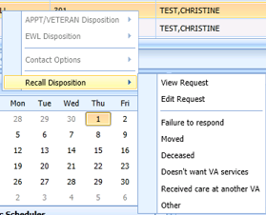

Figure 64: Recall Disposition Options

1. From the Recall **Comment** dialog box, enter the comments as necessary.
2. Click **OK**. The patient is removed from the request grid.

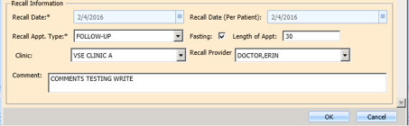

Figure 65: Recall Comment

## Contacting a Patient

A patient may need to be contacted by phone to schedule an appointment. Contact efforts can be added to the patient record for APPT and EWL requests. They are not viewable in the VS GUI but are storedin the **SDEC APPT REQUEST file.**

**Note:** Once a Contact Option has been processed for a patient it is dimmed in the option and no longer selectable.

### Call Attempt 1

Use the following procedure to document **Call Attempt 1** information. Once documented it is not available for selection in the future.

1. Log on to VS GUI as a Scheduler.
2. In the **Tasks** tab display, in the **Search** text box, type the patient’s last name or patient’s first initial of last name and last 4 of SSN (e.g. S1234), click the **Search** button, and select the requested patient name. Click **Search**.
3. Click **Search**.
4. Select the requested patient name from drop down list.
5. In the Request Type dialog box, click **Cancel**.
6. In the request grid, right click APPT or EWL request type, and then select **Contact Options**. The following **Contact Options** are available for selection:

* Call Attempt 1
* Letter Sent to Patient

1. Select **Call Attempt 1**.

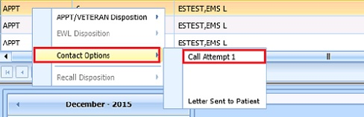

Figure 66: Contact Options–Call Attempt 1

1. The **Patient Contact** dialog displays, accept the default contact date/time or change as appropriate.

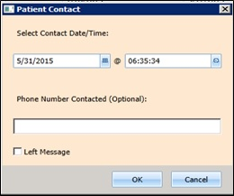

Figure 67: Patient Contact Dialog

1. Enter phone number that was contacted, if desired.
2. If a message was left, check the **Left Message** checkbox.
3. Click **OK** to close the dialog box.

### Call Attempt 2

Call Attempt 2 option is not available until after Call Attempt 1 has been completed. Once documented it is not available for selection in the future.

Use the following procedure to document Call Attempt 2 information:

1. Log on to VS GUI as a Scheduler.
2. From the **Tasks** tab display, in the **Search** text box enter the patient’s last name and first name.
3. Click **Search**.
4. Select the requested patient name from drop down list.
5. In the Request Type dialog box, click **Cancel**.
6. In the request grid, right click APPT or EWL request type, and then select **Contact Options**.
7. The following **Contact Options** are available for selection:

* Call Attempt 2
* Letter Sent to Patient

1. Select **Call Attempt 2**.

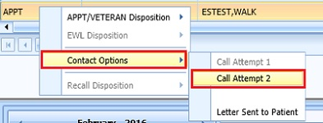

Figure 68: Contact Options–Call Attempt 2

1. The **Patient Contact** dialog displays, accept the default contact date/time or change as appropriate.



Figure 69: Patient Contact Dialog

1. Enter phone number that was contacted.
2. If a message was left, check the **Left Message** checkbox.
3. Click **OK** to close the dialog.

### Call Attempt 3

Call Attempt 3 option is not available until after Call Attempt 1 and Call Attempt 2 have been completed.

Use the following procedure to document Call Attempt 3 information:

1. Log on to VS GUI as a Scheduler.
2. From the **Tasks** tab display, in the **Search** text box enter the patient’s last name and first name.
3. Click **Search**.
4. Select the requested patient name from drop down list.
5. In the Request Type dialog box, click **Cancel**.
6. In the request grid, right click APPT or EWL request type, and then select **Contact Options**.
7. The following Contact Options are available for selection:

* Call Attempt 3
* Letter Sent to Patient

1. Select **Call Attempt 3**.

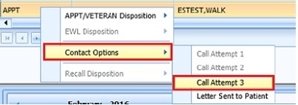

Figure 70: Contact Options–Call Attempt 3

1. The **Patient Contact** dialog displays, accept the default contact date/time or change as appropriate.



Figure 71: Patient Contact Dialog

1. Enter phone number that was contacted.
2. If a message was left, check the **Left Message** checkbox.
3. Click **OK** to close the dialog.

### Letter Sent to Patient

Letter Sent to Patient is an alternative option for contacting a patient and is available regardless of the previous Call Attempt Selections. Once documented it is not available for selection in the future.

Use the following steps to document Letter Sent to Patient:

1. Use Log on to VS GUI as a Scheduler.
2. From the **Tasks** tab display, in the **Search** text box enter the patient’s last name and first name.
3. Click **Search**.
4. Select the requested patient name from drop down list.
5. In the Request Type dialog box, click **Cancel**.
6. In the request grid, right click APPT or EWL request type, and then select **Contact Options**.
7. Select **Letter Sent to Patient**.

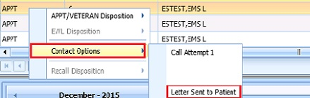

Figure 72: Contact Options–Letter Sent to Patient

1. The **Patient Contact** dialog displays, accept the default contact date/time or change as appropriate.



Figure 73: Patient Contact Dialog

1. Click **OK** to store Letter Sent to Patient information and close dialog.

# Appointment Management

## Adding Appointments

### Add Appointment for Appointment Request

1. Log into VS GUI as a Scheduler.
2. In the Tasks tab display, type the patient’s last name, first name in the Search text box, click Search button, and then select the requested patient name from drop down list.
3. In the **Request Type** dialog box, select **APPT** and click **OK** to create new request or click **Cancel** for existing request.

**Note:** Refer to Section 5.1.2 Adding Appointment Request for steps on adding new APPT Request.



Figure 74: Request Type

1. In Request Management Grid, select **APPT** request. The Clinic Schedule Grid displays the clinic schedule based upon CID/Preferred date of request. For past dates, the clinic schedule opens defaulted to current date. For current date (or CID/Preferred date less than 3 days in future), the clinic schedule displays defaulted to current date. For future dates, the clinic schedule displays -/+3 days of CID/Preferred date.

**Note:** For newly created APPT request the system automatically highlights APPT request and Clinic Schedule displays.

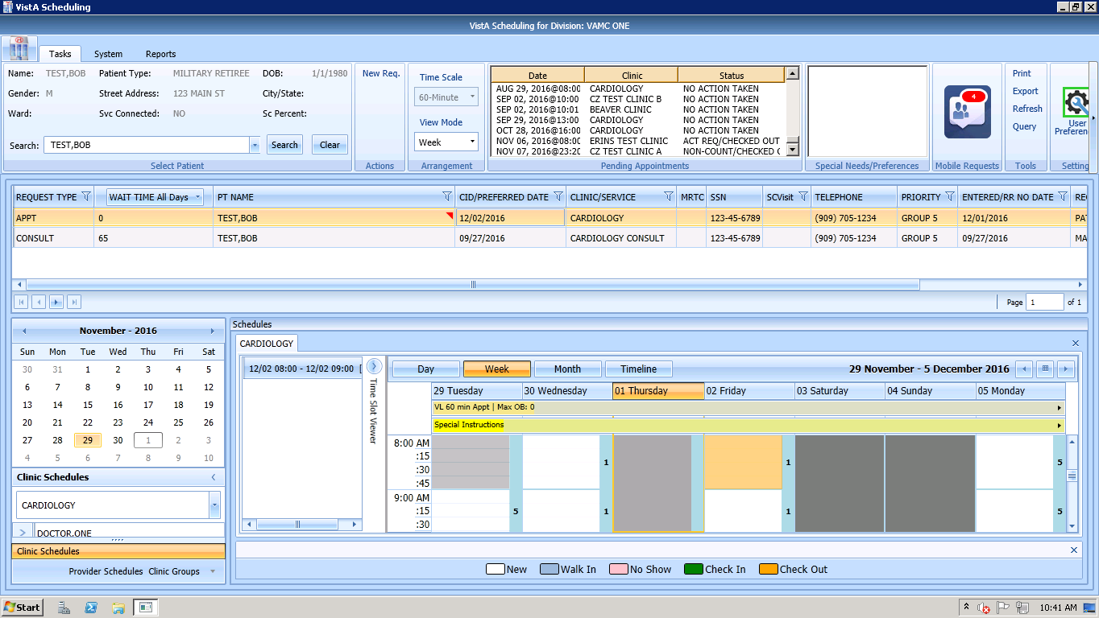

Clinic Schedule displays APPT Request with future CID/Preferred Date defaulted as -3/+3 days of date.

Figure 75: Select APPT Request–Clinic Schedule Grid Display

1. In Clinic Schedule Grid, select available time slot. Time Slot details display in Time Slot Viewer.

**Note:** Refer to Section 7.1.7 Time Slot Viewer for detailed information on Time Slot Viewer functionality.

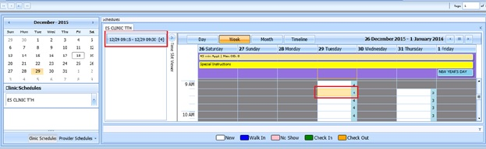

Figure 76: Select Time Slot

1. Right click in time slot. **Add Appointment** option displays. Create Walk In Appointment option is only available for selection on current date. It is not available for past or future CID/Preferred dates.

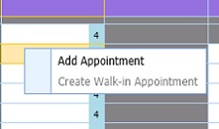

Figure 77: Right Click Options–Add Appointment

1. Select **Add Appointment**.
2. New Appointment dialog displays as well as Patient Eligibility dialog.

* **Appointments Tab**:
* **Patient Information** Section displays Name, DOB, SSN, Svc Connected, Sc Percent, Global Assessment of Function (score) (GAF) (read only), and Svc Related check box.
* **Appointment** information section displays Start Time, Appt Type, Duration, Clinic and Notes (Appointment Start Time; Duration on for appointments to Variable Length (VL) Clinics; and Notes are editable fields). Information can be added pertinent to appointment.
* **Appointment Conflicts** section displays any appointments already scheduled that potentially conflict with appointment being added.

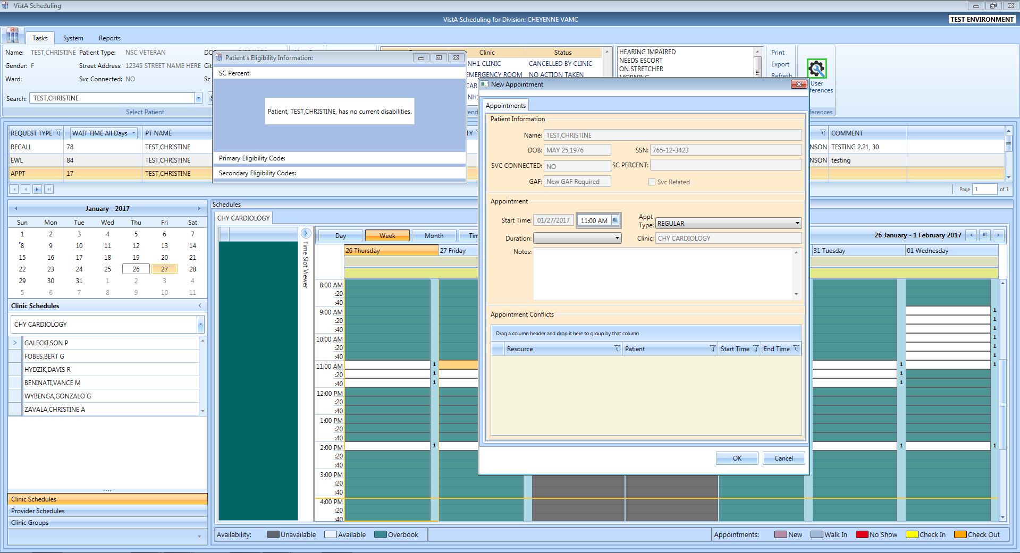

Figure 78: New Appointment Dialog

1. Add any applicable Notes to appointment. Click **OK**.
2. Print Letter? Dialog displays. Click **OK** to send Letter to patient. Click **Cancel** to not send letter.

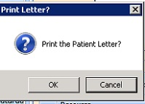

Figure 79: Print Letter? Dialog

1. Closing Request dialog displays. Click **OK**.

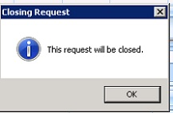

Figure 80: Closing Request Dialog

1. APPT Request is removed from Patient Request Management Grid. Next request for patient is moved up and highlighted.
2. Clinic Schedule closes and next appointments clinc schedule is opened.
3. New appointment displays in Pending Appointment Window in Ribbon Bar.
4. Select appointment from the Pending Appointment window to view the appointment in the Clinic S chedule Grid. The clinic schedule opens. For past dates, the clinic schedule opens defaulted to appointment date. For current date (or appointment date less than 3 days in future), the clinic schedule displays defaulted to current date. For future dates, the clinic schedule displays -/+3 days of appointment date.

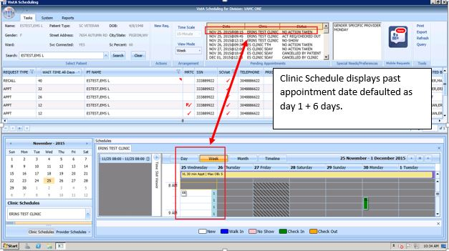

Figure 81: Clinic Schedule Grid–Past Appointment Date Display

For current date (or appointment date less than 3 days in future), the clinic schedule displays defaulted to current date.

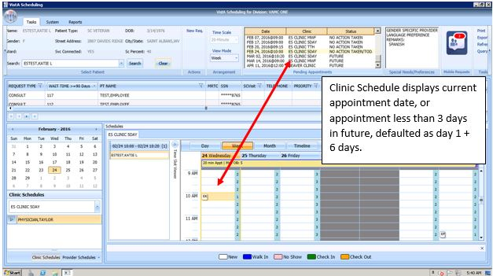

Figure 82: Clinic Schedule Grid–Current or less than 3 days in Future Appointment in Clinic Schedule Display

For future dates, the clinic schedule displays -/+3 days of appointment date.

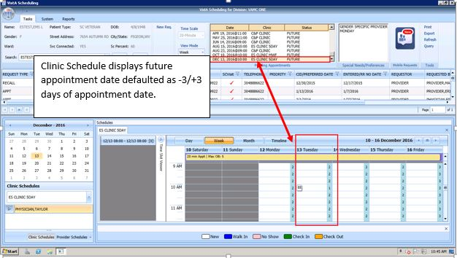

Figure 83: Clinic Schedule Grid--Future Appointment Date in Clinic Schedule Display

### Add Appointment for EWL Request

1. Log into VS GUI as a Scheduler.
2. In the Tasks tab display, type the patient’s last name, first name in the Search text box, click the **Search** button, and then select the requested patient name from drop down list.
3. In the **Request Type** dialog box, select **APPT** and then click **OK** to create new request or click **Cancel** for existing request.

**Note:** Refer to Section 5.1.5 for steps on transferring APPT request to new EWL Request.

VS GUI Request Type  window

Figure 84: Request Type

1. In **Request Management** Grid select **EWL** request. The Clinic Schedule Grid displays the clinic schedule based upon CID/Preferred date of request. For past dates, the clinic schedule opens defaulted to CID/Preferred date. For current date (or CID/Preferred date less than 3 days in future), the clinic schedule displays defaulted to current date. For future dates, the clinic schedule displays -/+3 days of CID/Preferred date.

**Note:** For newly created Recall request the system automatically highlights APPT request and Clinic Schedule displays. If EWL is for a service/specialty no grid is displayed and the clinic must be searched and selected.

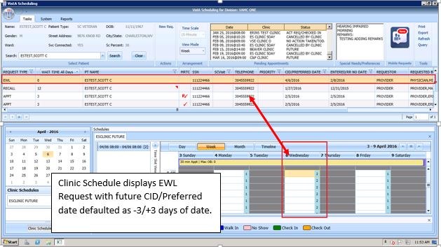

Figure 85: Select EWL Request

1. In Clinic Schedule Grid, select available time slot. Time Slot details display in Time Slot Viewer.

**Note:** See Section 7.1.7 Time Slot Viewer for detailed information on Time Slot Viewer functionality.

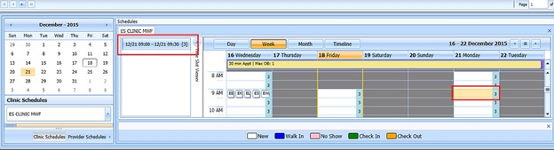

Figure 86: Select Time Slot

1. Right click in time slot. **Add Appointment** option displays.   
     
   **Note:** Create Walk In Appointment option is only available for selection on current date. It is not available for past or future CID/Preferred dates.



Figure 87: Right Click Options–Add Appointment

1. Select **Add Appointment**.
2. New Appointment dialog contains the following sections:

* **Appointments Tab:**
* **Patient Information** section displays Name, DOB, SSN, Svc Connected, Sc Percent, GAF (read only), and Svc Related check box.
* **Appointment** information section displays Start Time, Appt Type, Duration, Clinic and Notes (Appointment Start Time; Duration on for appointments to VL Clinics; and Notes are editable fields).
* **Appointment Conflicts** section displays any appointments already scheduled that conflict with appointment being added.

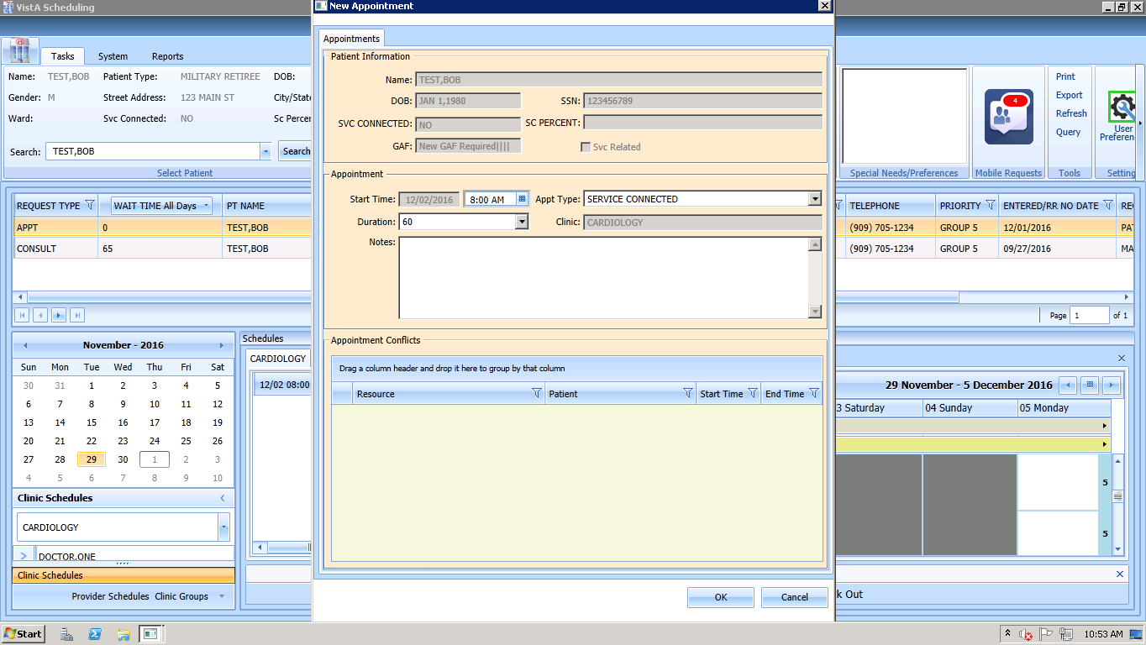

Figure 88: New Appointment Dialog

1. Add any applicable Notes to appointment. Click **OK**.
2. Print Letter? Dialog displays. Click **OK** to send Letter to patient. Click **Cancel** to not send letter.



Figure 89: Print Letter? Dialog

1. Closing Request dialog displays. Click **OK**.



Figure 90: Closing Request Dialog

1. EWL Request is removed from Patient Request Management Grid. The EWL request is dispositioned as scheduled. Next request for patient is moved up and highlighted.
2. Clinic Schedule closes and the clinic for the next request displays.
3. New appointment displays in Pending Appointment Window in Ribbon Bar.
4. Select appointment from the Pending Appointment window to view the appointment in the Clinic Schedule Grid. The clinic schedule opens. For past dates, the clinic schedule opens defaulted to appointment date.



Figure 91: Past Appointment Date in Clinic Schedule Grid–EWL Appointment Past Date Display

For current date (or appointment date less than 3 days in future), the clinic schedule displays defaulted to current date.

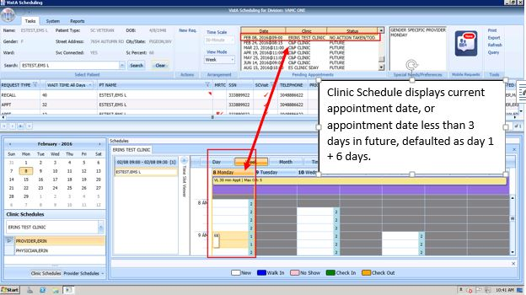

Figure 92: Clinic Schedule Grid–EWL Appointment Current Date

For future dates, the clinic schedule displays -/+3 days of appointment date.



Figure 93: Future Appointment Date in Clinic Schedule Grid–EWL Appointment Future Date Display

### Add Appointment for Recall Request

1. Log into VS GUI as a Scheduler.
2. In the **Tasks** tab display, in the **Search** text box, type the patient’s last name or patient’s first initial of last name and last 4 of SSN (e.g. S1234), click the **Search** button, and select the requested patient name. Click **Search**.
3. In the Request Type dialog box, select **Recall** and then click **OK** to create new request or click **Cancel** for existing request.

**Note:** Refer to Section 5.1.7 for steps on adding new Recall Request.



Figure 94: Request Type

1. In **Request Management** Grid select **Recall** request. The Clinic Schedule Grid displays the clinic schedule based upon CID/Preferred date of request. For past dates, the clinic schedule opens defaulted to the CID/Preferred date. For current date (or CID/Preferred date less than 3 days in future), the clinic schedule displays defaulted to current date. For future dates, the clinic schedule displays -/+3 days of CID/Preferred date.

**Note:** For newly created Recall request the system automatically highlights RECALL request in Request Management Grid and Clinic Schedule displays.

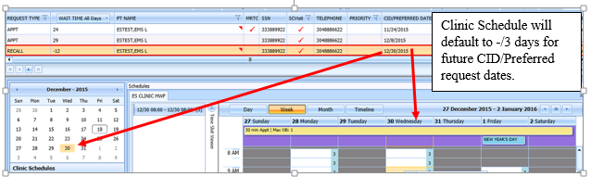

Figure 95: Select Recall Request

1. In Clinic Schedule Grid, select available time slot. Time Slot details display in Time Slot Viewer.

**Note:** See Section 7.1.7 Time Slot Viewer for detailed information on Time Slot Viewer functionality.

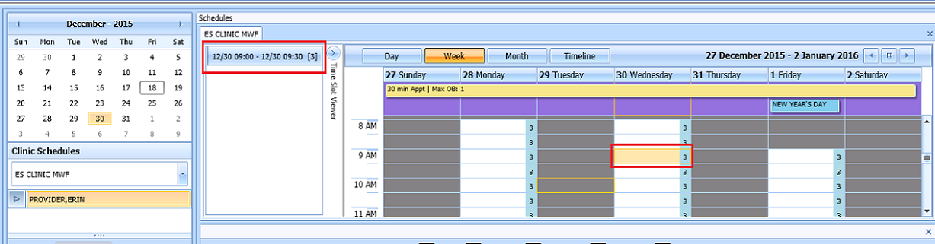

Figure 96: Select Time Slot

1. Right click in time slot. **Add Appointment** option displays.   
   **Note: Create Walk In Appointment** option is only available for selection on current date. It is not available for past or future CID/Preferred dates.

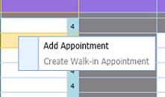

Figure 97: Right Click Options–Add Appointment

1. Select **Add Appointment**.
2. New Appointment dialog contains the following sections:

* **Appointments Tab:**
* **Patient Information Section displays** Name, DOB, SSN, SVC Connected, SC Percent, GAF (read only), and Svc Related check box**.**
* **Appointment** information section displays Start Time, Appt Type, Duration, Clinic and Notes (Appointment Start Time; Duration on for appointments to VL Clinics; and Notes are editable fields).
* **Appointment Conflicts** section displays any appointments already scheduled that conflict with appointment being added.



Figure 98: New Appointment Dialog

1. Add any applicable Notes to appointment. Click **OK**.
2. Print Letter? Dialog displays. Click **OK** to send Letter to patient. Click **Cancel** to not send letter.

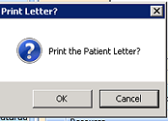

Figure 99: Print Letter? Dialog

1. Closing Request dialog displays. Click **OK**.

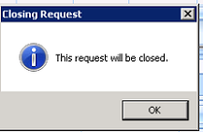

Figure 100: Closing Request Dialog

**Note:** The Recall request is not immediately removed from the request grid. The request is removed when the task “CLEAN UP CLINIC RECALL ENTRIES” has been run and when the appointment is made within the CLEAN UP DAY SETTING in ENTER/EDIT CLINIC RECALL SITE PARAMS menu option.

1. Clinic Schedule closes and the clinic for the next request displays.
2. New appointment displays in Pending Appointment Window in Ribbon Bar.
3. Select appointment from the Pending Appointment window to view it in Clinic Schedule Grid. The clinic schedule opens. For past dates, the clinic schedule displays defaulted to appointment date.



Figure 101: Past Appointment Date in Clinic Schedule display–Past Date Appointment

For current date (or appointment date less than 3 days in future), the clinic schedule displays appointment date as day 1 + 6 days to current date.



Figure 102: Clinic Schedule Display–Current Date Appointment

For future dates, the clinic schedule displays -/+3 days of appointment date.



Figure 103: Future Appointment Date in Clinic Schedule Display–Future Date Appointment

### Add Appointment for Consult Request

1. Log into VS GUI as a Scheduler.
2. Log into VS GUI as a Scheduler.
3. In the **Tasks** tab display, in the **Search** text box, type the patient’s last name or patient’s first initial of last name and last 4 of SSN (e.g. S1234), click the **Search** button, and select the requested patient name. Click **Search**.
4. In the **Request Type** dialog box, click **Cancel** and select existing **Consult**.

**Note:** Consult requests are added from CPRS.



Figure 104: Request Type

1. In Request Management Grid select ConsultRequest.

**Note:** Clinic Schedule does NOT display when selecting Consult request.

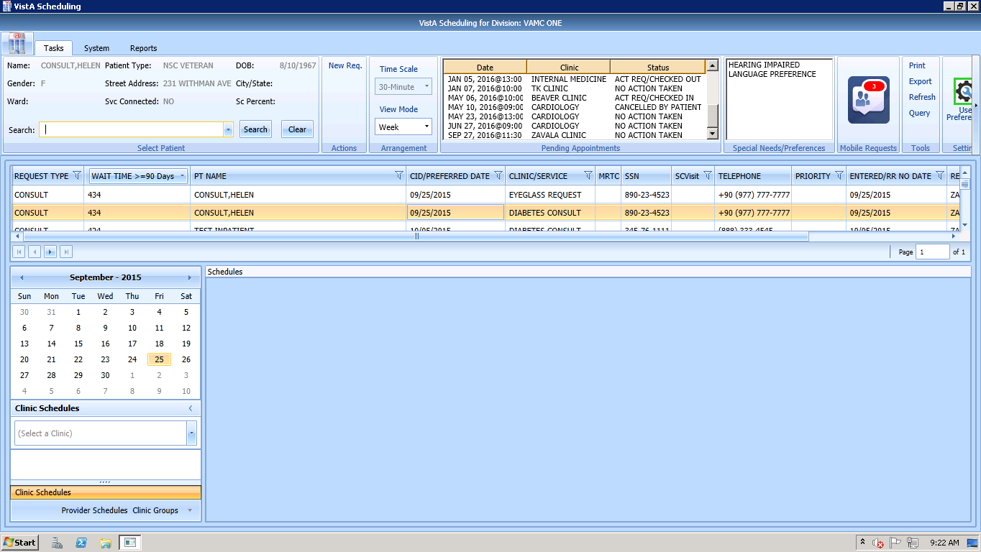

Clinic Schedule does not display when selecting a Consult Request.

Figure 105: Select Consult Request

1. From Clinic Schedules, enter clinic name (6 character minimum).

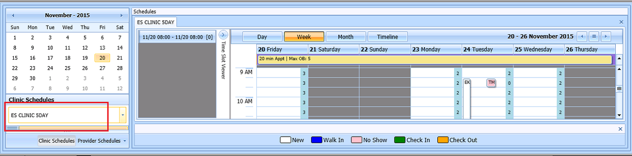

Figure 106: Clinic Schedules

1. In Clinic Schedule displays, left click available time slot. Time Slot details display in Time Slot Viewer.

**Note:** See Section 7.1.7 Time Slot Viewer for detailed information on Time Slot Viewer functionality.

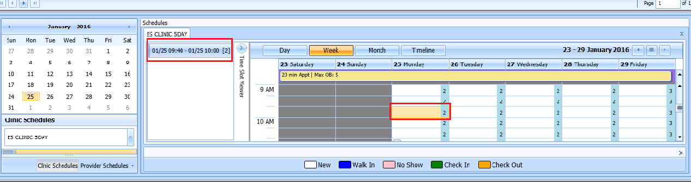

Figure 107: Select Time Slot

1. Right click in time slot. **Add Appointment** option displays.   
   **Note: Create Walk-In Appointment** option is only available for selection on current date. It is not available for past or future CID/Preferred dates.



Figure 108: Right Click Options–Add Appointment

1. Select **Add Appointment**.
2. New Appointment dialog displays as well as Patient Eligibility dialog.

* **Appointments Tab:**
* **Patient Information Section displays** Name, DOB, SSN, SVC Connected, SC Percent, GAF (read only), and Svc Related check box**.**
* **Appointment** information section displays Start Time, Appt Type, Duration, Clinic and Notes (Appointment Start Time; Duration on for appointments to VL Clinics; and Notes are editable fields).
* **Appointment Conflicts** section displays any appointments already scheduled that conflict with appointment being added.



Figure 109: New Appointment Dialog

1. Add any applicable Notes to appointment. Click **OK**.
2. Print Letter? Dialog displays. Click **OK** to send Letter to patient. Click **Cancel** to not send letter.



Figure 110: Print Letter? Dialog

1. Consult Request is removed from Patient Request Management Grid. Next request for patient is moved up and highlighted.
2. Clinic Schedule closes and clinic for the next request displays, if applicable.
3. New appointment displays in Pending Appointment Window in Ribbon Bar.
4. Select appointment from the Pending Appointment window to view it in the Clinic Schedule Grid. The clinic schedule opens. For past dates, the clinic schedule opens defaulted to appointment date.

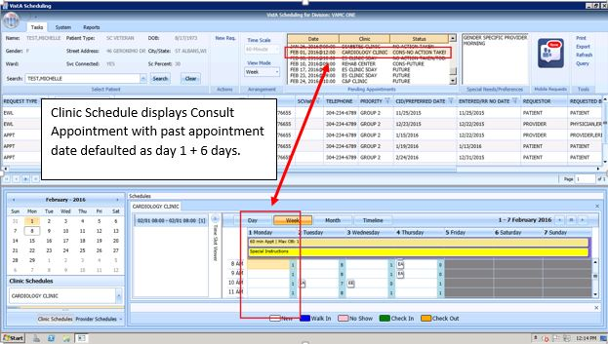

Figure 111: Clinic Schedule Display–Consult Past Appointment Date

For current date (or appointment date less than 3 days in future), the clinic schedule displays defaulted to current date.

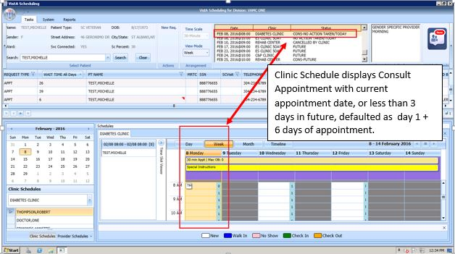

Figure 112: Consult with Current Date or less than 3 days in Future in Clinic Schedule Display

For future dates, the clinic schedule displays -/+3 days of appointment date.

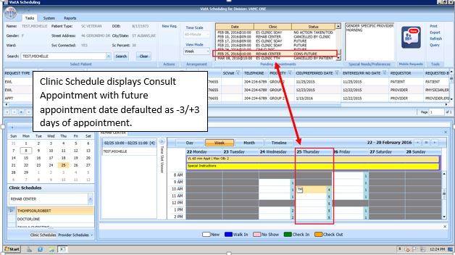

Figure 113: Consult Future Appointment Date in Clinic Schedule Display

## Disposition Appointments

### Edit Appointment Information

Editing appointment information can be done within the VS GUI.

Perform the following procedure to edit appointment information:

1. Log on to VS GUI as a Scheduler.
2. In the Tasks tab display, type the patient’s last name, first name in the Search text box, click the **Search** button, and then select the requested patient name from drop down list.
3. In **Request Type** dialog, click **Cancel**.
4. Locate the appointment to be edited in the Pending Appointments Window in the Ribbon Bar.
5. The clinic schedule displays. For past appointment dates, the clinic schedule opens defaulted to appointment date. For current date (or appointment date less than 3 days in future), the clinic schedule displays defaulted to current date. For future dates, the clinic schedule displays -/+3 days of appointment date.
6. In the Clinic Schedule Grid, locate the appointment, right click on the appointment, and then select **Edit Appointment**.

**Note:** See section 7.1.7 for Time Slot Viewer details.

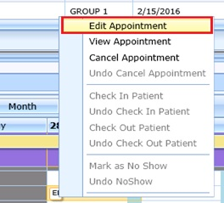

Figure 114: Appointment Right Click Options--Edit Appointment

1. Edit Appointment dialog displays.
2. The only field that is editable is Notes. Make any necessary edits to the appointment information and click OK

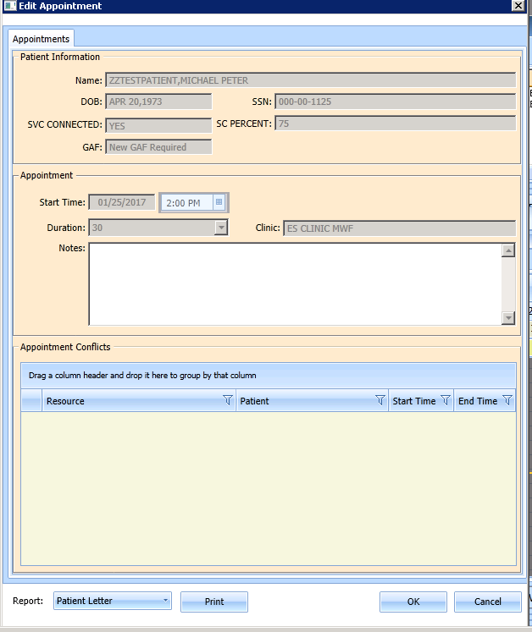

Figure 115: Edit Appointment Dialog

### View Appointment Information

Viewing appointment information can be done in the Clinic Schedule Grid in the VS GUI.

Perform the following procedure to view appointment information:

1. Log on to VS GUI.
2. In the **Tasks** tab display, in the **Search** text box, type the patient’s last name or patient’s first initial of last name and last 4 of SSN (e.g. S1234), click the **Search** button, and select the requested patient name. Click **Search**.
3. In Request Type dialog, click **Cancel**.
4. Locate the appointment to be viewed in the Pending Appointments Window in the Ribbon Bar.
5. The clinic schedule displays. For past appointment dates, the clinic schedule defaults to appointment date as Day 1 + 6 days. For current date (or appointment date less than 3 days in future), the clinic schedule displays defaulted to current date as Day 1 + 6 days. For future dates, the clinic schedule displays -/+3 days of appointment date.
6. In the Clinic Schedule Grid, locate the appointment, hover over the appointment, and the appointment details display in the hover box.

**VS GUI Hover Box Displaying Appointment Details window**

Figure 116: Hover Box Displaying Appointment Details

1. Right click appointment.
2. Select **View Appointment**.

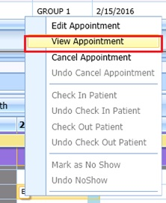

Figure 117: Appointment Right Click Options--View Appointment

1. **View Appointment** dialog displays. It is in read-only mode. No fields are editable. Click **OK** to close View Appointment dialog.

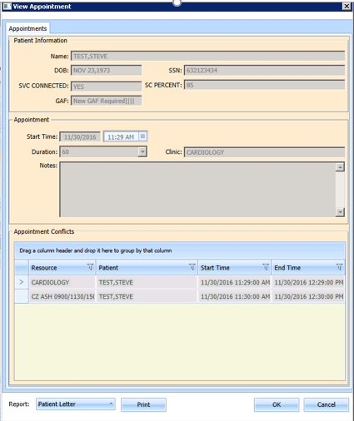

Figure 118: View Appointment Dialog

### Cancelling an Appointment

You can cancel an appointment without rebooking it.

1. Log on to VS GUI as a Scheduler.
2. In the **Tasks** tab display, in the **Search** text box, type the patient’s last name or patient’s first initial of last name and last 4 of SSN (e.g. S1234), click the **Search** button, and select the requested patient name. Click **Search**. .In Request Type dialog, click **Cancel**.
3. In Request Type dialog, click **Cancel**.
4. Select a scheduled appointment from Pending Appointment Window in Ribbon Bar.
5. The clinic schedule displays. For past appointment dates, the clinic schedule opens defaulted to appointment date. For current date (or appointment date less than 3 days in future), the clinic schedule displays defaulted to current date. For future dates, the clinic schedule displays -/+3 days of appointment date.
6. Select appointment from Clinic Schedule Grid.
7. Right click and select **Cancel**.

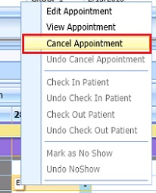

Figure 119: Appointment Right Click Options--Cancel Appointment

1. In the **Cancel Appointment** dialog box, select a cancellation option:
   * **Cancelled by Clinic**: The original CID/Preferred appointment date defaults to the patient desired date. The date cannot be edited.
   * **Cancelled by Patient**: The patient CID/Preferred date is available and defaults to original CID/Preferred date request. You can edit the date to change it.
2. Select **Reason for Cancellation** from list.
3. Edit CID/Preferred dates if applicable.
4. Add Remarks as needed.
5. Click **OK**. The appointment is canceled and not rebooked. If the appointment is linked to a consult, the consult status changes to Active.

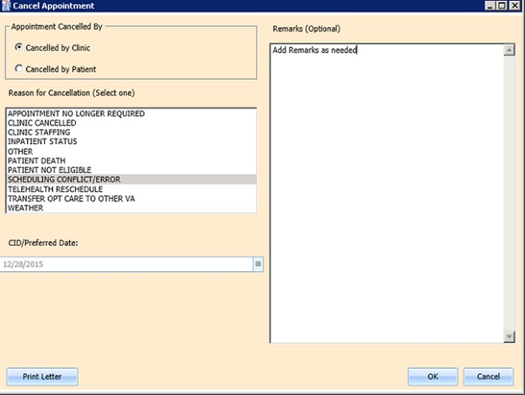

Figure 120: Cancel Appointment Dialog

1. Appointment displays in Pending Appointment with status of Cancelled by Clinic or Cancelled by Patient (as applicable).

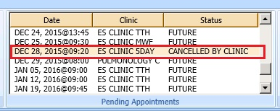

Figure 121: Pending Appointment Window–Appointment Status Cancelled by Clinic

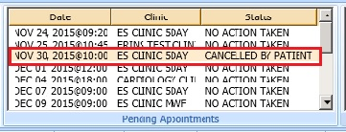

Figure 122: Pending Appointment Window–Appointment Status Cancelled by Patient

1. Clinic Schedule closes.
2. The patient’s appointment request reappears on the request grid for future rescheduling.
3. Select **APPT Request** and Clinic Schedule displays again.

**Note:** Time Slot count increases when appointment is canceled.

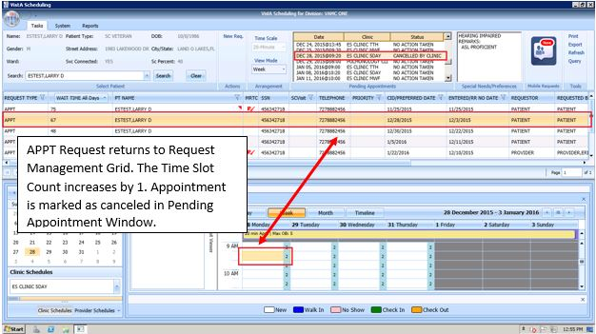

Figure 123: APPT Request Returns to Request Management Grid and Time Slot Count Increases

### Mark as No Show Appointment

Perform the following procedure to record a no show appointment.

1. Log on to VS GUI as a Scheduler.
2. In the Tasks tab display, type the patient’s last name, first name in the Search text box, click the **Search** button, and then select the requested patient name from drop down list.
3. In the **Request Type** dialog box, click **Cancel**.
4. From **Pending Appointment** Window select appointment to mark as no show.
5. The clinic schedule displays. For past appointment dates, the clinic schedule Clinic Schedule displays defaulted to appointment date. For current date (or appointment date less than 3 days in future), the clinic schedule displays defaulted to current date.
6. Select appointment from Clinic Schedule Grid.
7. Right click **Appointment**.
8. Select **Mark as No Show**.

**Note: “**Mark as No Show” is not available to select on future dated appointments.

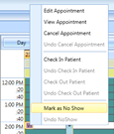

Figure 124: Appointment Right Click Options—Mark as No Show

1. **Mark as No Show** dialog displays.

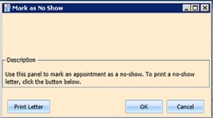

Figure 125: Mark as No Show Dialog

1. Click **OK**.
2. Appointment displays in red in Clinic Schedule Grid and Time Slot Viewer.

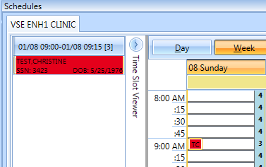

Figure 126: Clinic Schedule Display–No Show Red

1. Status in Pending Appointment Window in Ribbon Bar changes to No Show.
2. Request returns to Request Management Grid for patient.

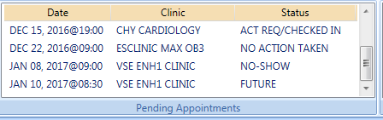

Figure 127: Pending Appointment Window–Appointment Status No-Show

### Undo No-Show Appointment

If a patient is recorded as a no-show but arrives in time to be seen, a previously recorded no show can be undone. Perform the following procedure to undo a no-show appointment.

1. Log on to VS GUI as a Scheduler.
2. In the **Tasks** tab display, in the **Search** text box, type the patient’s last name or patient’s first initial of last name and last 4 of SSN (e.g. S1234), click the **Search** button, and select the requested patient name. Click **Search**.
3. In Request Type dialog, click **Cancel**.
4. In the Pending Appointments Window in Ribbon Bar, locate the No Show appointment to undone.
5. The clinic schedule displays. For past appointment dates, the clinic schedule displays defaulted to appointment date. For current date (or appointment date less than 3 days in future), the clinic schedule displays defaulted to current date.
6. Right click **Appointment**.
7. Select **Undo NoShow**.

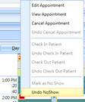

Figure 128: Appointment Right Click Options–Undo NoShow

1. In Clinic Schedule Grid, the appointment changes from red to purple.

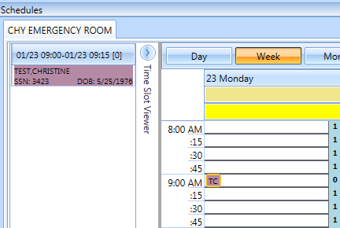

Figure 129: Appointment Clinic Schedule Display–Undo NoShow as Purple

1. Appointment status in Pending Appointment Window changes to No Action Taken.
2. Request closes and is relinked to appointment.

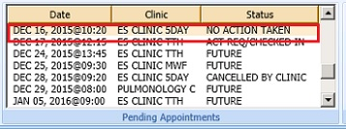

Figure 130: Pending Appointment Window Undo NoShow–Appointment Status No Action Taken

### Checking In a Patient

Perform the following procedure to check in a patient for an appointment.

1. Log on to VS GUI as a Scheduler.
2. In the **Tasks** tab display, in the **Search** text box, type the patient’s last name or patient’s first initial of last name and last 4 of SSN (e.g. S1234), click the **Search** button, and select the requested patient name. Click **Search**.
3. In the Request Type dialog box, click **Cancel**.
4. In the Pending Appointments Window in Ribbon Bar, locate the appointment to be checked in.
5. The clinic schedule displays. For past appointment dates, the clinic schedule Clinic Schedule opens defaulted to appointment date. For current date (or appointment date less than 3 days in future), the clinic schedule displays defaulted to current date.
6. Right click **Appointment**.
7. Select **Check In Patient**.

**Note:** Check In is not available for future dated appointments.

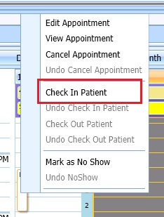

Figure 131: Appointment Right Click Options–Check In Patient

1. **Appointment Check In** dialog displays. Edit the check in date and time as needed.

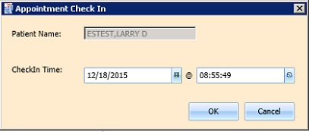

Figure 132: Appointment Check In Dialog

1. Click **OK**. The appointment color changes to yellow, signifying the patient has checked in for the appointment.

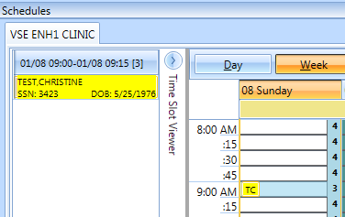

Figure 133: Clinic Schedule Display–Check In Yellow

1. In **Pending Appointment Window** in Ribbon Bar, appointment status changes to ACT REQ/CHECKED IN.

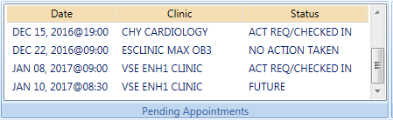

Figure 134: Pending Appointment Window–Appointment Status ACT REQ/CHECKED IN

### Undo a Patient Check In

If a patient is checked in by mistake, the check in can be undone.

Perform the following steps to undo a patient check in:

1. Log on to VS GUI as a Scheduler.
2. In the Clinic Schedule Grid, select the patient check in that needs to be undone.
3. Right-click and select **Undo Check In Patient**.

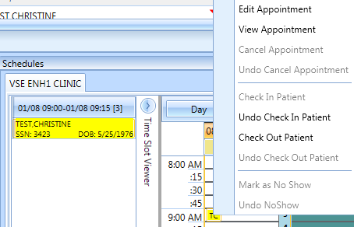

Figure 135: Appointment Right Click Options–Undo Check In Patient

1. Appointment changes color display from yellow to purple.

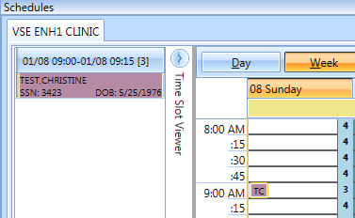

Figure 136: Clinic Schedule Display–Undo Check In Patient Purple

1. From Pending Appointment Window, appointment status changes to No Action Taken.

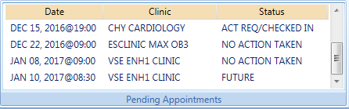

Figure 137: Pending Appointment Window–Appointment Status No Action Taken

### Check Out a Patient

Perform the following procedure to check out a patient.

1. Log on to VS GUI as a Scheduler.
2. In the **Tasks** tab display, in the **Search** text box, type the patient’s last name or patient’s first initial of last name and last 4 of SSN (e.g. S1234), click the **Search** button, and select the requested patient name. Click **Search**.
3. In the Request Type dialog box click **Cancel**.
4. In the Pending Appointments Window in Ribbon Bar, locate the appointment to be checked out.
5. Clinic Schedule displays. For past appointment date, Clinic Schedule opens defaulted to appointment date. For current date (or appointment date less than 3 days in future), schedule displays defaulted to current date. For future dates, schedule displays -/+3 days of appointment date.
6. Right click and select **Check Out Patient**.

**Note:** Check Out is not available to select if Check In has not been performed.

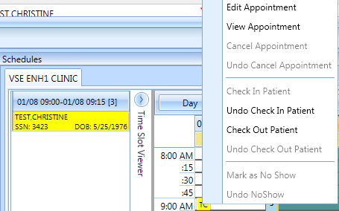

Figure 138: Appointment Right Click Option–Check Out Patient

1. Update the **Appointment Check Out** dialog box.
   * Confirm the date and time. Edit as needed.
   * Check **Follow-up Needed**, if applicable.

**Note:**: Check out must be at least 1 minute after check–in.

1. Click **OK**. The appointment status is changed to ACT REQ/**Checked Out** in Pending Appointment Window and the color changes to orange in Clinic Schedule.

**Note:** When Scheduler clicks OK, if Follow-up Needed was checked, then the New APPT Request dialog displays. This APPT Request dialog needs to be completed before Patient Check Out is complete.

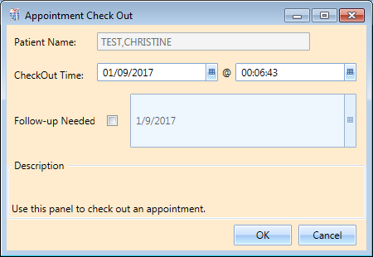

Figure 139: Appointment Check Out Dialog

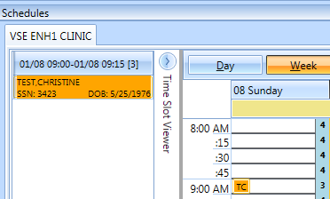

Figure 140: Clinic Schedule Display–Check Out Patient Orange

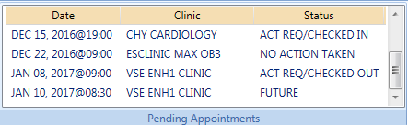

Figure 141: Pending Appointment Window–Appointment Status ACT REQ/CHECKED OUT

### Undo a Patient Check Out

If a patient is checked out by mistake, the check out can be undone.

Perform the following steps to undo a patient check out:

1. Log on to VS GUI as a Scheduler.
2. In the Clinic Schedule Grid, select the patient check in that needs to be undone.
3. Right click and select **Undo Check Out Patient**.

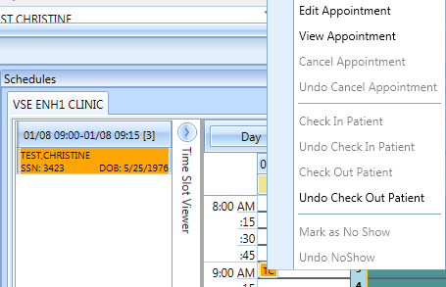

Figure 142: Appointment Right Click Options–Undo Check Out Patient

1. Appointment changes display from orange to yellow.

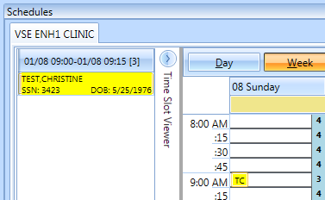

Figure 143: Clinic Schedule Display–Undo Check Out Patient Yellow

1. From Pending Appointment Window, appointment status changes to ACT REQ/CHECKED IN.

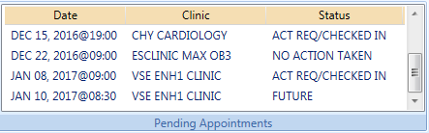

Figure 144: Pending Appointment Window--Appointment Status ACT REQ/CHECKED IN

Note: Undoing the check out will also delete all the encounter information that has been entered up to this point.

### Rescheduling an Appointment

You can cancel an appointment and reschedule it for another time.

1. Log on to VS GUI as a Scheduler.
2. In the **Tasks** tab display, in the **Search** text box, type the patient’s last name or patient’s first initial of last name and last 4 of SSN (e.g. S1234), click the **Search** button, and select the requested patient name. Click **Search**.
3. In Request Type dialog, click **Cancel**.
4. In the **Pending Appointments** Window in Ribbon Bar, locate and select the appointment to be rescheduled.
5. The Clinic Schedule displays. For past appointment date, Clinic Schedule opens defaulted to appointment date. For current date (or appointment date less than 3 days in future), schedule displays defaulted to current date. For future dates, schedule displays -/+3 days of appointment date.
6. In Clinic Schedule Grid, select the scheduled appointment, drag and drop it to another open time slot.
7. **Move Appointment** dialog displays.
8. Click **OK** to confirm new appointment time.

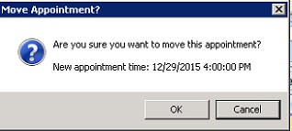

Figure 145: Move Appointment? Dialog

1. In the **Cancel Appointment** dialog box, define the fields as appropriate to cancel the original appointment.

**Note:** Refer to Section 6.2.3 Cancelling an Appointment for detailed instructions.

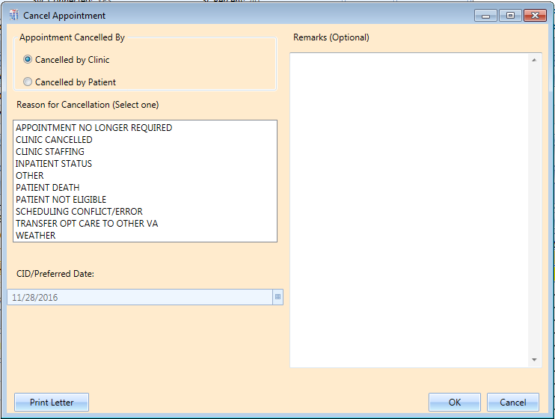

Figure 146: Cancel Appointment Dialog

1. Click **OK**. In Pending Appointment Window in Ribbon Bar, the original appointment is canceled and a new appointment is created. If the appointment is linked to a consult, the consult status changes to Scheduled and the cancellation and reschedule are recorded in the consult.

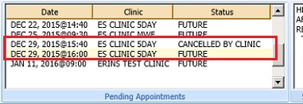

Figure 147: Pending Appointment Window–Appointment Status Cancelled and Future

1. The patient’s appointment request no longer appears on the request grid.

## Multiple Appointment Requests and Appointments

Multiple Appointment Requests allow the scheduler to create requests and book a series of appointments at one time for a patient.

### Multiple Appointment Request

1. Log into VS GUI as a Scheduler.
2. In the **Tasks** tab display, in the **Search** text box, type the patient’s last name or patient’s first initial of last name and last 4 of SSN (e.g. S1234), click the **Search** button, and select the requested patient name. Click **Search**.
3. In the Request Type dialog box, select APPT to create a new request.
4. **Patient’s Eligibility Information** dialog displays.
5. In the **Appointment Request** dialog confirm Patient Information details.
6. In the **Appointment Request** dialog box, complete the Request Information section.

* Select **Clinic** or **Service/Specialty** radio button. For Clinic enter clinic name (minimum of 6 characters required). For Service/Specialty enter service or specialty (minimum of 6 characters required).
* Enter **CID/Preferred Date** for the preferred appointment date. Scheduler can enter date directly or select date from Calendar control option.
* Select **Appointment Type** if not defaulted by patient eligibility and clinic selection then choose from drop down list.
* In **Request By**, select either Provider or Patient.
* If **Provider** selected then enter provider name (3 character minimum) and select from list.   
  **Note:** If, Patient was selected in Request By field, then Provider field is dimmed and not editable.
* **Status** is automatically populated.

1. Established – The patient has been seen at that clinic in the past 24 months
2. New – The patient has not been seen at that clinic in the past 24 months

* **Multiple Appointments Required** check box is enabled. Click box to enter check mark.
  + **Number of Appointments Required** drop down is visible. Up to 60 appointments can be requested at one time.
  + **Interval Between Appointments** (In days) drop down is visible. Up to 30 days between appointments can be requested at one time.

**Note:** The combination of Number of Appointments Required and Interval Between Appointments cannot exceed 24 months. If the selected combination does exceed 24 months to complete, when the Scheduler selects OK to complete the Appointment Request the MRTC Interval/Appt.# Dialog displays, “The combination of requested appointments and the interval between appointments exceeds 24 months. Please adjust the number of requested appointments and/or the interval between appointments so that the combined duration is less than 24 months.” The adjustment must be made before the Multiple Appointment Request can be completed.

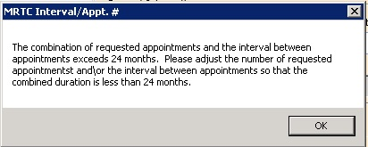

Figure 148: MRTC Interval/Appt. # Dialog

* Text can be added in **Comment** field up to 80 characters to add information regarding Appointment Request. For MRTC Requests the text displays in Request Management Grid under Comment column after the {Day, Interval} information.

1. Click **OK. Find Appointment** dialog displays to allow Scheduler to book Multiple Appointments at one time. See section 6.3.2 for booking appointments from Find Appointment Dialog.

#### Note Regarding Parent and Child Appointment Requests

When booking Multiple Appointment Requests the scheduler can click **Close** in the Find Appointment dialog. If this is done prior to the first appointment in the series being booked the Parent MRTC Request is placed in the Request Grid with a “P” and check mark in MRTC Column. The {Day, Interval} requested in the Appointment Request displays in the Comment column. Any text entered into Comment field of Appointment Request dialog displays in the Comment column after the {Day, Interval} information. MRTC APPT Requests with Comments are flagged with a red arrow in the Request Management Grid.

If the scheduler books the first appointment in the series and then clicks CLOSE in the Find Appointment Dialog the Parent Request displays in the Request Grid. Additionally, the remaining unbooked appointments display as individual Child MRTC Requests in the Request Grid with a check mark in the MRTC Column but not a “P”. The appointment placement in the series as well as the number of total appointments requested display in the Comments column. Any comments entered in the original MRTC Appointment Request dialog display in each individual Child Request after the {Day, Interval} information.

Selecting the Parent MRTC Request launches the **Find Appointment** dialog and the scheduler can continue booking all remaining appointments for the series from Find Appointment. However, selecting a Child MRTC Request opens the Clinic Schedule and the Scheduler can only book the individual appointment following the same steps as adding an appointment for an APPT Request (refer to Section 6.1.1). The Parent MRTC Request is not removed from the Request Grid until all appointments in the series have been booked. A Child MRTC Request is removed from the Request Grid at the time the appointment is booked.

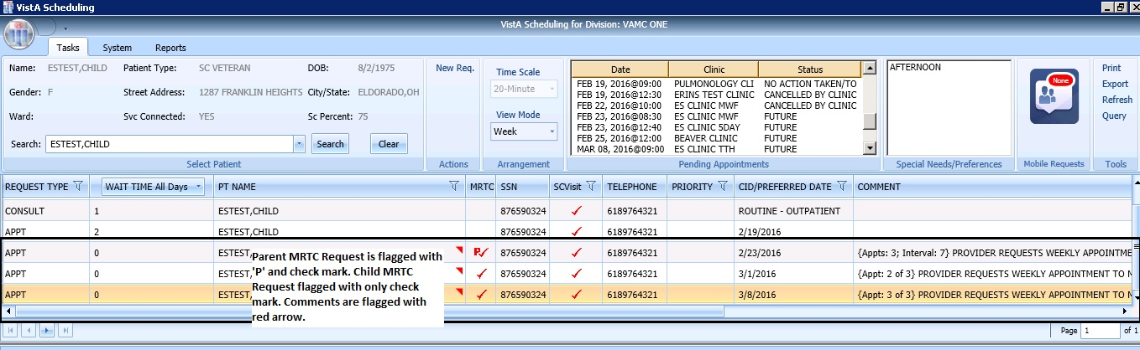

Figure 149: MRTC Requests displayed in Request Management Grid

### Adding Multiple Appointments from Find Appointment Dialog

When Scheduler clicks **OK** in **Appointment Request Dialog** with **Multiple Appointment Required** checked**,** the **Find Appointment** dialog displays to allow Scheduler to book Multiple Appointments at one time.

1. In the Find Appointment dialog the following information is displayed:

* **Calendar** in upper left corner. The CID/Preferred date entered in Appointment Request is highlighted.
* The **Clinic** is defaulted in drop down field from Appointment Request in Resources Section in the upper middle pane of Find Appointment dialog. This field is editable and Clinics can be switched between appointments as needed.
* Patient’s **Time of Day** and **Day of Week** preferences are defaulted in upper right pane of Find Appointment dialog. These can be edited/adjusted as needed.
* The CID/Preferred date entered in Appointment Request is displayed under the Time of Day and Day of Week preferences in Find Appointment dialog with tag labeled **Original CID:**. This is data not editable.
* **Search** button is available if availability needs recalculated due to date or clinic changes.
* **Multiple Appointment Required** information is defaulted from Appointment Request in middle of Find Appointment dialog. This information is not editable.
* **CID** drop down displays list of unbooked appointment dates. These dates are calculated based upon the original CID/Preferred Date + Number of Appointments + Interval Between Appointments.
* For clinics with special instructions defined, the **Special Instructions Button** displays in Search Results section of Find Appointment dialog. When clicked, a Special Instruction dialog displays with the defined information available to review.
* The clinic’s **appointment length, variable length, and Max Overbook** settings display in label in Search Results section.
* In **Search Results** section, availability results display -/+ 3 Days of CID date for future dates. For current CID dates availability display Day 1 + 6 Days in Search Results field.   
  **Note:** Time of Day and Day of Week preferences limit availability results.
  + Book Column allows Scheduler to select time slot for booking appointment.
  + Start Time Column displays start time of time slot.
  + End Time Column displays end time of time slot.
  + Resource Column displays name of Clinic currently selected.
  + Slots Column displays available time slot count. Slots available for overbooking display based upon the Scheduler’s security key allowances.

**Note:** Time Slots do not display if no availability is defined for that time period for the clinic or overbooking has been reached beyond the Scheduler’s security key allowances.

* **Number of Available Slots**: Count displays at bottom of Find Appointment dialog notifying Scheduler how many slots are displaying as available for the selected CID date.
* **Next** and **Book** buttons are disabled until first Time Slot(s) is selected for booking.

1. Select time slot in Booking Column.   
   **Note:** If Clinic DISPLAY INCREMENTS PER HOUR is defined for a count less than the defined LENGTH OF APP'T then multiple Time Slots may need to be selected to satisfy the Appointment Booking Requirements and enable the Book Button.
2. Click **Book** button.   
   **Note:** If the selected time slot has reached its defined slot count and scheduler has appropriate security keys to overbook, then a dialog displays alerting scheduler that continuing with scheduling appointment will result in overbooking the selected time slot. Scheduler can click **OK** to confirm overbooking and continue to New Appointment dialog.

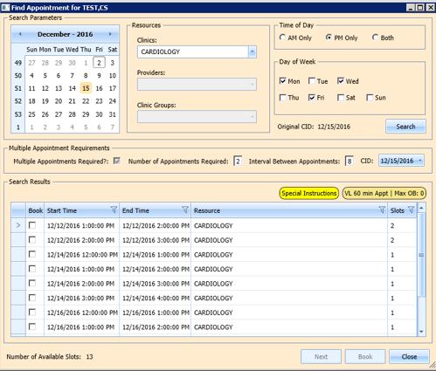

Figure 150: Find Appointment Dialog

1. New Appointment dialog displays. New Appointment dialog has one tab:

* **Appointments Tab:**
* **Patient Information Section displays** Name, DOB, SSN, SVC Connected, SC Percent, GAF (read only), and Svc Related check box**.**
* **Appointment** information section displays Start Time, Appt Type, Duration, Clinic and Notes (Appointment Start Time; Duration on for appointments to VL Clinics; and Notes are editable fields).
* **Appointment Conflicts** section displays any appointments already scheduled that conflict with appointment being added.

1. Confirm information in New Appointment dialog and add any applicable text to Notes section. Click **OK**.
2. Print Letter? Dialog displays. Click **OK** to Print the Patient Letter. Click **Cancel** to close dialog and not print Patient Letter.
3. Closing Request dialog displays “This request will be closed.”
4. Click **OK**.
5. First MRTC Appointment is booked. CID date in Find Appointment dialog changes to next appointment date in series. MRTC Booking Status dialog displays to track appointments as they are booked. An arrow points to date in MRTC Series that is being booked and automatically updates as appointments are completed. The following information displays in the MRTC Booking Status dialog:

* CID Date—Calculated by first booked appointment date and Interval Requested.
* Appointment Date—date selected when booking appointments.
* Resource—Clinic name where appointment was booked.

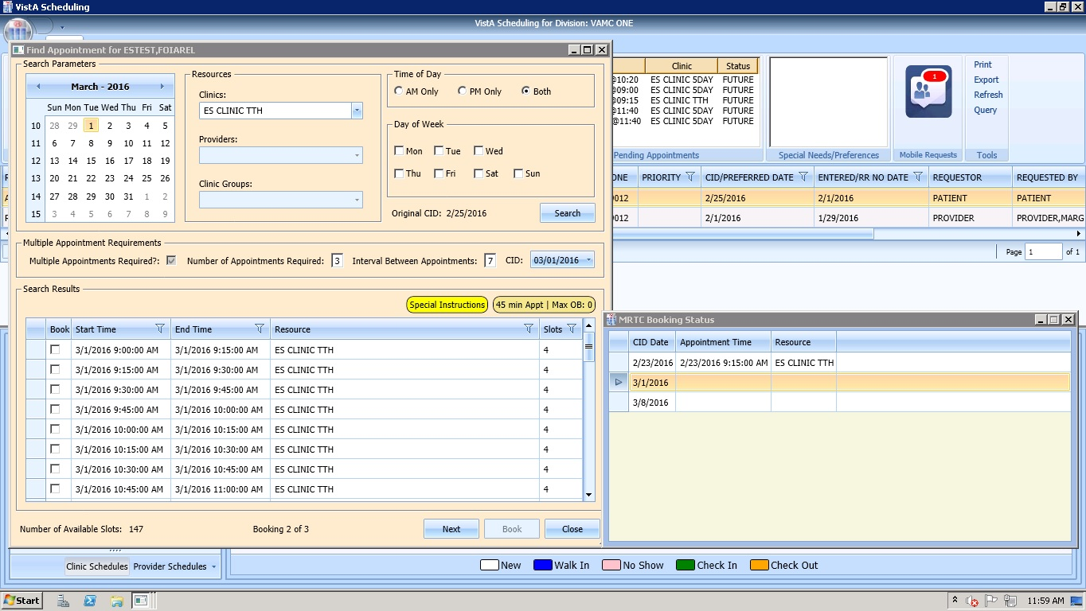

Figure 151: Find Appointment Dialog and MRTC Booking Status Dialog

1. Select time slot for second MRTC appointment in series.
2. Click **Book**.
3. New Appointment dialog displays.
4. Confirm information in New Appointment dialog and add any applicable text to Notes section. Click **OK**.
5. Print Letter? Dialog displays. Click **OK** to Print the Patient letter. Click **Cancel** to close dialog and not print Patient Letter.
6. Closing Request dialog displays “This request will be closed.”
7. Click **OK**.
8. Second MRTC Appointment is booked. CID date in Find Appointment dialog changes to next appointment date in series. Appointment date is added in MRTC Booking Status dialog for second appointment and arrow progress to next appointment (if applicable).
9. Once all MRTC Appointments have been booked for the series, the Closing Request dialog displays, “The Parent MRTC Request will be closed.”
10. If a clinic has a future inactive date and the CID date falls + 3 days after the Inactivate Date, a grey label displays in the Search Results section of the Find Appointment dialog, “There are no slots available. The selected Clinic will be deactivated on {Inactivation Date}. Please select another clinic and click **Search** to complete the MRTC request.” To complete adding appointments for the series, the Scheduler needs to change to an appropriate clinic in the Resources section with availability and continue adding appointments for the remainder of the series’ requests.

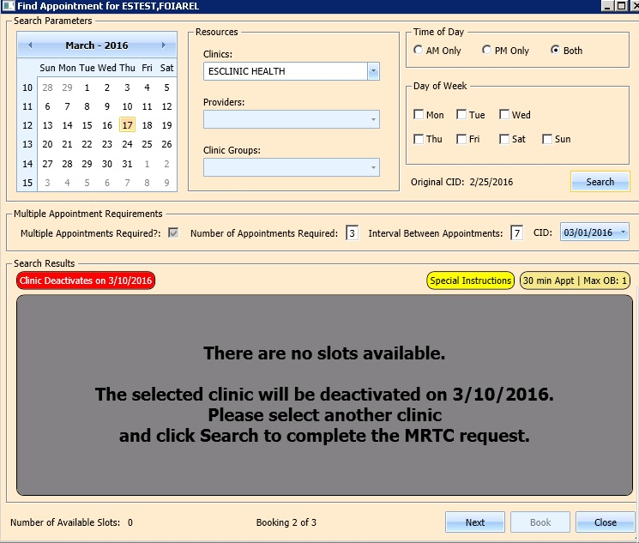

Figure 152: Future Clinic Inactivation Date

## Overbooking Appointments

Schedulers can overbook appointments based upon the following rules:

1. The Scheduler must have the SDOB security key to overbook up to the clinic’s Max OB definition. Schedulers must have the SDMOB security key to schedule beyond the clinic’s Maximum (Max) Overbook (OB) definition. Schedulers with both overbook security keys can overbook on any day that has availability defined regardless of the clinic’s Max OB definition. Schedulers cannot overbook if they are not assigned an overbooking security key.
2. The Clinic must have availability defined for the day in question. If there is no availability defined, then Schedulers will not be able to overbook appointments on that day regardless of the security key assigned to them.
3. Appointments cannot be overbooked prior to the start of the day’s clinic availability.

### Overbooking Appointments with SDMOB Security Key

Schedulers assigned the Scheduling Master Overbook security key (SDMOB) can overbook anytime outside of clinic availability from clinic start time to 11:59 pm even if the Max Overbook Limit defined for a clinic has been reached.

Perform the following steps to overbook an appointment with the SDMOB security key:

1. Log into VS GUI as a Scheduler.
2. In the **Tasks** tab display, in the **Search** text box, type the patient’s last name or patient’s first initial of last name and last 4 of SSN (e.g. S1234), click the **Search** button, and select the requested patient name. Click **Search**.
3. In the **Request Type** dialog box, select **APPT**, and then click **OK**. to create new request or click **Cancel** for existing request.

**Note:** Refer to Section 5.1.2 Adding Appointment Request for steps on adding new APPT Request.

VS GUI Request Type window

Figure 153: Request Type

1. In **Request Management** grid select **APPT** request. The Clinic Schedule Grid displays the clinic schedule based upon CID/Preferred date of request. For past dates, the clinic schedule opens defaulted to CID/Preferred date as Day 1 + 6 Days. For current date (or CID/Preferred date less than 3 days in future), the clinic schedule displays defaulted to current date as Day 1 + 6 Days. For future dates, the clinic schedule displays -/+3 days of CID/Preferred date.

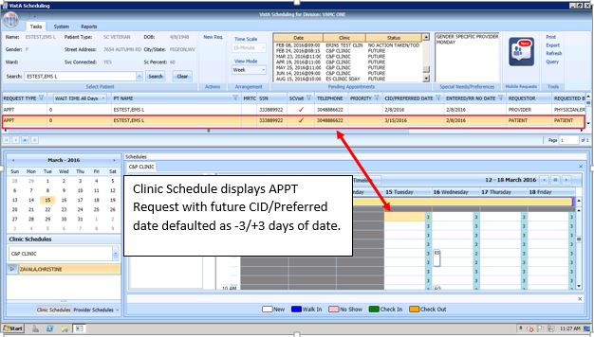

Figure 154: Clinic Schedule Display–APPT Request Future CID/Preferred Date

**Note:** For newly created APPT request, the system automatically highlights APPT request and Clinic Schedule displays.

1. In Clinic Schedule Grid, select time slot in grey that is within the clinic hours, from clinic start time to 11:59, or a date/time slot that has existing overbooks.

**Note:** Clinic Max Overbook limit displays in Clinic Day Event notes.

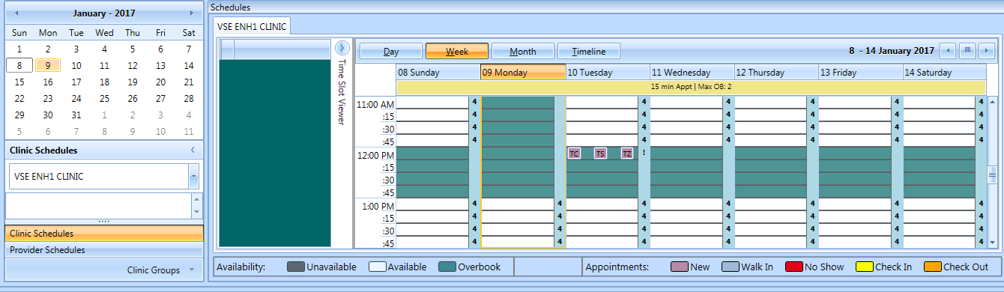

Select time slot that already has overbooked appointments beyond MO limit; or grey slot after clinic availability.

Max Overbook Limit Display for Clinic.

Figure 155: Max Overbook Limit

1. Right click in time slot. **Add Appointment** option displays.   
   **Note: Create Walk In Appointment** option is only available for selection on current date. It is not available for past or future CID/Preferred dates.  
   **Note:** Right click options do not display if selected time slot is for a day that has no availability defined or is prior to the clinic start time.



Figure 156: Appointment Right Click Options–Add Appointment

1. Select **Add Appointment**.
2. Overbook message displays.
3. Click **OK**.
4. New Appointment dialog displays as well as Patient Eligibility dialog.

* **Appointments Tab:**
* **Patient Information Section displays** Name, DOB, SSN, SVC Connected, SC Percent, GAF (read only), and Svc Related check box**.**
* **Appointment** information section displays Start Time, Appt Type, Duration, Clinic and Notes (Appointment Start Time; Duration on for appointments to VL Clinics; and Notes are editable fields).
* **Appointment Conflicts** section displays any appointments already scheduled that conflict with appointment being added.

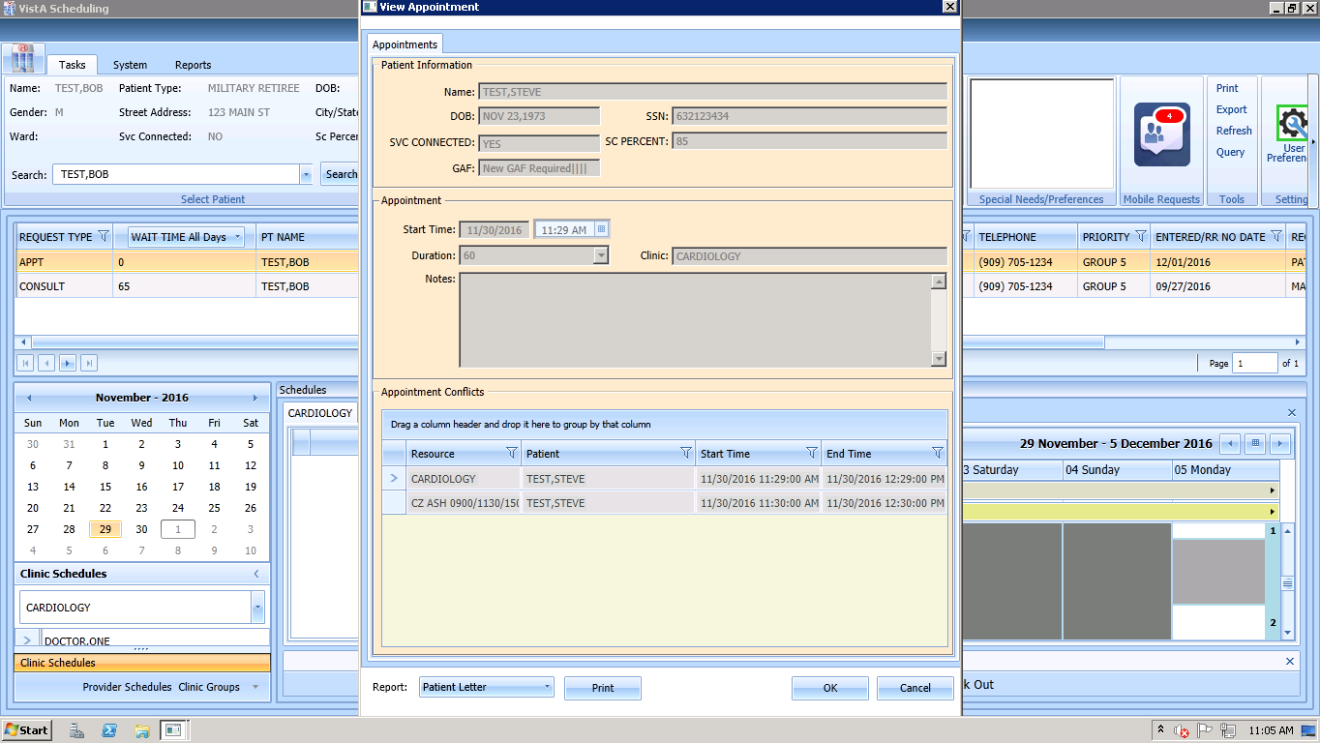

Figure 157: New Appointment Dialog – Appointments

1. Add any applicable **Notes** to appointment. Click **OK**.
2. Print Letter? Dialog displays. Click **OK** to send Letter to patient. Click **Cancel** to not send letter.



Figure 158: Print Letter? Dialog

1. Closing Request dialog displays. Click **OK**.



Figure 159: Closing Request Dialog

1. APPT Request is removed from Patient Request Management Grid. Next request for patient is moved up and highlighted.
2. Clinic Schedule closes.
3. New appointment displays in Pending Appointment Window in Ribbon Bar.
4. Select appointment from the Pending Appointment window to view it in the Clinic Schedule Grid. The clinic schedule opens. For past dates, the clinic schedule opens defaulted to appointment date. For current date (or appointment date less than 3 days in future), the clinic schedule displays defaulted to current date. For future dates, the clinic schedule displays -/+3 days of appointment date.
5. Overbook count increases in Clinic Schedule time slot and in Time Slot Viewer. If the appointment count has filled the time slot, a hover window displays showing the slot count.

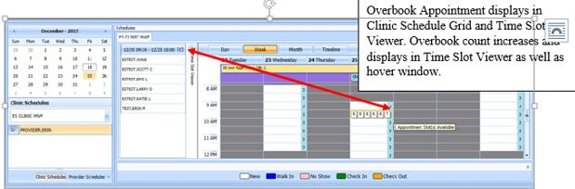

Figure 160: Clinic Schedule Display--Overbook Appointment

### Overbooking Appointments with SDOB Security Key

Schedulers assigned the Scheduling Overbook, SDOB, Security Key can overbook outside of clinic availability from clinic start time to 11:59pm. They cannot overbook past the Max Overbook Limit defined for a clinic.

Perform the following steps to overbook an appointment with the SDOB security key:

1. Log into VS GUI as a Scheduler.
2. In the **Tasks** tab display, in the **Search** text box, type the patient’s last name or patient’s first initial of last name and last 4 of SSN (e.g. S1234), click the **Search** button, and select the requested patient name. Click **Search**.
3. In the **Request Type** dialog box, select **APPT** and then click **OK** to create new request or click **Cancel** for existing request.

**Note:** Refer to Section 5.1.2 Adding Appointment Request for steps on adding new APPT Request.

VS GUI Request Type window

Figure 161: Request Type

1. Select APPT request in the **Request Management** Grid. The Clinic Schedule Grid displays the clinic schedule based upon CID/Preferred date of request. For a past date, clinic schedule opens defaulted to CID/Preferred date as Day 1 + 6 days. For a current date (or CID/Preferred date less than 3 days in future), the clinic schedule displays defaulted to current date as Day 1 + 6 days. For future dates, the clinic schedule displays -/+3 days of CID/Preferred date.

**Note:** For newly created APPT request the system automatically highlights the APPT request and the Clinic Schedule displays.

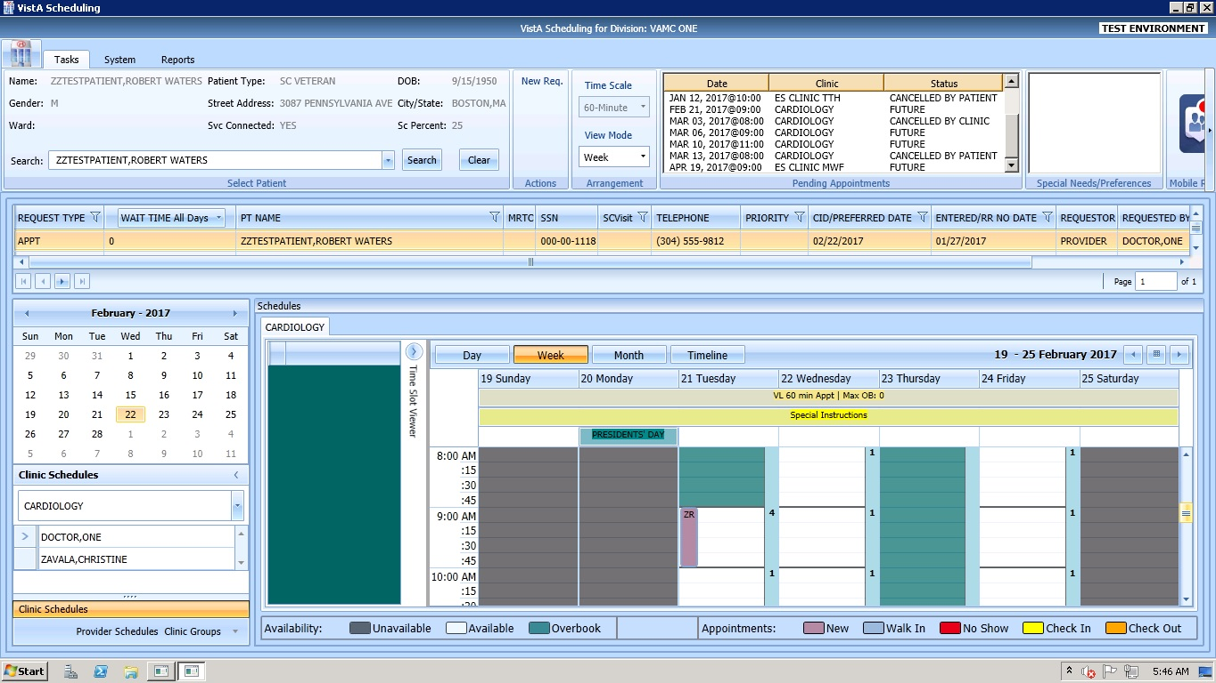

Figure 162: Clinic Schedule Display–APPT Request Future CID/Preferred Date

In Clinic Schedule Grid, select time slot in teal that is within the clinic hours, close of clinic hours to 11:59, or a date that does not already have existing overbooks. **Note:** Clinic Max Overbook limit displays in Clinic Day Event notes.

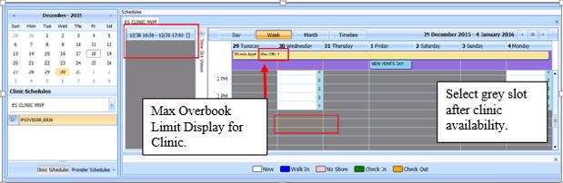

Figure 163: Overbook After Hours Time Slot

1. Right click in time slot. Add Appointment option displays. The Create Walk In Appointment option is only available for selection on current date. It is not available for past or future CID/Preferred dates.   
     
   **Note:** Right click options do not display if selected time slot is for a day that has no availability defined, is prior to the clinic start time, or the Max Overbook limit has been met for the day.



Figure 164: Appointment Right Click Options–Add Appointment

1. Select **Add Appointment**.
2. Overbook message displays.

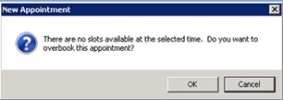

Figure 165: Overbook Confirmation Dialog

1. Click **OK**.
2. New Appointment dialog displays as well as Patient Eligibility dialog.

* **Appointments Tab:**
* **Patient Information Section displays** Name, DOB, SSN, SVC Connected, SC Percent, GAF (read only), and Svc Related check box**.**
* **Appointment** information section displays Start Time, Appt Type, Duration, Clinic and Notes (Appointment Start Time; Duration on for appointments to VL Clinics; and Notes are editable fields).
* **Appointment Conflicts** section displays any appointments already scheduled that conflict with appointment being added.



Figure 166: New Appointment Dialog

1. Add any applicable Notes to appointment. Click **OK**.
2. Print Letter? Dialog displays. Click **OK** to print Patient Letter. Click **Cancel** to exit dialog and not print Patient Letter.



Figure 167: Print Letter? Dialog

1. Closing Request dialog displays. Click **OK**.



Figure 168: Closing Request Dialog

1. APPT Request is removed from the Patient Request Management Grid. Next request for patient is moved up and highlighted.
2. Clinic Schedule closes.
3. New appointment displays in Pending Appointment Window in Ribbon Bar.
4. Select appointment from the Pending Appointment window to view it in the Clinic Schedule Grid. The clinic schedule opens. For past dates, the clinic schedule opens defaulted to appointment date. For current date (or appointment date less than 3 days in future), the clinic schedule displays defaulted to current date. For future dates, the clinic schedule displays -/+3 days of appointment date.
5. Overbook count increases in clinic schedule time slot and in Time Slot Viewer. If the appointment count has filled the time slot, a hover window displays showing the slot count.

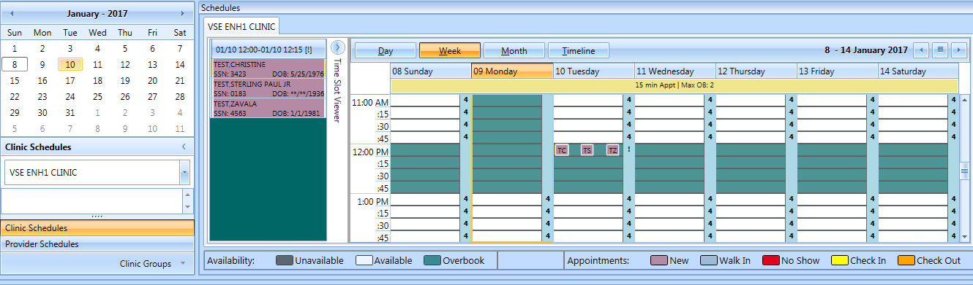

Clinic Schedule Grid displays in teal for after hours and Overbook count displays in the Clinic Schedule Grid on the correct slot as well as the Time Slot Viewer.

Figure 169: Clinic Schedule Display–Overbook Appointment After Hours

## Variable Length Appointment

Scheduling appointments can typically be done in fixed length intervals based upon the clinic definitions. However, a clinic can be setup as a variable length clinic, allowing a user to schedule an appointment for an extended amount of time as needed rather than scheduling multiple appointments.

### Identifying a Variable Length Clinic

In order to identify if a clinic is set up for variable length scheduling, perform the following steps:

1. Log on to VS GUI.
2. From Clinic Schedules, search and select clinic by typing clinic name (6 character minimum) or by typing clinic abbreviation (4 character minimum).

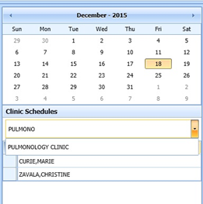

Figure 170: Clinic Schedules–Clinic Search

1. The selected clinic’s schedule displays defaulted to current date as Day 1 + 6 days.

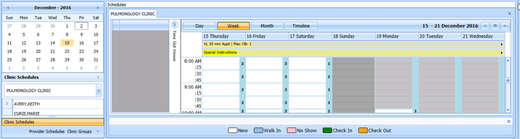

Figure 171: Clinic Schedule Grid

1. To confirm clinic is able to book variable length appointments, view the All Day Event Bar in Clinic Schedule Grid. A label displays the clinic’s defined appointment length and max overbooking limit. If the clinic is designated as a variable length clinic, the letters “VL” display before the appointment length.

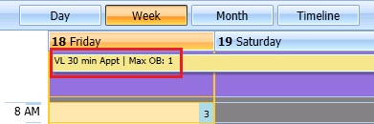

Figure 172: Variable Length Indicator

### Add a Variable Length Appointment

Perform the following steps to add a Variable Length Appointment:

1. In the clinic schedule, select the time slot that the appointment shall begin at.
2. Right click and select **Add Appointment**. The New Appointment dialog displays.

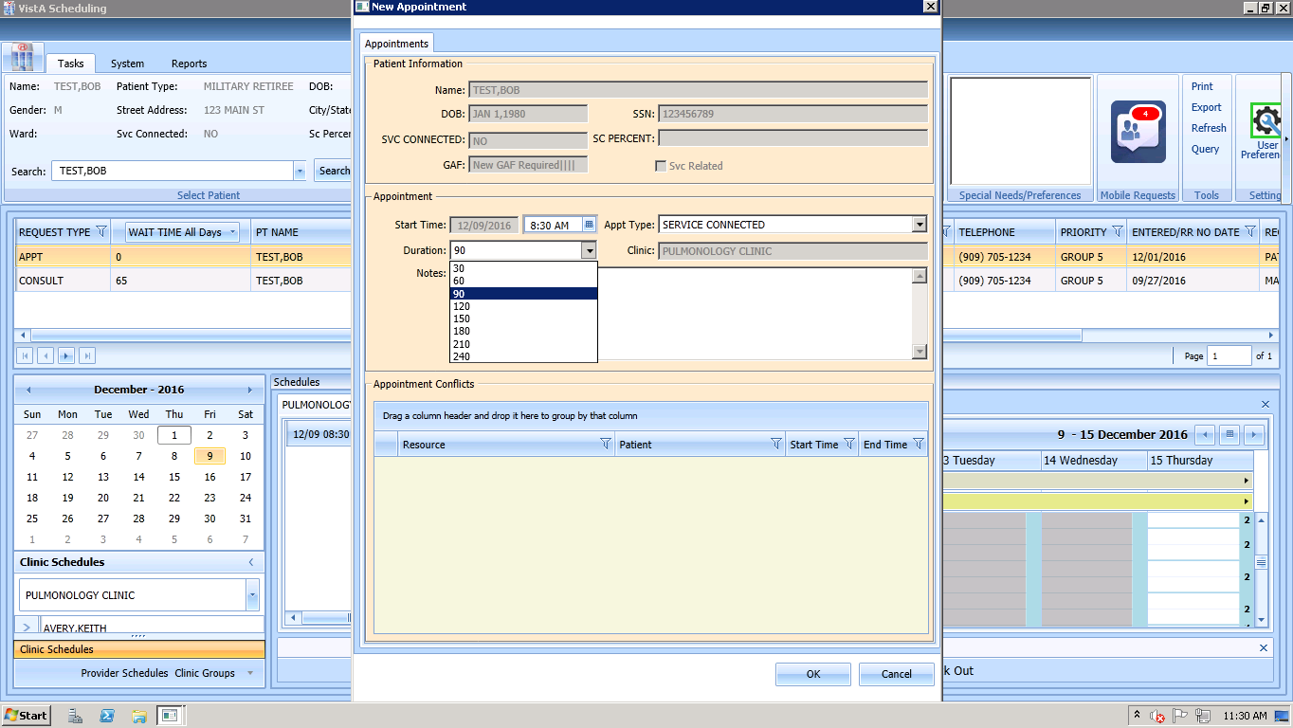

Figure 173: New Appointment Dialog

1. Select the Duration drop down box and select the appropriate duration of appointment.

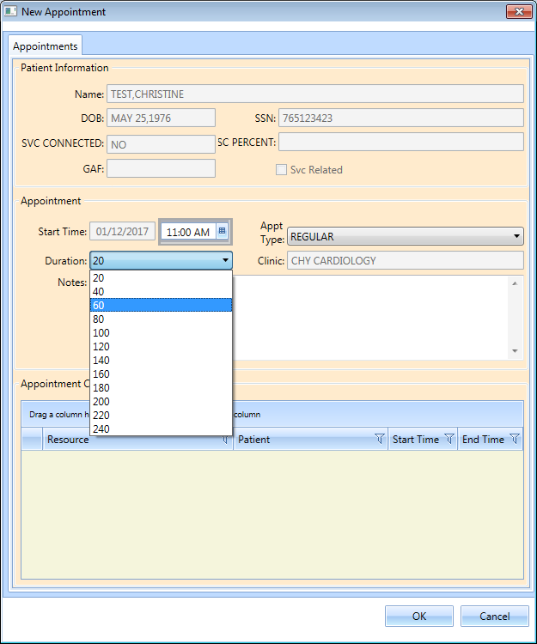

Figure 174: Clinic Schedule Display–Multiple Time Slot Selected

1. The New Appointment dialog box appears. Confirm that the appointment duration reflects the correct amount of time.

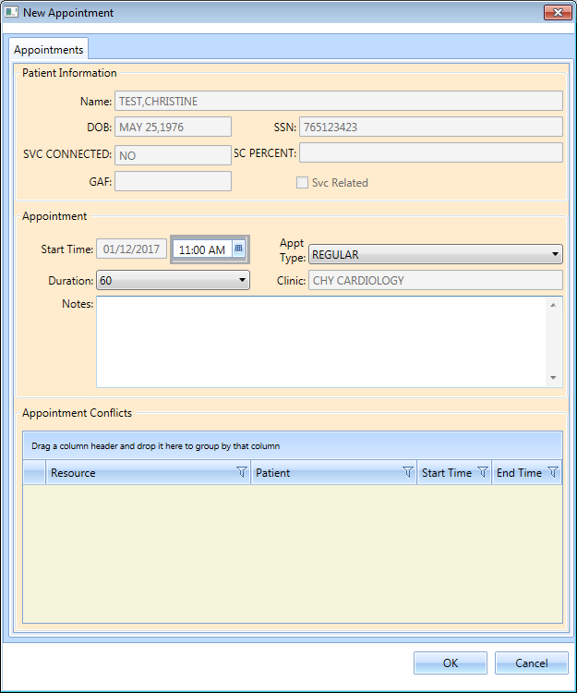

Figure 175: New Appointment Dialog–Variable Length Appointment Duration

1. Click **OK**. The Print Letter? dialog box displays.
2. Click **Cancel**. The Closing Request dialog box displays “This request will be closed”.
3. Click **OK**. New appointment displays in Pending Appointment window.
4. Select appointment from Pending Appointment window. Clinic Schedule displays with booked appointment spanning two time slots, indicating a variable length appointment.

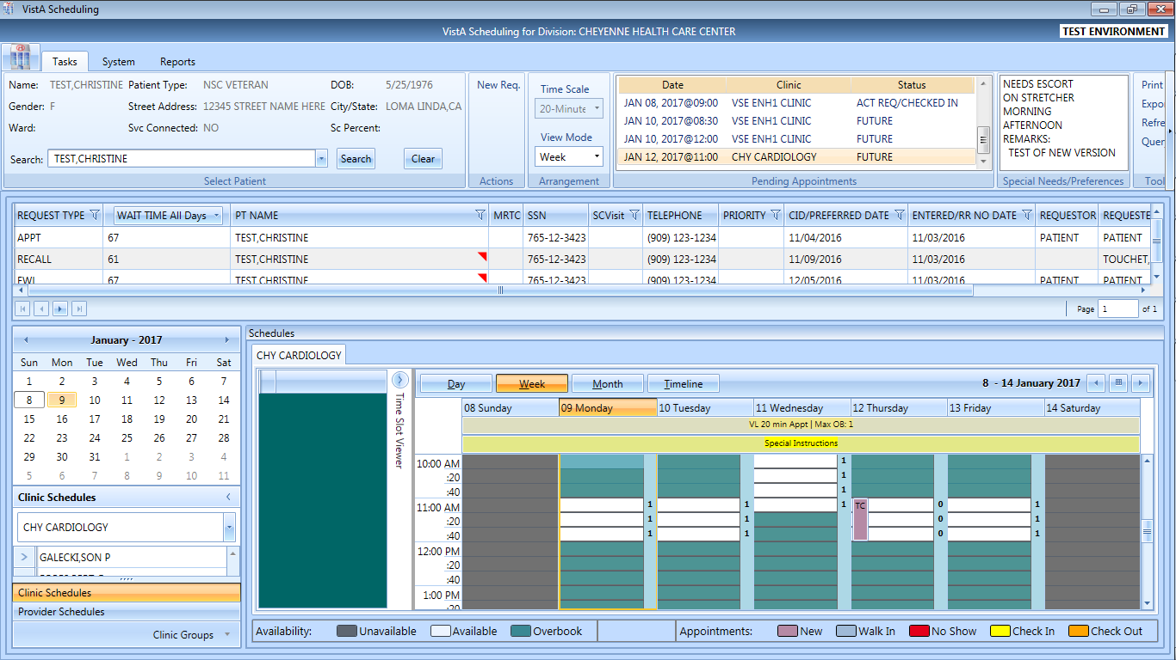

Figure 176: Clinic Schedule Display–Appointment Length Extended

## Compensation and Pension (C&P) Appointments

### Adding Compensation & Pension APPT Request

1. Log into VS GUI.
2. In the Tasks tab display, type the patient’s last name, first name in the Search text box, click the **Search** button, and then select the requested patient name from drop down list.
3. Select APPT Request Type.
4. Complete APPT Request dialog. Refer to Section 5.1.2 Adding Appointment Request for instructions on completing APPT Request dialog.
5. Select appropriate Clinic for Compensation and Pension appointment.
6. Enter CID/Preferred Date.
7. In Appointment Type drop down, select Compensation & Pension.
8. Click **OK**.
9. APPT Request is displayed in patient’s Request Management Grid.

### Add Compensation & Pension Appointment for Pending 2507 Request NOT Previously Linked to Appointment

1. Log into VS GUI.
2. In the **Tasks** tab display, in the **Search** text box, type the patient’s last name or patient’s first initial of last name and last 4 of SSN (e.g. S1234), click the **Search** button, and select the requested patient name. Click **Search**.
3. In Request Type click **Cancel**.
4. In Request Management Grid, select pending C&P APPT Request.
5. In Clinic Schedule Grid, left click open time slot.
6. Right click, select **Add Appointment**.   
   **Note:** Create Walk-In Option is available if current day is selected in Clinic Schedule.
7. New Appointment dialog displays.
8. Confirm Appointment Type is listed as Compensation & Pension. If not, select from drop down list.
9. Add any applicable appointment information to Notes section.
10. Click **OK**.
11. Dialog displays:

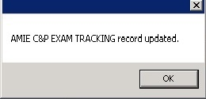

Figure 177: AMIE C&P EXAM TRACKING Record Updated

**Note:** If patient did NOT have pending 2507 Request on file a dialog displays:

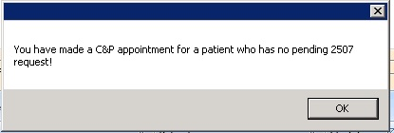

Figure 178: C&P Appointment for Patient with No Pending 2507 Request

1. Click **OK**.
2. Print Letter? Dialog displays.
3. Click **OK** to print Patient Letter. Click **Cancel** to exit out of dialog and not print patient letter.
4. Closing Request Dialog displays:

“This request will be closed."

1. Click **OK**.
2. New C&P Appointment displays in Pending Appointment window. AMIE Tracking Link is updated.

### Add Compensation & Pension Appointment for Pending 2507 Request Already Linked to Appointment NOT Due to Cancellation

1. Log into VS GUI.
2. In the Tasks tab display, type the patient’s last name, first name in the Search text box, click the **Search** button, and then select the patient name with pending C&P APPT Request from drop down list.
3. In Request Type click **Cancel**.
4. In Request Management Grid, select pending C&P APPT Request.
5. In Clinic Schedule Grid left click open time slot.
6. Right click, select **Add Appointment**.   
   **Note:** Create Walk-In Option is available if current day is selected in Clinic Schedule.
7. New Appointment dialog displays.
8. Confirm Appointment Type is listed as Compensation & Pension. If not, select from drop down list.
9. Click **OK**.
10. Comp & Pension Requests dialog displays with the following information:

* Name: Veteran name
* Request Date: Date 2507 Request created

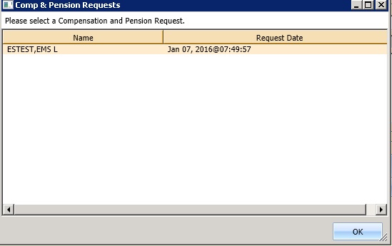

Figure 179: Comp & Pension Requests Dialog

1. Select appropriate 2507 Request from list.
2. Click **OK**.
3. Comp & Pension Request displays with option to select Yes or No:

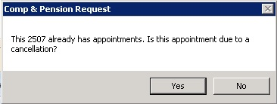

Figure 180: Comp & Pension Request Due to Cancellation Dialog

1. Click **No**.
2. Dialog displays:



Figure 181: AMIE C&P EXAM TRACKING Record Updated

1. Click **OK**.
2. Print Letter? Dialog displays.
3. Click **OK** to print Patient Letter. Click **Cancel** to exit out of dialog and not print Patient Letter.
4. Closing Request dialog displays: “This request will be closed.”
5. New C&P Appointment displays in Pending Appointment Window. AMIE Tracking Link is updated.

### Add Compensation & Pension Appointment for Pending 2507 Request due to Clinic Cancellation

1. Log into VS GUI.
2. In the **Tasks** tab display, in the **Search** text box, type the patient’s last name or patient’s first initial of last name and last 4 of SSN (e.g. S1234), click the **Search** button, and select the requested patient name. Click **Search**.
3. In Request Type click **Cancel**.
4. In Request Management Grid, select pending C&P APPT Request.
5. In Clinic Schedule Grid, left click open time slot.
6. Right click time slot, select Add Appointment.   
   **Note:** Create Walk-In Option is available if current day is selected in Clinic Schedule.
7. New Appointment dialog displays.
8. Confirm Appointment Type is listed as Compensation & Pension. If not, select from drop down list.
9. Click **OK**.
10. Comp & Pension Requests dialog displays with the following information:

* Name: Veteran name
* Request Date: Date 2507 Request created



Figure 182: Comp & Pension Requests Dialog

1. Select appropriate 2507 Request from list.
2. Click **OK**.
3. Comp & Pension Request displays with option to select Yes or No:



Figure 183: Comp & Pension Request Due to Cancellation Dialog

1. Click **Yes**.
2. Comp & Pension Appointment Links dialog displays with the following information and OK or Cancel is available to select with the following information:

* Initial Appointment Date
* ClockStop Appointment Date
* Current Appointment Date
* Clinic Name

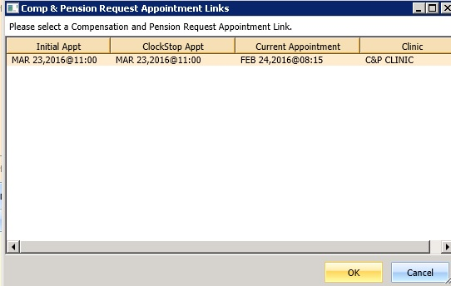

Figure 184: Comp & Pension Request Appointment Links Dialog

1. Click **OK**.

**Note:** If Scheduler clicks **Cancel** instead of OK, the following dialog displays:

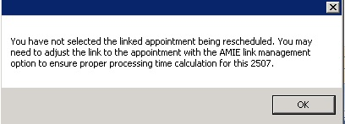

Figure 185: C&P Appt Links Due to Veteran Cancellation or No Show

1. C&P Appt Links dialog displays with option to select Yes or No:

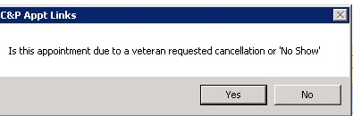

Figure 186: Comp & Pension Due to Cancellation Dialog

1. Click **No**.
2. Dialog displays:

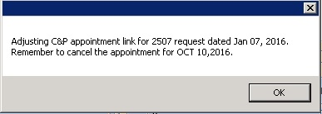

Figure 187: C&P Appointment Link Adjustment Dialog

1. Click **OK**.
2. Print Letter? Dialog displays.
3. Click **OK** to print Patient Letter. Click **Cancel** to exit out of dialog and not print Patient Letter.
4. Closing Request dialog displays: “This request will be closed.”
5. New C&P Appointment displays in Pending Appointment Window. AMIE Tracking Link is updated.

**Note:** Previous appointment linked to 2507 Request must be manually dispositioned.

### Add Compensation & Pension Appointment for Pending 2507 Request due to Veteran Cancellation/No Show

1. Log into VS GUI.
2. In the **Tasks** tab display, in the **Search** text box, type the patient’s last name or patient’s first initial of last name and last 4 of SSN (e.g. S1234), click the **Search** button, and select the requested patient name. Click **Search**.
3. In Request Type click **Cancel**.
4. In Request Management Grid, select pending C&P APPT Request.
5. In Clinic Schedule Grid, left click open time slot.
6. Right click time slot, select **Add Appointment**.   
   **Note**: Create Walk-In Option is available if current day is selected in Clinic Schedule.
7. New Appointment dialog displays.
8. Confirm Appointment Type is listed as Compensation & Pension. If not, select from drop down list.
9. Click **OK**.
10. Comp & Pension Requests dialog displays with the following information:

* Name: Veteran name
* Request Date: Date 2507 Request created



Figure 188: Comp & Pension Request Dialog

1. Select appropriate 2507 Request from list.
2. Click **OK**.
3. Comp & Pension Request displays with option to select Yes or No:



Figure 189: Comp & Pension Request Due to Cancellation Dialog

1. Click **Yes**.
2. Comp & Pension Appointment Links dialog displays with the following information:

* Initial Appointment Date
* ClockStop Appointment Date
* Current Appointment Date
* Clinic Name



Figure 190: Comp & Pension Request Appointment Links Dialog

1. Click **OK**.

**Note:** If Scheduler clicks **Cancel** instead of OK, the following dialog displays:



Figure 191: Comp & Pension Canceled Appointment Links Dialog Warning

1. C&P Appt Links dialog displays with option to select Yes or No:



Figure 192: C&P Appt Links Due to Veteran Cancellation or No Show

1. Click **Yes**.
2. Dialog displays:



Figure 193: AMIE C&P EXAM TRACKING Record Updated

1. Click **OK**.
2. Print Letter? Dialog displays.
3. Click **OK** to print Patient Letter. Click **Cancel** to exit out of dialog and not print Patient Letter.
4. Closing Request dialog displays: “This request will be closed.”
5. New C&P Appointment displays in Pending Appointment Window. AMIE Tracking Link is updated.

**Note:** Previous appointment linked to 2507 Request must be manually dispositioned.

### Disposition Appointment Linked to Pending 2507 Request

1. Log into VS GUI.
2. In the **Tasks** tab display, in the **Search** text box, type the patient’s last name or patient’s first initial of last name and last 4 of SSN (e.g. S1234), click the **Search** button, and select the requested patient name. Click **Search**.
3. In Request type click **Cancel**.
4. In Pending Appointment Window, select pending C&P Appointment linked to pending 2507 Request.
5. In Clinic Schedule Grid, left click appointment.
6. Right click and the following options are available to select:

* Edit Appointment
* View Appointment
* Cancel Appointment

1. Select **Cancel Appointment**.
2. Cancel Appointment dialog displays. See section 6.2.3 for detailed instructions on completing Cancel Appointment dialog.
3. Select **Appointment Cancelled By**.
4. Select **Reason for Cancellation**.
5. Edit CID/Preferred Date if applicable.
6. Enter Remarks.
7. Click **OK**.
8. Dialog displays:

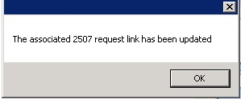

Figure 194: C&P Cancel Appointment Associated 2507 Request Updated

**Note:** If C&P appointment was NOT linked to 2507 request, the following message displays in dialog:

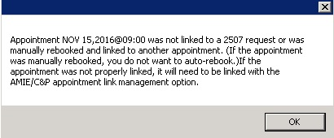

Figure 195: C&P Cancel Appointment NOT linked to Pending 2507 Request

1. Click **OK**.
2. Appointment status is updated in Pending Appointment Window. Appointment is removed from Clinic Schedule. AMIE Link is updated.

## Veteran Appointment Request Scheduling

The Veteran Appointment Request (VAR) Interface provides an interface between the VS GUI and the VAR appointment request database, including:

* Link the appointment requested in VAR and processed in VistA so that the state of the appointment in VistA (e.g., cancelled, checked out) can be displayed in the GUI application.
* View appointment requests within the GUI.
* Communicate or message the Veteran from within the GUI up to a limit of four times.
* Close out requests from within the GUI.

VAR requests are displayed on the **Tasks** tab display in the **Mobile Requests** section. A counter, showing the number of pending mobile requests, also displays in the section.

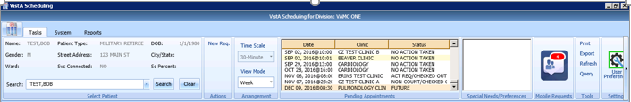

Figure 196: Mobile Requests

### Scheduling a Mobile Request

Perform the following steps to schedule a mobile request.

1. In the **Tasks** tab display, click on the **Mobile Requests** button. The Mobile Request List displays.

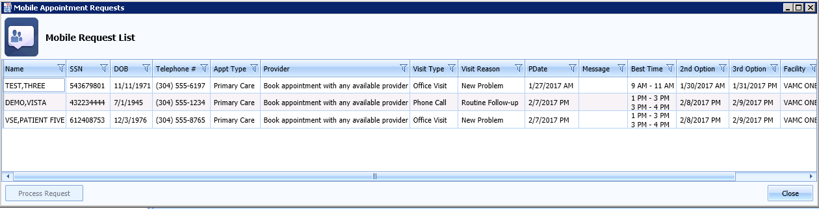

Figure 197: Mobile Request List

1. Click on the mobile request and select **Process Request**. This locks the request, so that other schedulers cannot work on the request at the same time. It remains open until the APPT request is created or an appointment cannot be booked.

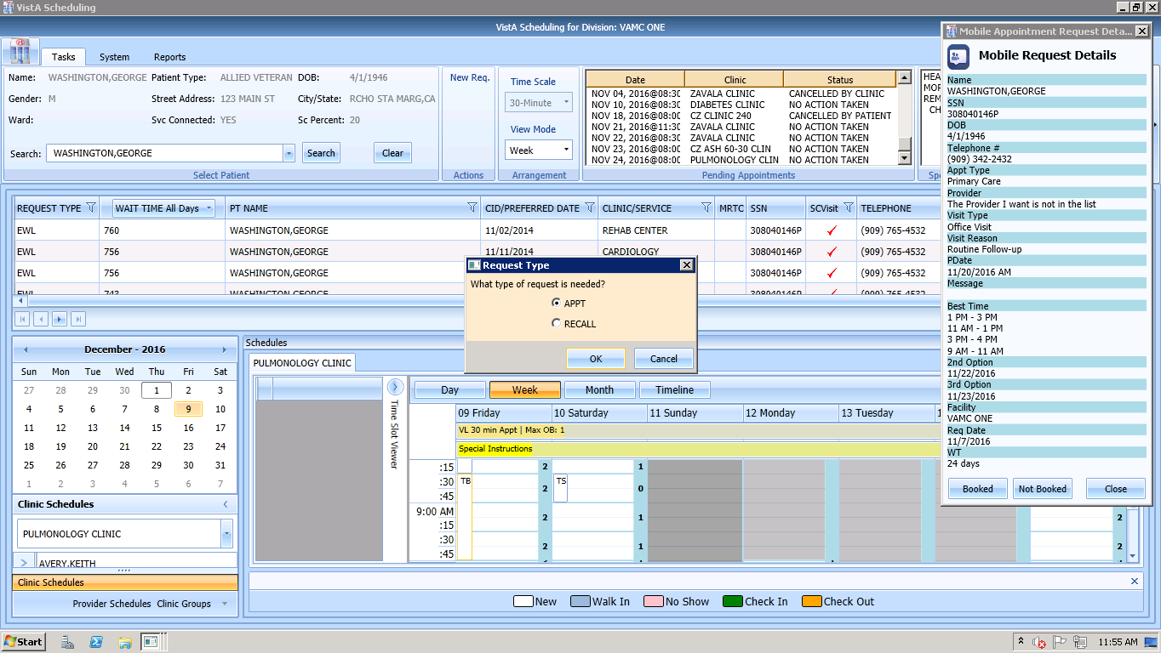

Figure 198: Mobile Request Selected

1. The primary date selected by the Veteran defaults to the CID/Preferred date in the request. The AM/PM selection defaults to the Time of Day in APPT Request dialog.
2. Once completed, the appointment request displays as a VETERAN Request in the Request Management Grid. The Clinic Schedule displays -/+ 3 days for future CID/Preferred dates.
3. If the selected clinic has availability that meets the Veteran Request requirements, the user can schedule the appointment by right clicking and selecting **Add Appointment** in the available time slot in Clinic Schedule Grid.
4. The New Appointment dialog displays. The user can click **OK** and complete the appointment booking.
5. If the request is scheduled, click **Booked** in the **Mobile Request Details** window. The request is removed from the Mobile Request List and the user can send a **Booked** message to the Veteran.
6. If the request cannot be scheduled, click **Not Booked**. A Request Not Available dialog displays, allowing the user to send a **Not Booked** message to the Veteran.

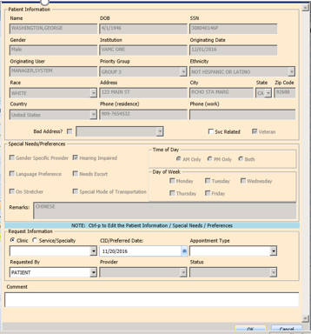

Figure 199: Veteran APPT Request

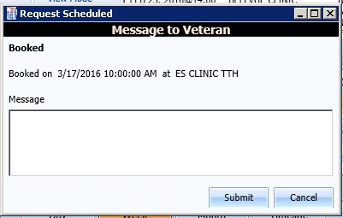

Figure 200: Message to Veteran Dialog

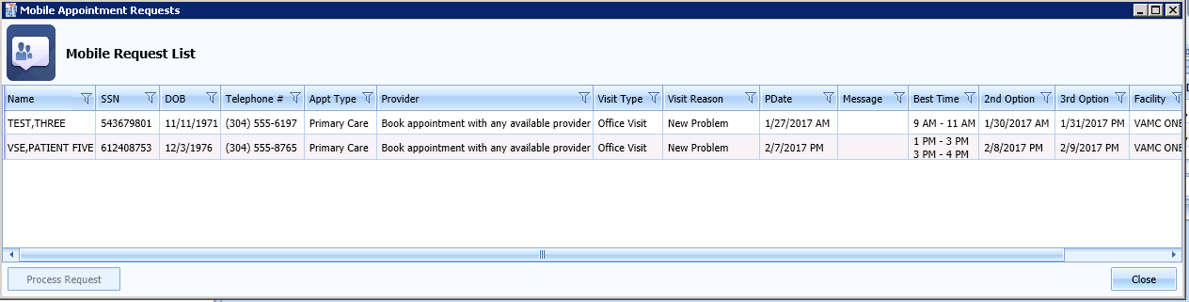

Figure 201: Mobile Request Removed from Grid

# Clinics

## Tasks Tab

### Viewing Clinic Schedule Availability

The VS GUI displays a consistent color visual indicator for a clinic’s workable hours including bookable holidays, non-workable hours including non-bookable holiday, clinic cancellation, and no availability as follows:

Table 1: Clinic Schedule Availability

|  |  |
| --- | --- |
| **Appointment Availability Type** | **Color** |
| Available/Hours of Operation | White |
| Unavailable/ Non-workable hours during day with availability defined (i.e. clinic lunch breaks). | Grey |
| Cancelled Availability for Clinic—Partial and All Day Cancellation. | Cancelled-Grey + hash mark (\\) |
| Holiday but bookable | White |
| Holiday but NOT bookable | Grey |
| No availability defined for day (i.e. Saturday or Sunday). | Grey |
| No availability defined for the clinic | Grey |

Use the following procedure to search for a clinic and view the clinic schedule:

1. In the **Tasks** tab, from Clinic Schedules, enter a partial name of a clinic (6 characters minimum).

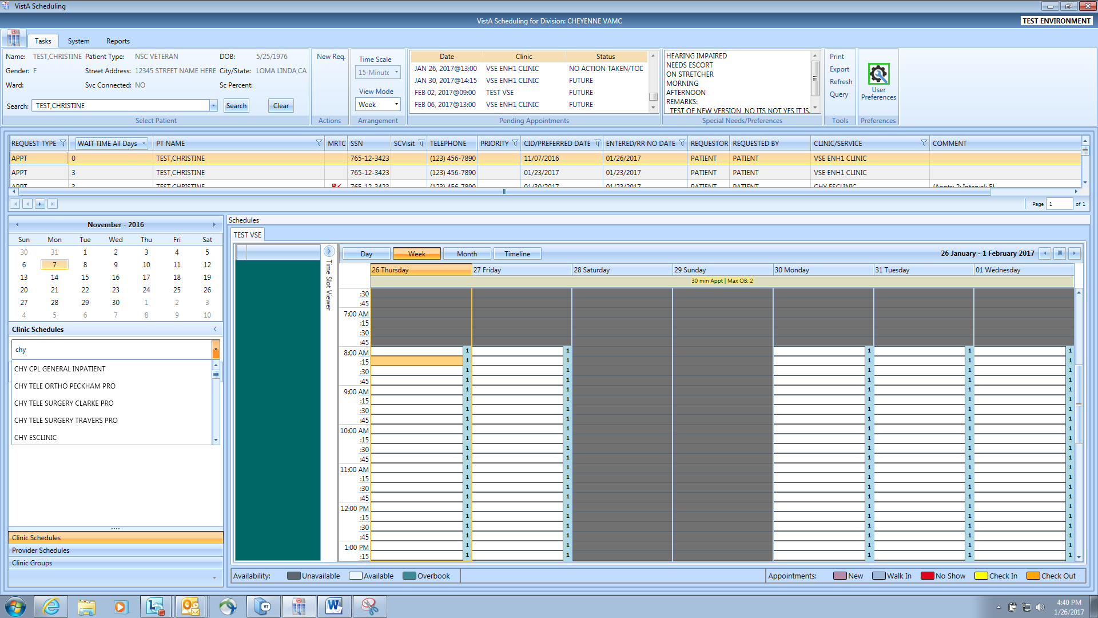

Figure 202: Clinic Schedules Search

1. Select the desired clinic from the returned list.
2. The selected clinic schedule displays.

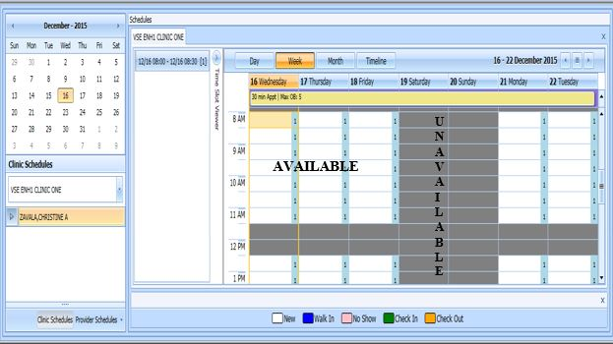

Figure 203: Clinic Schedules Display Available vs Unavailable

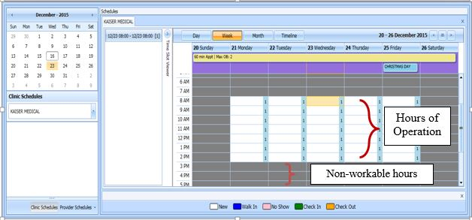

Figure 204: Clinic Schedules Display Hours of Operation

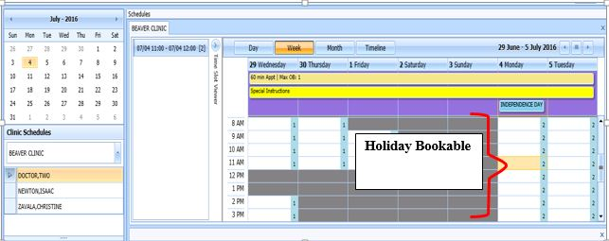

Figure 205: Clinic Schedules Display–Holiday Bookable

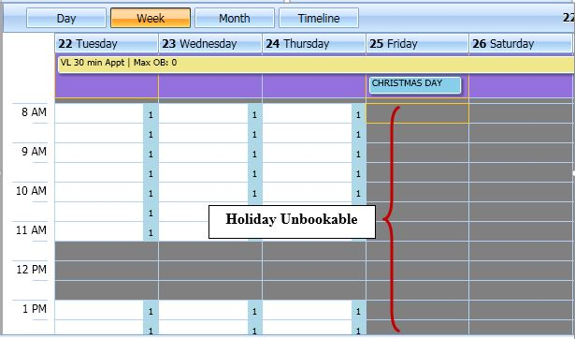

Figure 206: Clinic Schedules Display--Holiday Unbookable

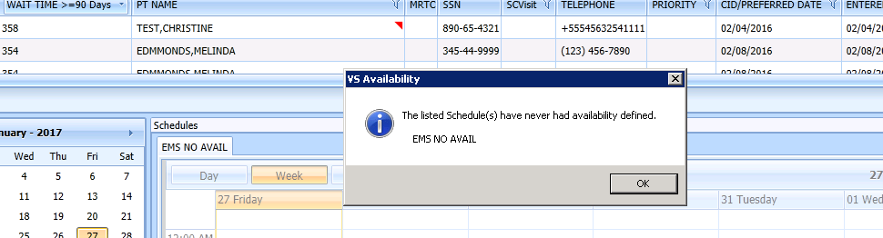

Figure 207: Clinic Schedule Display–No Availability Defined

### Viewing Clinic’s Availability Cancellation

Clinic Schedule displays full or partial day cancellation with grey + \\ over the cancelled time slots.

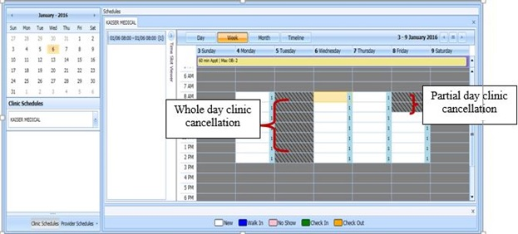

Figure 208: Clinic Schedule Display–Cancel Availability

### Viewing Clinic’s Length of Appointment and Maximum Overbook

A label in the All Day Event Bar displays Length of Appointment and Maximum Overbook values defined for the selected Clinic.

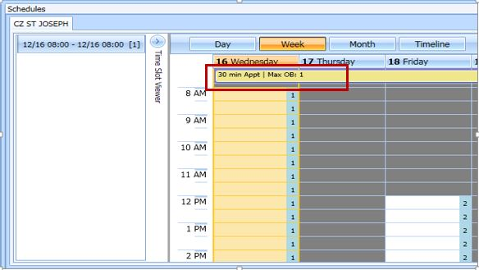

Figure 209: Appointment Length and Max Overbook Allowed

### Viewing Clinic’s Variable Length Indicator

For clinics defined as Variable Length, a flag “VL” displays before the Length of Appointment information in the All Day Event Bar in the Clinic Schedule Grid.   
  
**Note:** Refer to Section 6.5.2 on How to Add Variable Length Appointment.

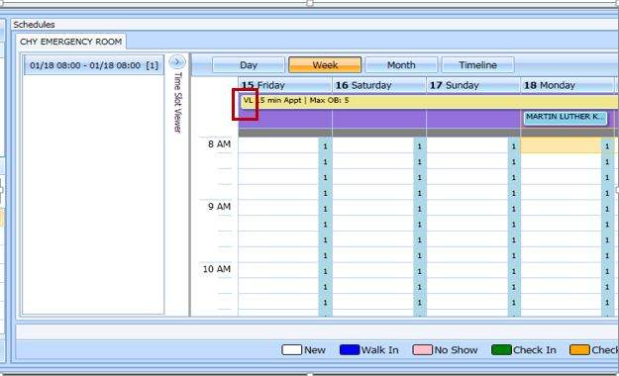

Figure 210: Variable Length Indicator

### Viewing Clinic’s Special Instructions

Use the following procedure to display a clinic’s special instructions:

1. In the **Tasks** tab, from Clinic Schedules, enter a partial name of a clinic (6 characters minimum).
2. Select the desired clinic from the returned list.
3. The selected clinic schedule displays to the user. Special Instruction Indicator displays in All Day Event Bar in Clinic Schedule.
4. Click the **Special Instructions** indicator.

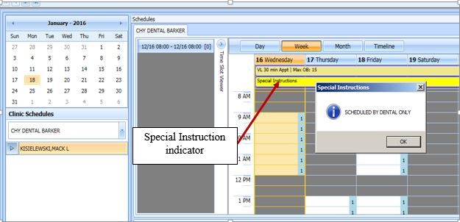

Figure 211: Special Instructions Indicator

### Viewing Clinic’s Available Slots

Time Slot Count for availability displays as follows: 0-9 and j-z --denote available slots where j=10,k=11...z=26. Upper Case Letters A-W denote overbooks, with A being the first slot to be overbooked and B being the second for that same time, etc. Special characters *,$,!,@,# denote overbooks or appointments that fall outside of a clinic's regular hours.

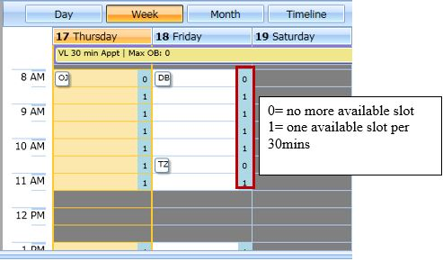

Figure 212: Time Slot Count

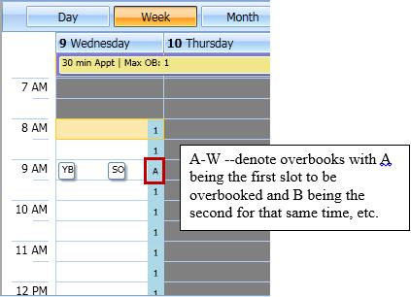

Figure 213: Overbook Time Slot Count

### Time Slot Viewer

The Time Slot Viewer displays to the left of the Clinic Schedule Grid. It displays appointment information per selected time slot. For appointments booked in the time slot, the full patient name displays in a list in the order they were added to the time slot.

1. In the **Tasks** Tab, from Clinic Schedules, enter a partial name of a clinic (6 characters minimum).
2. Select the desired clinic from the returned list.
3. The selected clinic schedule displays.  
   **Note:** Time Slot Viewer can be expanded or minimized in Clinic Schedule Grid.

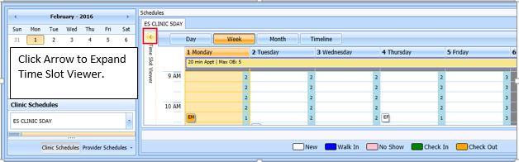

Figure 214: Minimized Time Slot Viewer

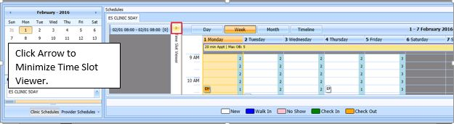

Figure 215: Expanded Time Slot Viewer

1. Selecting a time slot from the Clinic Schedule populates the Time Slot Viewer with the following information:

* Date/Time of Time Slot.
* Available slot count left for time slot.
* Patient names are listed, in the order they were booked, for any appointments scheduled in the time slot.

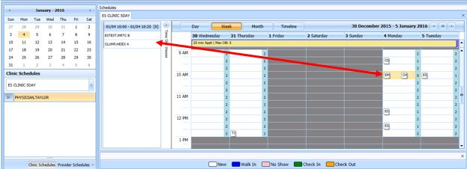

Figure 216: Time Slot Viewer Displays Slot Details

1. Appointments can be added from Time Slot Viewer.

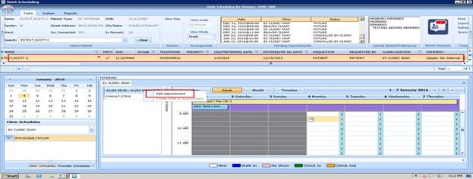

Figure 217: Time Slot Viewer Right Click Options–Add Appointment

1. For booked appointments, right click extended action options are available from Time Slot Viewer, the same as in Clinic Schedule Grid.

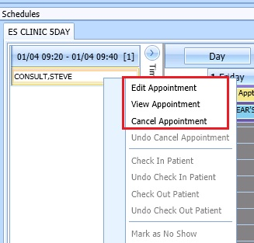

Figure 218: Time Slot Viewer Right Click–Edit, View, Cancel

1. Check In Patient from Time Slot Viewer is the same as from Clinic Schedule Grid.

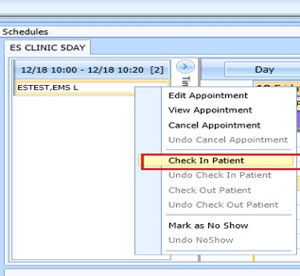

Figure 219: Time Slot Viewer–Check In Patient

1. Check Out from Time Slot Viewer is the same as from Clinic Schedule Grid.

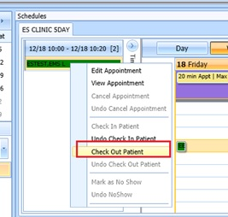

Figure 220: Time Slot Viewer–Check Out Patient

1. Mark as No Show from Time Slot Viewer the same as from Clinic Schedule Grid.

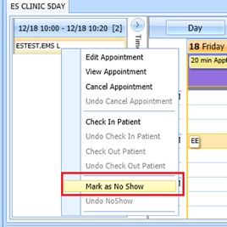

Figure 221: Time Slot Viewer–Mark as No Show

### Viewing Provider Availability

Use the following procedure to search for a provider and view the provider’s schedule.

1. In the **Tasks** tab, under the request grid calendar, select **Provider Schedules**.

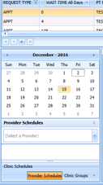

Figure 222: Provider Schedules

1. Enter a partial name of a provider (3 characters minimum). Select the desired provider from the returned drop down list.

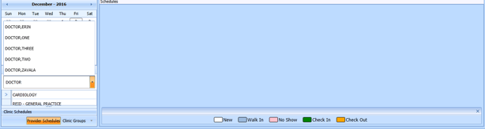

Figure 223: Provider Schedules Selection List

1. The selected provider schedule displays.

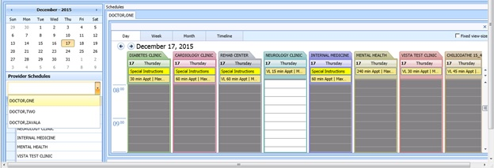

Figure 224: Provider Schedule Display

1. The provider’s availability across all clinics displays. If provider has only one clinic, that clinic’s schedule and availability appear.

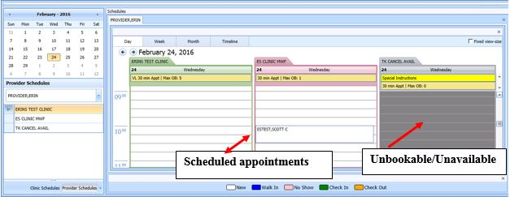

Figure 225: Provider Schedules Booked Appointments

1. Available appointment slots display as white space which Scheduler can select to add an appointment.
2. Appointments display with the name of the patient in a specific Clinic Schedule time slot.
3. Greyed time slots in the Clinic Schedule indicate no availability and Scheduler is unable to add appointments for those specific slots.

**Note:** Refer to Section 6 for Appointment Management instructions on how to Add, Check-In, Check-Out, and Cancel Appointments.

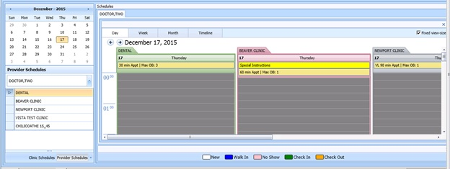

Fixed view size

Figure 226: Fixed View Size

1. By selecting the Fixed View Size option, when viewing multiple provider schedules for different clinics, the system adjusts all the slots to the same expanded width view.

### Viewing Clinic Group Availability

Use the following procedure to search for a clinic group and view the clinic group’s schedule.

1. In the **Tasks** tab, under the request grid calendar, select **Clinic Groups**.

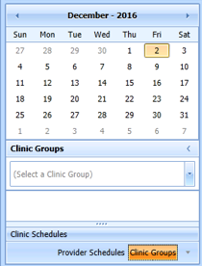

Figure 227: Clinic Groups

1. Enter a partial name of a clinic group (6 character minimum). Select the desired Clinic Group from the returned list.

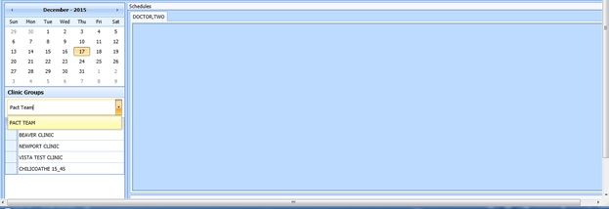

Figure 228: Clinic Groups Search Result List

1. The selected clinic group schedule(s) displays, starting with today’s date in the Day view.

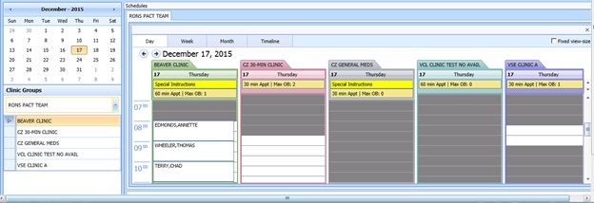

Figure 229: Clinic Groups Schedule Display

**Note:** Refer to Section 6 for Appointment Management instructions on how to Add, Check-In, Check-Out, and Cancel Appointments.

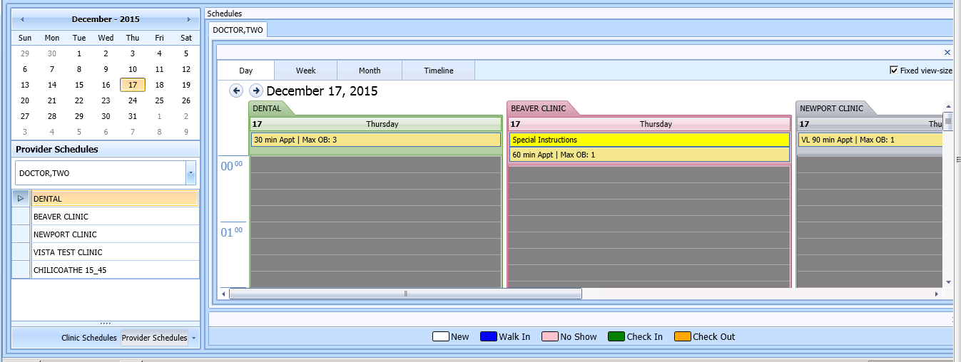

Fixed view size

Figure 230: Provider Schedules–Fixed View Size

1. By selecting Fixed View Size, when viewing multiple Clinic Group schedules for different clinics, the system adjusts all the slots to the same expanded width view.

## System Tab

The **System** tab requires the SDECZMGR security key in order to access the tab.

### Viewing Clinic Availability Information

Use the following procedure to quickly search for clinic availability. Clinic availability cannot be modified from the VS GUI.

1. In the **Systems** tab display, click **Availability** in the **Resource Schedules** section.
2. In the **Availability Selection** dialog, type in the desired clinic name.
3. Select the desired clinic and click **OK**.

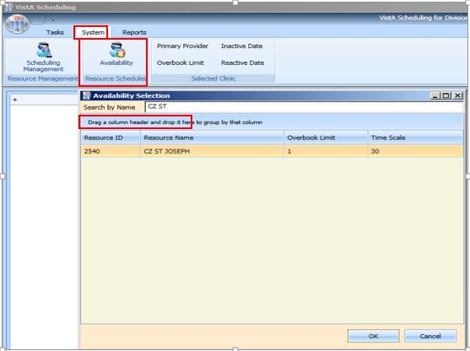

Figure 231: Clinic Availability Search

1. The Schedule displays for the selected clinic. Primary Provider, Overbook Limit, Inactive Date, and Reactive Date, as applicable, also display in the **Selected Clinic** section of the window. The Schedule also displays the number of appointments per slot and the number of slots total per appointment length in minutes and total number of minutes that are bookable. The Schedule uses the same visual coloration as in Clinic Schedule for workable hours, non-workable hours, and no availability.

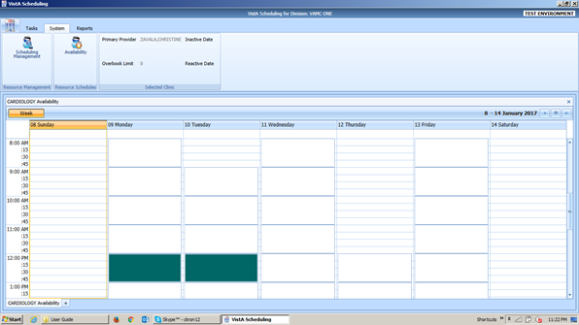

Figure 232: Clinic Availability

### Adding and Removing Privileged Users

#### Add Privileged User

Perform the following procedure to ADD a privileged user(s) to a prohibited clinic.

1. In the Systems tab display, click **Scheduling Management**.
2. In the **Prohibited Clinic** search box, type in a partial or full name of the clinic (minimum 6 characters).
3. Click **Find**. A list of prohibited clinics displays
4. Select the appropriate prohibited clinic. A list of privileged users for the selected clinic displays.

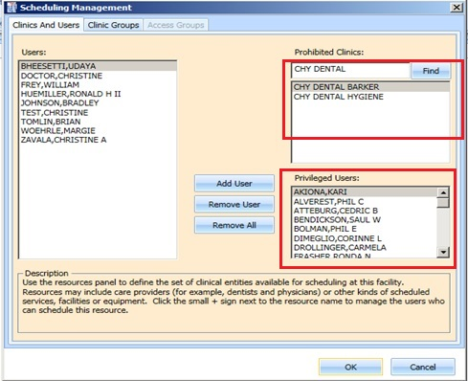

Figure 233: Clinics and Users

1. Select a user from the left and click **Add User**.

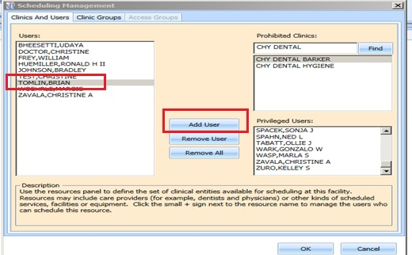

Figure 234: Add Privileged User

1. Click **OK** to file the change.

#### Remove Privileged User

Perform the following procedure to REMOVE a privileged user(s) from a prohibited clinic.

1. In the Systems tab display, Click **Scheduling Management**.
2. In the **Prohibited Clinic** search box, type in a partial or full name of the clinic (minimum 6 characters).
3. Click **Find**. A list of prohibited clinics displays.
4. Select the appropriate prohibited clinic. A list of privileged users for the selected clinic displays.
5. Select a user from the **Privileged User** list for the selected prohibited clinic and click **Remove User** or, if all privileged users need to be removed, click **Remove All.**

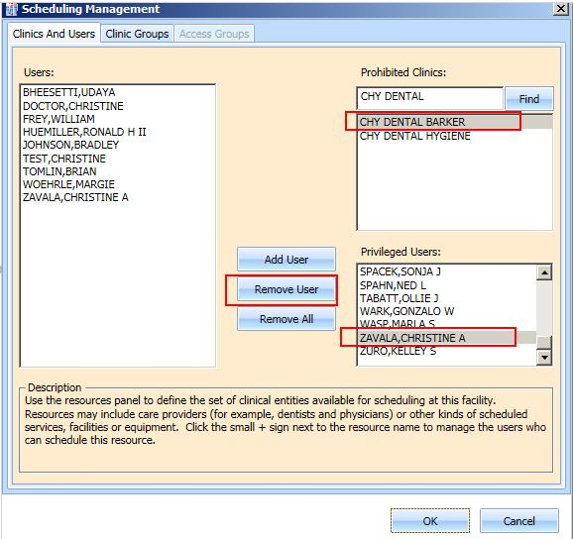

Figure 235: Remove Privileged User

### Creating Clinic Groups

Perform the following procedure to create a Clinic Group.

1. In the Systems tab display, Click **Scheduling Management**.
2. Select **Clinic Groups** tab.
3. Click **New Group**.
4. Enter name in the **Clinic Group Name** text box.

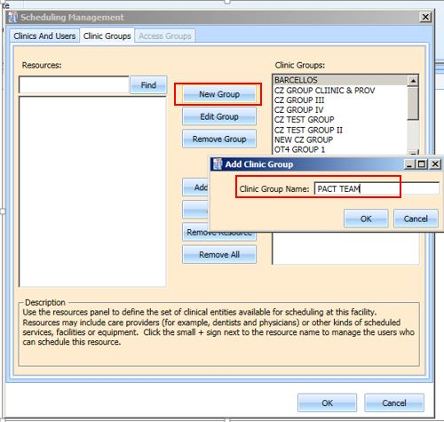

Figure 236: Create New Clinic Group

1. Click **OK**.
2. Select the newly added **Clinic Group**.
3. Enter partial name search for a **Resource** and click **Find.** A resource can be a clinic or a provider that is active with an active person class.

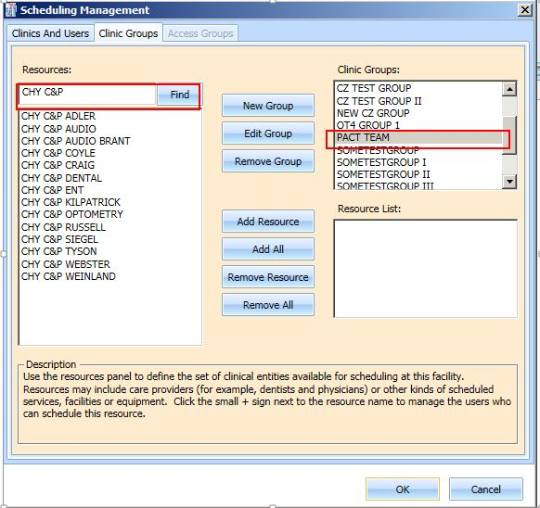

Figure 237: Find Resource

1. Select the appropriate resource to add to the Clinic Group and click **Add Resource**. If all of the resources listed from the search need to be added, click **Add All**.

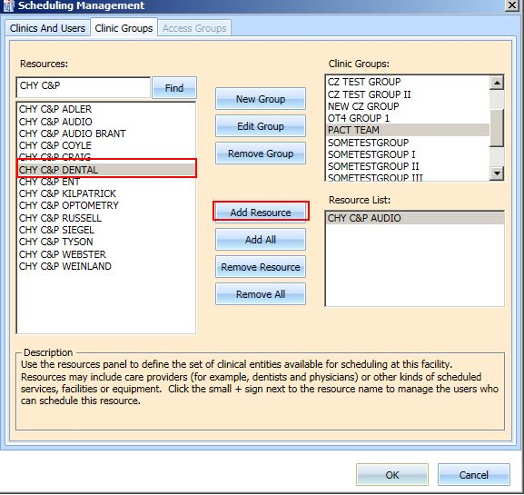

Figure 238: Add Resource to Clinic Group

1. Click **OK** to file.

### Removing Resource(s) from a Clinic Group

Perform the following procedure to remove a resource(s) from a Clinic Group.

1. In the Systems tab display, click **Scheduling Management**.
2. Select **Clinic Groups** tab.
3. Select a clinic group to be edited from the **Clinic Group** list. Resources defined for the Clinic Group are displayed in the **Resource List** box.
4. Select a resource to remove and click **Remove Resource**. If all resources need to be removed, click **Remove All**.

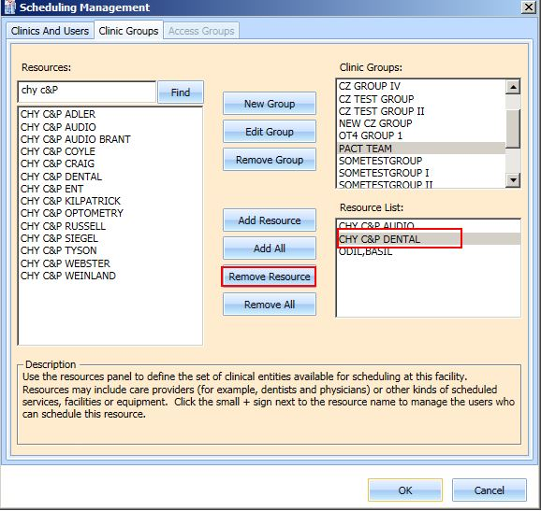

Figure 239: Remove Resource from Clinic Group

# Reports

The **Reports** tab display provides a means to view and print various reports. The Reports tab requires the SDECZMGR manager security key in order to access the tab. The following selections and reports are available:

1. Audit Activity
2. Clinics

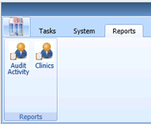

Figure 240: Reports Tab Selections

## Audit Activity Report

Audit Activity reports can be generated for individual schedulers by name or for All Schedulers.

### Generating an Audit Activity Report for Individual Scheduler

Perform the following procedure to view Audit Activity for individual scheduler.

1. From the **Reports** tab display, select **Audit Activity**. The Audit Activity dialog displays.
2. Select the individual **Scheduler** name from drop down list.
3. Select **Start** **Date** and **End** **Date** either by typing or by calendar control.

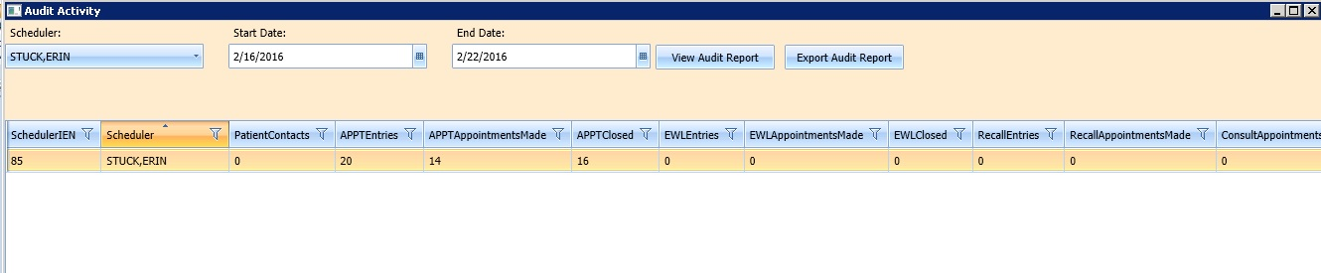

Figure 241: Audit Activity Report–Individual Scheduler

1. The following columns display data for the selected Scheduler based upon time frame specified:

* SchedulerIEN (New Person File)
* SchedulerName
* PatientContacts
* APPTEntries
* APPTAppointmentsMade
* APPTClosed
* EWLEntries
* EWLAppointmentsMade
* EWLClosed
* RecallAppointmentsMade
* ConsultAppointmentsMade
* AppointmentsCancelled
* TotalActions

1. Click **Close** to exit the Audit Activity report dialog.

### Generating Audit Activity Report for All Schedulers

1. From Reports tab select **Audit Activity**. The Audit Activity dialog displays.
2. In **Scheduler** drop down list select **All**.
3. Enter **Start Date** and **End Date** for audit report.
4. Click **View Audit Report** button.
5. The following columns display data for All Schedulers based upon time frame specified:

* SchedulerIEN (Internal Entry Number – New Person File)
* SchedulerName
* PatientContacts
* APPTEntries
* APPTAppointmentsMade
* APPTClosed
* EWLEntries
* EWLAppointmentsMade
* EWLClosed
* RecallAppointmentsMade
* ConsultAppointmentsMade
* AppointmentsCancelled
* TotalActions

1. Click **Close** to exit the Audit Activity report dialog.

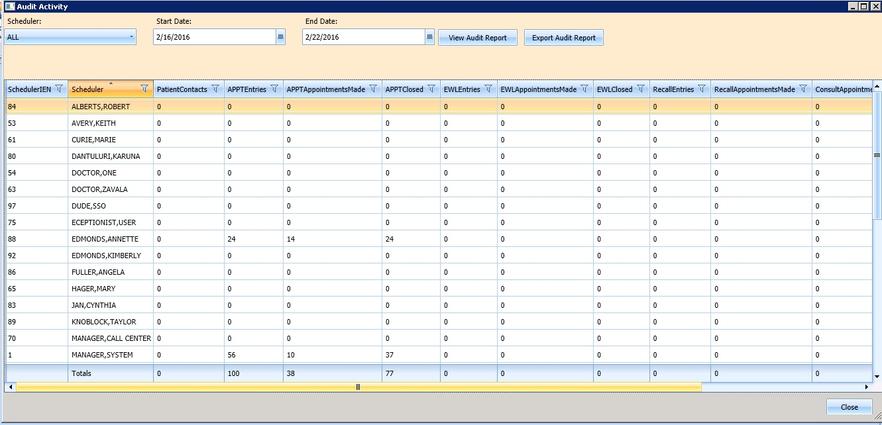

Figure 242: Audit Activity Report–All Schedulers

### Working with Audit Activity Report Data

#### Sorting by Column Header

1. Log into VS GUI.
2. Select **Reports** tab.
3. Select **Audit Activity** from Reports section. Audit Activity dialog displays for all schedulers defined in the New Person file (#200).
4. The following data displays on screen for the selected scheduler(s):

* SchedulerIEN (New Person File)
* SchedulerName
* PatientContacts
* APPTEntries
* APPTAppointmentsMade
* APPTClosed
* EWLEntries
* EWLAppointmentsMade
* EWLClosed
* RecallAppointmentsMade
* ConsultAppointmentsMade
* AppointmentsCancelled
* TotalActions

1. To change the sort for the report by data specified in a different column, select the applicable column header. The first click of the column header sorts the report by data in the specified column in ascending order. The second click of the column header sorts the report by data in the specified column in descending order.
2. Click **Close** to exit the Audit Activity Report dialog.

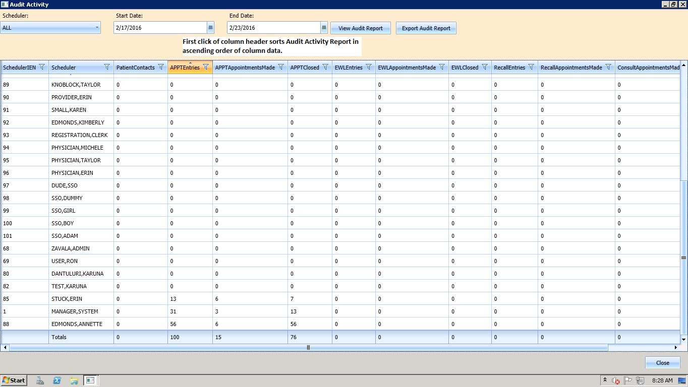

Figure 243: Audit Activity Sort–Ascending

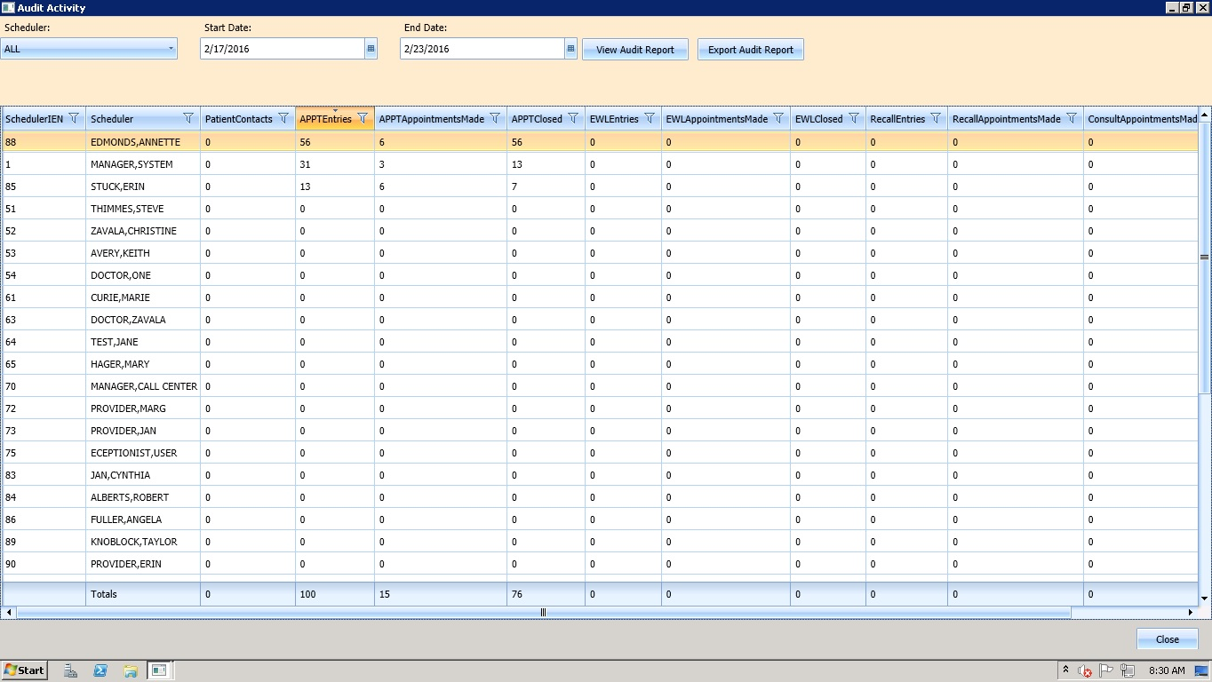

Figure 244: Audit Activity Sort –Descending

#### Filtering by Column Data

1. Data in Audit Activity report can be filtered by selecting a filter option available in each column header (i.e., All Schedulers who have greater than or equal to 10 APPTAppointmentMade in the selected date range). 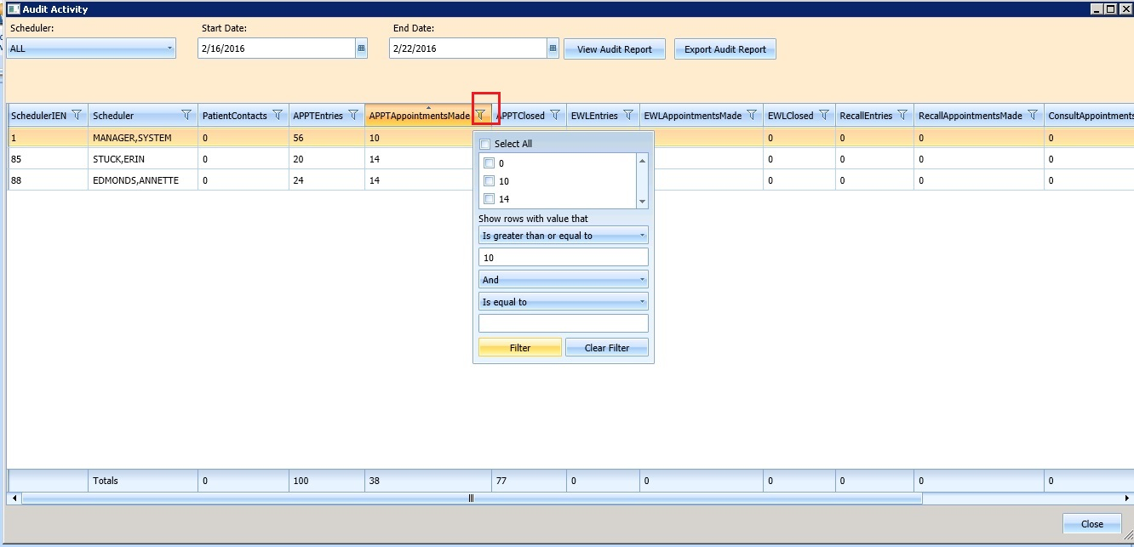

Figure 245: Audit Activity Report–Filtered

1. Multiple filters can be selected to refine results (i.e., All Schedulers who have greater than or equal to 10 APPTEntries but less than or equal to 30 APPTClosed for the selected date range).
2. Selected filters are highlighted in column headers.
3. To remove filters, select filter option in column header and click **Clear Filter** button.
4. Click **Close** to exit the Audit Activity report dialog.

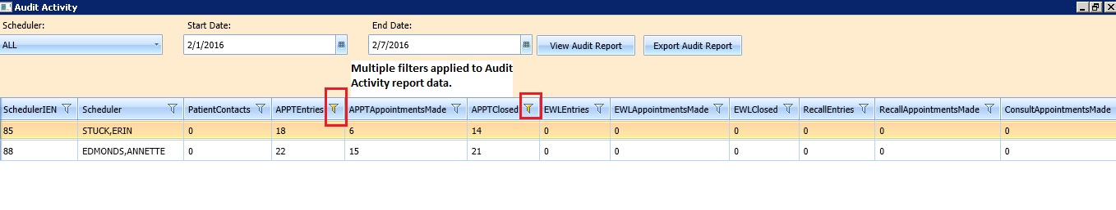

Figure 246: Audit Activity Report–Multiple Filters

### Export Audit Activity Report for Individual or All Schedulers

The data displayed on screen can be exported to an Excel spreadsheet.

1. To export audit report, click **Export Audit Report** button.
2. Save As dialog displays.
3. Select location to save report file.
4. File name defaults as “Audit Report” (edit as necessary).
5. Confirm “Save As Type” is Excel files.
6. Click **Save**.
7. Report is generated containing data displayed on screen in the Audit Activity dialog and saved to the location specified in the Save As dialog.
8. Click **Close** to exit the Audit Activity report dialog.

## Clinics Report

The Clinic Report is accessed in the **Reports** tab display by selecting **Clinics** from the Reports section. The report displays clinic activity for all clinics defined in Hospital Location file as the default. The Clinic Report can be limited to individual clinics using the following steps.

### Clinic Activity Report—Individual Clinic

1. Log into VS GUI.
2. Select **Reports** tab.
3. From Reports section, click **Clinics**.
4. In Clinic Activity dialog, enter clinic name (6 character minimum) that is defined in Hospital Location file. Click the **Search** button.
5. The following data displays on screen for the selected clinic:

* Clinic name
* Division
* Stop Code
* Service
* CreateDT
* InactiveDT
* ReactiveDT
* AppType
* DefaultProv
* AdditionalProv
* ApptLength
* Variable
* MaxDays

1. Click **Clear** button to remove search criteria and return to the Clinic Activity report for all clinics.
2. Click **Exit** to close the Clinic Activity Report dialog.

### Working with the Clinic Activity Report

#### Sorting by Column Headers

1. Log into VS GUI.
2. Select **Reports** tab.
3. Select **Clinics** from Reports section. Clinic Activity dialog displays for all clinics defined in the Hospital Location file (File #44).
4. The following data displays on screen for the selected clinic:

* Clinic name
* Division
* Stop Code
* Service
* CreateDT
* InactiveDT
* ReactiveDT
* AppType
* DefaultProv
* AdditionalProv
* ApptLength
* Variable
* MaxDays

**Note:** The sort default is by alphabetical order by Clinic name.

1. To change the sort for the report by data specified in a different column, select the applicable column header. The first click of the column header sorts the report by data in the specified column in ascending order. The second click of the column header sorts the report by data in the specified column in descending order.
2. Click **Exit** to close the Clinic Activity Report dialog.

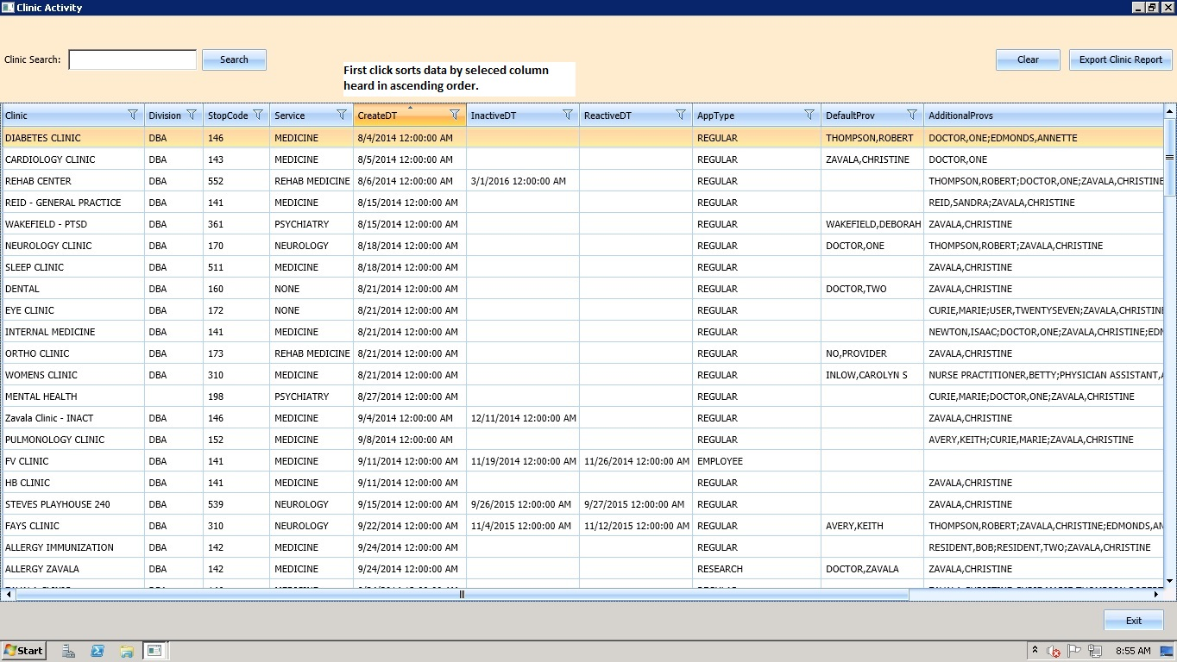

Figure 247: Clinic Activity Report Sort–Ascending Order

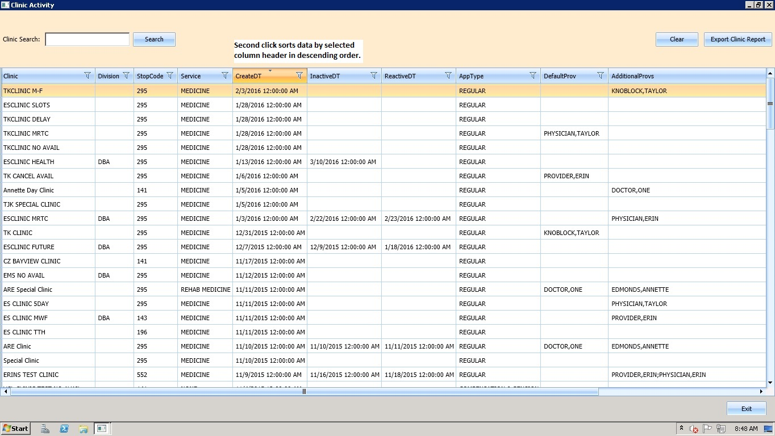

Figure 248: Clinic Activity Report Sort–Descending Order

#### Filtering by Column Data

1. Data in Clinics Activity report can be filtered by selecting the filter option in each column header (e.g., Clinic Activity data can be filtered by all Clinics with a defined Service of Rehab Medicine).

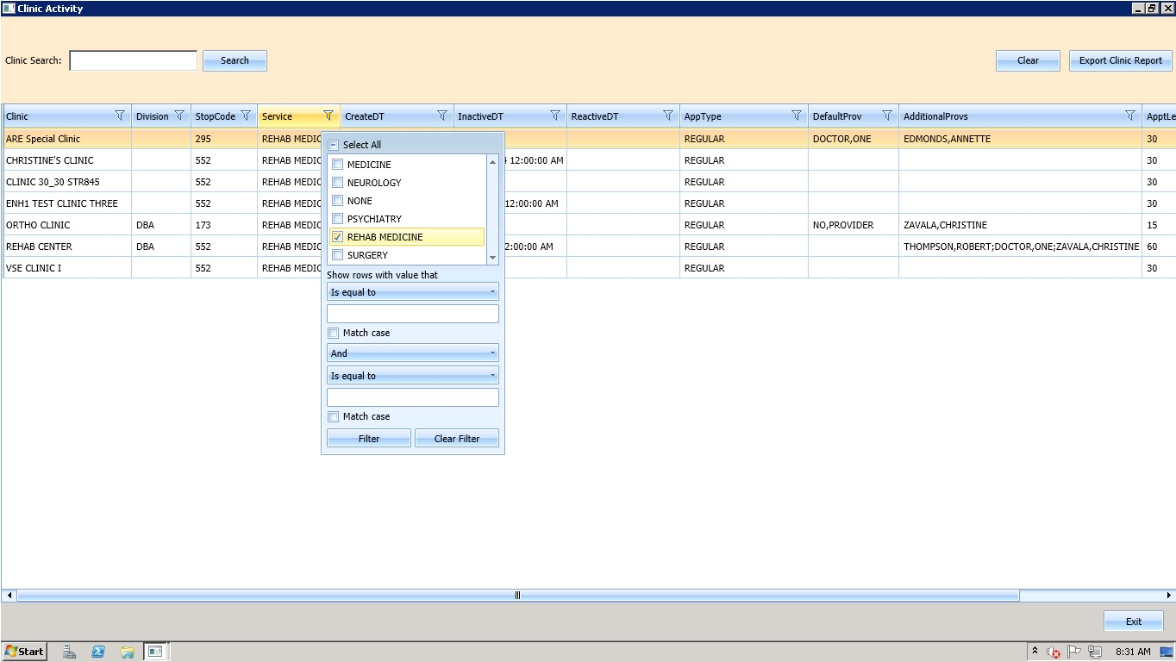

Figure 249: Clinic Activity Report–Filtered

1. Multiple filters can be selected to refine results (e.g., Clinic Activity data can be filtered by all Clinics with a defined Service of Rehab Medicine that also have no DefaultProv defined).
2. Selected filters are highlighted in column headers.
3. To remove filters, select filter option in column header and click the **Clear Filter** button.
4. Click **Exit** to close the Clinic Activity report dialog.

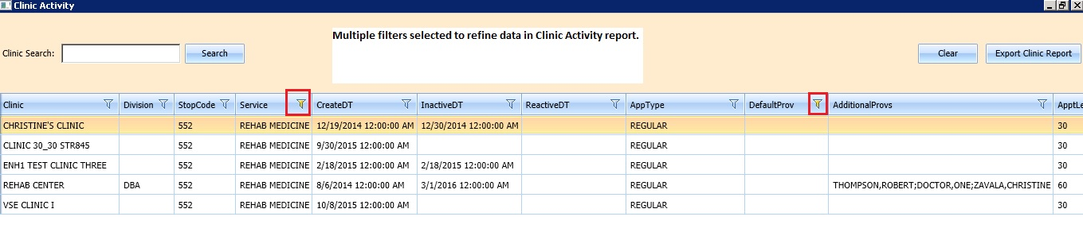

Figure 250: Clinic Activity Report–Multiple Filters

### Exporting a Clinic Report

Use the following procedure to export a Clinic Report.

1. In the **Reports** tab display, in the **Reports** section, select **Clinics.**
2. The **Clinic Activity** dialog opens, displaying the report.

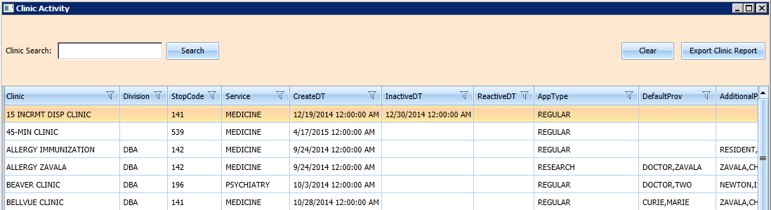

Figure 251: Clinic Activity

1. If applicable, search for specific clinic in the Clinic Search field. Click the **Search** button.
2. Click **Export Clinic Report**.
3. A **Save As** dialog box displays.
4. Select location to save the report.
5. Confirm file name (defaults to “Clinic Report”).
6. Confirm Save as Type is Excel files.
7. Click **Save**.
8. Data displayed on screen is exported into file and saved to the specified location with the defined name.
9. Click **Exit** to close the Clinic Activity report dialog.

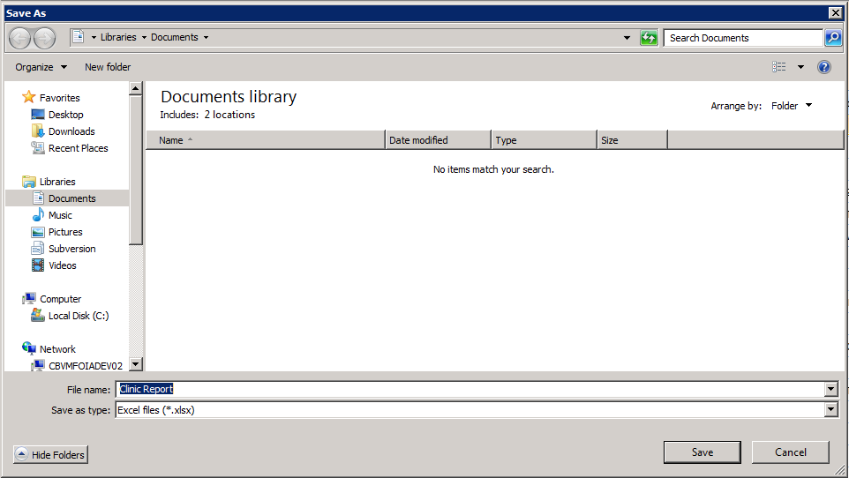

Figure 252: Save As

# Trash Queue Cleanup

For administrators who need to identify and purge unresolved requests, the solution allows a task to be run to identify open appointment requests or duplicate appointment requests and close them, producing a report for administrators. This excludes VAR requests which are called Veteran or Mobile requests – all stored in the SDEC APPT REQUEST file.

## Compile List of Re-Opened REQUEST Records that Can Be Closed

The following dialog allows the user to find open appointment requests or duplicate appointment requests in order to produce a report for administators to review/verify.

Use the following procedure:

1. Log on to the VistA Legacy System.
2. Enter **TEST an option not in your menu**.
3. Follow the steps shown below.

Select Option: SDEC INITIAL CLEANUP UTILITY VS GUI Initial Cleanup Utility

The following Utility will allow the Closing of Re-Opened SDEC APPT REQUEST

records which have resulted from a Cancellation in VistA of a corresponding

SDEC APPOINTMENT.

Select one of the following:

1 Compile List of Re-Opened REQUEST records that can be Closed

2 Commit Records to Be Closed from Compiled List

What Would You like to Do?: **1 Compile List of Re-Opened REQUEST records that can be Closed**

Please enter in, one by one, a list of Clinics to EXCLUDE from Compilation.

Enter CLINIC to EXCLUDE: <Hit **Enter** to not exclude any Clinics>

You did not choose any Clinics to Exclude.

Are you sure you want to run cleanup for ALL clinics? (Y OR N):? NO// y YES

Compiling for all Clinics excluding the following:

DEVICE: HOME// HOME (CRT)

(You may enter a device that prints to a file, a printer, email message, or you may print on the screen.)

*** Open SDEC APPT REQUESTs List run Jan 09, 2017@02:48:47 ***

LAST 4 APPT REQ IEN

CLINIC PATIENT SSN APPT IEN CID DATE

=============================================================================

VSE ENH1 CLINIC FAULCON,GONZALO J 2916 1747 ; 1985 12/27/2016

VSE ENH1 CLINIC TEST,STERLING PAUL JR 0183 1752 ; 1988 12/27/2016

Reopened REQUEST Records that Can Be Closed

## Commit Records to Be Closed from Compiled List

The following dialog allows the user to commit Records to Be Closed from the Compiled List created via SDEC INITIAL CLEANUP UTILITY.

Use the following procedure:

1. Log on to the VistA Legacy System.
2. Enter **TEST an option not in your menu**.
3. Follow the steps shown below.

Select Option: SDEC INITIAL CLEANUP UTILITY VS GUI Initial Cleanup Utility

The following Utility will allow the Closing of Re-Opened SDEC APPT REQUEST

records which have resulted from a Cancellation in VistA of a corresponding

SDEC APPOINTMENT.

Select one of the following:

1 Compile List of Re-Opened REQUEST records that can be Closed

2 Commit Records to Be Closed from Compiled List

What Would You like to Do?: **2 Commit Records to Be Closed from Compiled List**

Open SDEC APPT REQUEST Compilation Lists to Choose From:

Batch # Run User Start Date Finish Date

=============================================================================

1 STUCK,ERIN Dec 14, 2016@07:41:56 Dec 14, 2016@07:41:56

2 KRON,CAROLYN S Dec 16, 2016@23:54:52 Dec 16, 2016@23:54:53

3 KRON,CAROLYN S Dec 22, 2016@11:47:18 Dec 22, 2016@11:47:19

4 KRON,CAROLYN S Jan 09, 2017@02:34:05 Jan 09, 2017@02:34:05

5 KRON,CAROLYN S Jan 09, 2017@02:48:47 Jan 09, 2017@02:48:47

Enter Batch #:**5**

Committing Open records for Batch # 5 to Closed...Done

Once the task completes, the CURRENT STATUS is changed to “CLOSED” and the DISPOSITION fields in the SDEC APPT REQUEST file are set accordingly.

To verify the record has been closed, go to VA FileMan and Inquire to view the SDEC APPT REQUEST File (#409.85). View the following fields:

* CURRENT STATUS
* DATE DISPOSITIONED
* DISPOSITIONED BY
* DISPOSITION
* DISPOSITION CLOSED BY CLEANUP

Select Systems Manager Menu <TEST ACCOUNT> Option: fm VA FileMan

VA FileMan Version 22.0

Enter or Edit File Entries

Print File Entries

Search File Entries

Modify File Attributes

Inquire to File Entries

Utility Functions ...

Data Dictionary Utilities ...

Transfer Entries

Other Options ...

Select VA FileMan <TEST ACCOUNT> Option: inquire to File Entries

OUTPUT FROM WHAT FILE: SDEC APPT REQUEST//

Select SDEC APPT REQUEST PATIENT: TEST,STERLING PAUL JR

1 TEST,STERLING PAUL JR

2 TEST,STERLING PAUL JR

3 TEST,STERLING PAUL JR

4 TEST,STERLING PAUL JR

5 TEST,STERLING PAUL JR

Press <RETURN> to see more, '^' to exit this list, OR

CHOOSE 1-5:

.

.

.

Press <RETURN> to see more, '^' to exit this list, OR

CHOOSE 10-15:

16 TEST,STERLING PAUL JR

17 TEST,STERLING PAUL JR

18 TEST,STERLING PAUL JR

19 TEST,STERLING PAUL JR

20 TEST,STERLING PAUL JR

Press <RETURN> to see more, '^' to exit this list, OR

CHOOSE 1-20: 16 TEST,STERLING PAUL JR

ANOTHER ONE:

STANDARD CAPTIONED OUTPUT? Yes// (Yes)

Include COMPUTED fields: (N/Y/R/B): NO// b BOTH Computed Fields and Record Num

ber (IEN)

DISPLAY AUDIT TRAIL? No// y YES

NUMBER: 1752 PATIENT: TEST,STERLING PAUL JR

CREATE DATE: DEC 23, 2016 INSTITUTION: CHEYENNE VAMC

REQUEST TYPE: APPOINTMENT

REQ APPOINTMENT TYPE: REGULAR

Created on Dec 23, 2016@14:37:43 by User #520736464 (SDECRPC Option)

PATIENT STATUS: NEW

Created on Dec 23, 2016@14:37:43 by User #520736464 (SDECRPC Option)

REQ SPECIFIC CLINIC: VSE ENH1 CLINIC

Created on Dec 23, 2016@14:37:43 by User #520736464 (SDECRPC Option)

ORIGINATING USER: KRON,CAROLYN S PRIORITY: FUTURE

REQUESTED BY: PATIENT

Created on Dec 23, 2016@14:37:43 by User #520736464 (SDECRPC Option)

CID/PREFERRED DATE OF APPT: DEC 27, 2016

Created on Dec 23, 2016@14:37:43 by User #520736464 (SDECRPC Option)

**CURRENT STATUS: CLOSED**

**Changed from "OPEN" on Jan 09, 2017@02:49:09 by User #520736464**

**(SDEC INITIAL CLEANUP UTILITY Option)**

Changed from "CLOSED" on Dec 23, 2016@14:47:01 by User #520736464

(SDCANCEL Option)

Changed from "OPEN" on Dec 23, 2016@14:38:10 by User #520736464

(SDECRPC Option)

Enter RETURN to continue or '^' to exit:

Created on Dec 23, 2016@14:37:43 by User #520736464 (SDECRPC Option)

COMMENTS: TEST

Created on Dec 23, 2016@14:37:43 by User #520736464 (SDECRPC Option)

ENROLLMENT PRIORITY: GROUP 8 MULTIPLE APPOINTMENT RTC: NO

DATE/TIME ENTERED: DEC 23, 2016@13:37

DATE EDITED: DEC 23, 2016@14:37 EDITED BY: KRON,CAROLYN S

REQ SPECIFIC CLINIC: VSE ENH1 CLINIC

**DATE DISPOSITIONED: JAN 09, 2017 DISPOSITIONED BY: KRON,CAROLYN S**

**DISPOSITION: ENTERED IN ERROR DISPOSITION CLOSED BY CLEANUP: YES**

SERVICE CONNECTED PERCENTAGE: 0 SERVICE CONNECTED PRIORITY: NO

## View Unresolved APPT Requests Reopened by the SDCANCEL Option

The following dialog allows a user that holds the new SDEC REQ REOPENED BY SDCANCEL menu option within their Scheduling Outputs menu to view unresolved appointment requests.

To view, use the following procedure:

1. Go to the **Outputs** option under the Scheduling Manager’s Menu.
2. Select **VS GUI Requests Reopened by Cancel Availability**.
3. Follow the steps shown below.

Select Scheduling Manager's Menu <TEST ACCOUNT> Option: outputs

AQK Encounter Activity Report (Reno's)

AQK2 ACRP Stop Code Report

CAAR Clinic Appointment Availability Report

Appointment List

Appointment Management Report

Cancelled Clinic Report

Clinic Assignment Listing

Clinic List (Day of Week)

Clinic Next Available Appt. Monitoring Report

Clinic Profile

Display Clinic Availability Report

Enrollments > X Days

File Room List

Future Appointments for Inpatients

Inpatient Appointment List

Management Report for Ambulatory Procedures

No-Show Report

Patient Profile MAS

PCMM Main Menu ...

Print Scheduling Letters

Provider/Diagnosis Report

Radiology Pull List

Routing Slips

Visit Rpt by Transmitted OPT Encounter

VS GUI Requests Reopened by Cancel Availability

Workload Report

Select Outputs <TEST ACCOUNT> Option: **vs guI Requests Reopened by Cancel Availab**

**ility**

Select CLINIC: **vse en**

1 VSE ENH1 CLINIC

2 VSE ENH1 CLINIC ONE ZAVALA,CHRISTINE A

3 VSE ENH1 CLINIC TWO

CHOOSE 1-3: **1 VSE ENH1 CLINIC**

Select CLINIC:

DEVICE: HOME// HOME (CRT)

VS GUI Requests Re-Opened by Cancel Availability (SDCANCEL) Option

for clinics: VSE ENH1 CLINIC

PATIENT SSN TELEPHONE CID/PREF DATE

TEST,CHRISTINE 000-12-1234 (555)123-1234 JAN 12,2017

# VistA Scheduling 508 Compliance

The following section outlines the process for executing VistA Scheduling Application functionality from the keyboard.

## Tasks Tab

The Hot Key, **Ctrl + T**, is used to navigate to the **Tasks Tab**.

### Ribbon Bar

**Tabbing:**

1. Log on to VS GUI as a Scheduler.
2. Focus is on Search field indicated by field being highlighted and cursor blinking.
3. The Scheduler can use the **Tab** key to advance through the Ribbon Bar. Beginning at the **Patient Search** field, the order will be going left to right. If the controls in each section listed below are enabled tabbing will highlight each one:

* Patient Search Field
* Search Button
* Clear Button
* Actions
* Arrangement
* Pending Appointments
* Special Needs/Preferences
* Mobile Requests
* Tools
* Print
* Export
* Refresh
* Query

1. After leaving the **Tools** section, control will go back to **Patient Search** field.

Table 2: Hot Keys for Ribbon Bar Components

|  |  |
| --- | --- |
| Ribbon Bar Component | Hot Key |
| Patient Search Field | **Alt + S** |
| Action | **Alt + A** |
| Arrangement | **Alt + G** |
| Pending Appointment Window | **Alt + P** |
| Special Needs/Preferences | **Alt + N** |
| Mobile Requests | **Alt + M** |
| Tools | **Alt + T** |

### Request Type Dialog

**Tabbing:**

1. From the **Actions Pane**, with **New Req.** highlighted, press **Enter**. The **Request Type** dialog box displays.
2. Focus is **OK**.
3. Tab to **CLEAR**.
4. Tab to **APPT Request Type**.
5. Tab to **RECALL Request Type**.
6. To select a **Request Type**, tab to highlight and press **Space Bar** key to select.
7. Tab to **OK**.
8. Press **Enter**.  
   **Note:** Arrow keys can also be used to navigate Request Type dialog box.

Table 3: Hot Keys for Request Type Dialog

|  |  |
| --- | --- |
| Component | Hot Key |
| OK | **Alt + O** |
| Clear | **Alt + C** |

### Appointment Request Dialog

**Tabbing:**

1. The **Appointment Request Dialog** displays with focus on **OK** button.
2. Tab to **CLEAR**.
3. Tab to the **Svc Related** check box. Press the **Space Bar** to select.
4. Tab to the **Clinic** radio button (default selection).
5. Tab to **Service/Specialty**. Press the **Space Bar** to select.
6. Tab to the **Clinic** field. Enter the **Clinic Name** (four character minimum).
7. Tab to the **CID/Preferred Date** field.
8. Once highlighted press **Enter** to display **Calendar** control.
9. Use the up and down arrow keys to navigate dates in the calendar and press **Enter** to select date.
10. Tab to **Appointment Type**.
11. Use the up and down arrow keys to select **Appointment Type**.
12. Tab to the **Requested By** field.
13. Use the arrow keys to select **Requested By**.
14. Tab to the **Provider** field (if applicable) to enter the **Provider** name (three character minimum).
15. Tab to the **Multiple Appointments Required** check box. Press the **Space Bar** to select.
16. Tab to the **Number of Appointments Required** field.
17. Use the up and down arrow keys to select the number of appointments required.
18. Tab to the **Interval Between Appointments** field.
19. Use the up and down arrow keys to select the number of days between appointments.
20. Tab to the **Comments** field.
21. Enter text in the **Comments** field.
22. Tab to the **OK** Button.
23. Press **Enter** to select and create APPT Request and exit dialog.

Table 4: Hot Keys for Appointment Request Dialog

|  |  |
| --- | --- |
| Component | Hot Key |
| OK | **Alt + O** |
| Clear | **Alt + C** |

### Query Dialog

1. The **Query Dialog** displays with focus on **Patient** field.
2. Enter the patient name **Last Name**, **First Name** orlast initial and last four of SSN.
3. Tab to the **Find** button.
4. Press **Enter**.
5. Use the **Down Arrow** key to highlight names in **Patient** list.
6. Use the **Enter** key to select patients from list to include in query.
7. Tab to the **Patients** column.
8. Use the **Down Arrow** key to highlight names listed. To remove names from selection press **Enter**.
9. Tab to the **Request Type Filter**.
10. Press **Enter** to display **Request Types** dialog box.
11. Use the arrow keys to navigate the **Request Type** selection grid.
12. Press the **Space Bar** key to select highlighted **Request Type**.
13. Tab to **OK** to confirm selection.
14. Tab to **Cancel** to quit selection and exit dialog.
15. Tab to the **Clinic/Service Filter**.
16. Press **Enter** to display **Clinics** dialog box.
17. Enter the **Clinic/Service** name in field (four character minimum).
18. Tab to the **Find** button.
19. Tab to the **Select All** check box.
20. Press **Space Bar** key to **Select All**.
21. Tab to the **Clinics** or **Services** radio button.
22. The **Clinics** radio button is defaulted. The **Services** radio button can be selected by pressing the **Space Bar** key.
23. Use the arrow keys to navigate up and down **Clinics/Service Grid**.
24. Use the **Space Bar** key to select/unselect from list.
25. Tab to **OK** and press **Enter** to confirm selections for query.
26. Tab to **Cancel** and press **Enter** to quit selection and exit dialog.
27. Tab to **Priority Group Filter**.
28. Press **Enter** to display **Priority Group** dialog box.
29. Tab to the **Select All** check box.
30. Press the **Space Bar** key to select (if applicable).
31. Tab to the **Priority Group** grid list.
32. Use the arrow keys to navigate up and down list.
33. Use the **Space Bar** key to select/unselect **Priority Group** options.
34. Tab to **OK** and press **Enter** to confirm selections for query.
35. Tab to **Cancel** and press **Enter** to quit selection and exit dialog.
36. Tab to the **Wait Time** drop down.
37. Use the arrow keys to navigate options for query selection.
38. Tab to the **ScVisit?** drop down.
39. Use the arrow keys to navigate options for query selection.
40. Tab to the **Service Connected?** drop down.
41. Use the arrow keys to navigate options for query selection.
42. Tab to the **Origination Date** field.
43. Enter the date for query selection as applicable.
44. Tab to the **CID/Preferred Date** field.
45. Enter the date for query selection as applicable.
46. Tab to the **Urgency** field (Applicable to Consult Requests only)
47. Use the arrow keys to navigate list for query selection.
48. Tab to the Change **Sort** field.
49. Use the arrow keys to navigate list for query selection.
50. Tab to the **Clear** button.
51. Press **Enter**. The **Clear Filter** dialog box displays.
52. Tab to **OK**.
53. Press **Enter** to clear the **Request Query** dialog box of all filter selections and start query selection process again.
54. Tab to **Cancel**.
55. Press **Enter** to **Cancel Clear Filter** selection and exit dialog.   
    **Note:** Selecting **Cancel** in this dialog will keep current **Request Query** dialog filter selections for query.
56. Tab to **Submit** button.
57. Press **Enter**. The **Request Query Confirmation** dialog box displays.
58. Tab to **OK**.
59. Press **Enter** to display query results in **Request Management Grid**.
60. Tab to **Cancel**.
61. Press **Enter** to key to abort query results and return to **Request Query** dialog box.
62. Tab to the **Close** button.
63. Press **Enter** to close **Request Query** dialog box.

## Systems Tab

The Hot Key, **Ctrl + Y**, is used to navigate to the **Systems Tab**.

### Systems Tab Ribbon Bar

**Tabbing:**

1. Tab to **Scheduling Management**.
2. Press **Enter** to display **Scheduling Management** dialog box.
3. Tab to **Availability**.
4. Press **Enter** to display **Availability Selection** dialog box.

Table 5: Hot Keys for Systems Tab Ribbon Bar

| Ribbon Bar Component | Hot Key |
| --- | --- |
| Systems Tab | **Ctrl + Y** |
| Scheduling Management | **Alt + M** |
| Availability | **Alt + H** |
| Selected Clinic | **Alt + L** |

### Scheduling Management Dialog

#### Clinics and Users Tab

**Tabbing:**

1. The **Scheduling Management Dialog** displays with **Clinics** and **Users** tab enabled. Focus is on **OK** button.
2. Tab to the **Users Selection List**.
3. Use the **Down** **Arrow** key to highlight the **First Name** in **Users List**.
4. Press **Enter** to select **User Name**.
5. Tab to the **Prohibited Clinic** field.
6. To select the **Prohibited Clinic**, and enter the **Clinic Name**.
7. Tab to **Find Button** and press **Enter**. The **Prohibited Clinic List** is displayed.
8. Use the arrow keys to navigate up and down the list.
9. Tab to the **Privileged Users List** that are assigned to selected clinic.
10. Tab to the **Add User** button.
11. Tab to the **Remove User** button.
12. Tab to the **Remove All** button.\

Table 6: Hot Keys for Scheduling Management Dialog

| Component | Hot Key |
| --- | --- |
| Add User | **Alt + A** |
| Remove User | **Alt + R** |
| Remove All | **Alt + E** |
| Find | **Alt + F** |
| OK | **Alt + O** |
| Cancel | **Alt + C** |

#### Clinic Groups Tab

**Tabbing:**

1. The OK button has the focus when Clinic Group Tab displays.
2. Tab to Resources.
3. Enter Clinic Schedule Resource—User name, Clinic Name, Clinic Group.
4. Tab to Find Button and press Enter to search.
5. Use the Down Arrow to highlight first name in Resource List.
6. Tab to the New Group button.
7. Tab to the Edit Group button.
8. Tab to the Remove Group button.
9. Tab to the Clinic Groups List.
10. Tab to the Add Resource button.
11. Tab to the Add All button.
12. Tab to the Remove Resource button.
13. Tab to the Remove All button.

Table 7: Hot Keys for Clinic Groups Tab

| Component | Hot Key |
| --- | --- |
| New Group | **Alt + N** |
| Edit Group | **Alt + E** |
| Remove Group | **Alt + R** |
| Add Resource | **Alt + S** |
| Add All | **Alt + L** |
| Remove Resource | **Alt + D** |
| Remove All | **Alt + X** |
| OK | **Alt + O** |
| Cancel | **Alt + C** |

### Availability Selection Dialog

**Tabbing:**

1. The **Availability Selection Dialog** displays with focus on **OK** button.
2. Tab to the **Cancel** button.
3. Tab to the **Search by Name** field.
4. Enter the **Clinic Name** (four character minimum).
5. Tab to the **Resource List Grid**.
6. Use the arrow keys to navigate up and down **Resource List**.
7. Press **Enter** to select the highlighted **Resource**. **Select** **Clinic Availability** displays.

Table 8: Hot Keys for Availability Selection Dialog

| Component | Hot Key |
| --- | --- |
| Search Field | **Alt + S** |
| First Row of Results Grid | **Alt + G** |
| OK | **Alt + O** |
| Cancel | **Alt + C** |

## Reports Tab

The Hot Key, **Ctrl + R**, is used to navigate to the **Reports Tab**.

### Reports Tab Ribbon Bar

**Tabbing:**

1. Tab to **Audit Activity**.
2. Tab to **Clinics**.
3. Tab to **Management Reports**.

Table 9: Hot Keys for Reports Tab Ribbon Bar

| Ribbon Bar Component | Hot Key |
| --- | --- |
| Reports Tab | **Ctrl + R** |
| Reports | **Alt + R** |

### Audit Activity Dialog

**Tabbing:**

1. The **Audit Activity** dialog box displays with focus on Close button.
2. Tab to the **Scheduler** drop down.
3. Default is **All**.
4. Use **Down** **Arrow** key to select user name (listed in alphabetical order).
5. Enter the user name (last name, first name) to jump to specific user.
6. Tab to the **Start** **Date** field.
7. Press **Enter** to select **Calendar** control.
8. Use the arrow keys to select date.
9. Tab to the **End Date** field.
10. Press **Enter** to select **Calendar** control.
11. Use arrow keys to select date.
12. Tab to the **View Audit Report**.
13. Press **Enter** to display **Audit Report in Grid**.
14. Tab to the **Export Audit Report**.
15. Press **Enter** to display **Save As** dialog box.   
    **Note:** Only data outputted to screen will appear in exported **Audit Report**.
16. Tabbing is enabled for **Audit Report Grid**.

Table 10: Hot Keys for Audit Activity Dialog

| Component | Hot Key |
| --- | --- |
| Scheduler drop down | **Alt + S** |
| Audit Report | **Alt + V** |
| Export Report | **Alt + E** |
| Close | **Alt + C** |

### Clinic Activity Dialog

**Tabbing:**

1. The **Clinic Activity** dialog box displays with focus on **Exit** button.
2. Tab to **Clinic Search** field.
3. Enter the **Clinic** N**ame** (six character minimum).
4. Tab to the **Search** button.
5. Press **Enter**.
6. Tab to the **Clinic Results Grid**.
7. Tab through **Clinic Results Grid** including **Column Headers** and **Filter** dialogs.

Table 11: Hot Keys for Clinic Activity Dialog

| Component | Hot Key |
| --- | --- |
| Search Button | **Alt + S** |
| Clear | **Alt + C** |
| Export | **Alt + E** |
| Exit | **Alt + X** |

# Troubleshooting

Please contact the National Service Desk (NSD) and open a ticket for any VS GUI related issues.

## **Changing User ID and Password**

Contact your supervisor or System Administrator for User ID or Password changes.

## Special Instructions for Error Correction

There are some warnings that may be displayed in a dialog. These include:

Table 12: Warning Messages

| Reason for Message | Message | Action | Result |
| --- | --- | --- | --- |
| Sensitive Information Warning | Warning displays to the user:  ***WARNING***  ***RESTRICTED RECORD*** | Click **OK** | User is able to log into the Security Log Audit Trail |
| Warning for similar names and Social Security Number | Similar Names dialog displays  System lit patients with similar name and same last four digit of SS# | Click **OK** | User is able to continue |
| Accessing deceased patient’s record | This patient died on <Date of Death>  Do wish to continue? | Click **OK** | User is able to perform action such as Disposition, Cancel Appointments |
| Accessing own record at selection | Security regulations prohibit computer access to your own medical record. | Click **OK** | User is unable to perform any activity/actions |

# Acronyms and Abbreviations

| Term | Description |
| --- | --- |
| Access Block | A color-coded representation of the amount of time allotted for a specific Access Type (or appointment). |
| Access Types | The variety of different appointment types available in the Legacy VistA Scheduling package. Each type of appointment, such as routine physical, dental, walk-in, or other specific appointment type is an Access Type. |
| Access Groups | Categories of Access Types. Assigning Access Types to Access Groups makes it easier to schedule and search for certain types of appointments. |
| API | Application Program Interface |
| Appointment | A scheduled or unscheduled meeting between patient and healthcare professional.; an appointment can include several encounters with providers or clinics for tests, procedures, etc |
| CID | Clinically Indicated Date |
| Clinic | A medical center location where patients receive care by a doctor or authorized provider. |
| Enh | Enhancement |
| EWL | Electronic Wait List |
| GUI | Graphical User Interface |
| MUMPS | Massachusetts General Hospital Utility Multi-Programming System |
| NSR | New Service Request |
| OT3 | Optional Task #3 |
| OT4 | Optional Task #4 |
| OVAC | Office For Veterans Access to Care |
| PACT | Patient-Aligned Care Teams |
| PIMS | Patient Information Management System |
| POC | Point of Contact |
| Provider | A doctor or other authorized provider in the medical center who provides patient care. |
| PWS | Performance Work Statement |
| RM Grid | Request Management Grid |
| RTC | Return to Clinic |
| Slot | Number of appointments per defined appointment length that have been previously set up in VistA Scheduling. For example, If Slots = 4 and your clinic (resource) appointment length is 30 minutes, then there are four available appointments for every 30 minutes. |
| T4 | Transformation Twenty-One Total Technology |
| TAC | Technology Acquisition Center |
| TCP/IP | Transmission Control Protocol/Internet Protocol |
| VA | Department of Veterans Affairs |
| VAR | Veteran Appointment Request |
| VistA | Veterans Health Information Systems and Technology Architecture |
| VSE | VistA Scheduling Enhancements |

# Hot Keys Quick List

Patient demographic information can be displayed and edited at any point in the process by entering **Ctrl + P** to bring up the Patient Info screen.

Ribbon Bar Components

|  |  |
| --- | --- |
| Ribbon Bar Component | Hot Key |
| Patient Search Field | **Alt + S** |
| Action | **Alt + A** |
| Arrangement | **Alt + G** |
| Pending Appointment Window | **Alt + P** |
| Special Needs/Preferences | **Alt + N** |
| Mobile Requests | **Alt + M** |
| Tools | **Alt + T** |

Request Type Dialog

|  |  |
| --- | --- |
| Component | Hot Key |
| OK | **Alt + O** |
| Clear | **Alt + C** |

Appointment Request Dialog

|  |  |
| --- | --- |
| Component | Hot Key |
| OK | **Alt + O** |
| Clear | **Alt + C** |

Systems Tab Ribbon Bar

| Ribbon Bar Component | Hot Key |
| --- | --- |
| Systems Tab | **Ctrl + Y** |
| Scheduling Management | **Alt + M** |
| Availability | **Alt + H** |
| Selected Clinic | **Alt + L** |

Scheduling Management Dialog

| Component | Hot Key |
| --- | --- |
| Add User | **Alt + A** |
| Remove User | **Alt + R** |
| Remove All | **Alt + E** |
| Find | **Alt + F** |
| OK | **Alt + O** |
| Cancel | **Alt + C** |

Clinic Groups Tab

| Component | Hot Key |
| --- | --- |
| New Group | **Alt + N** |
| Edit Group | **Alt + E** |
| Remove Group | **Alt + R** |
| Add Resource | **Alt + S** |
| Add All | **Alt + L** |
| Remove Resource | **Alt + D** |
| Remove All | **Alt + X** |
| OK | **Alt + O** |
| Cancel | **Alt + C** |

Availability Selection Dialog

| Component | Hot Key |
| --- | --- |
| Search Field | **Alt + S** |
| First Row of Results Grid | **Alt + G** |
| OK | **Alt + O** |
| Cancel | **Alt + C** |

Reports Tab Ribbon Bar

| Ribbon Bar Component | Hot Key |
| --- | --- |
| Reports Tab | **Ctrl + R** |
| Reports | **Alt + R** |

Audit Activity Dialog

| Component | Hot Key |
| --- | --- |
| Scheduler drop down | **Alt + S** |
| Audit Report | **Alt + V** |
| Export Report | **Alt + E** |
| Close | **Alt + C** |

Clinic Activity Dialog

| Component | Hot Key |
| --- | --- |
| Search Button | **Alt + S** |
| Clear | **Alt + C** |
| Export | **Alt + E** |
| Exit | **Alt + X** |